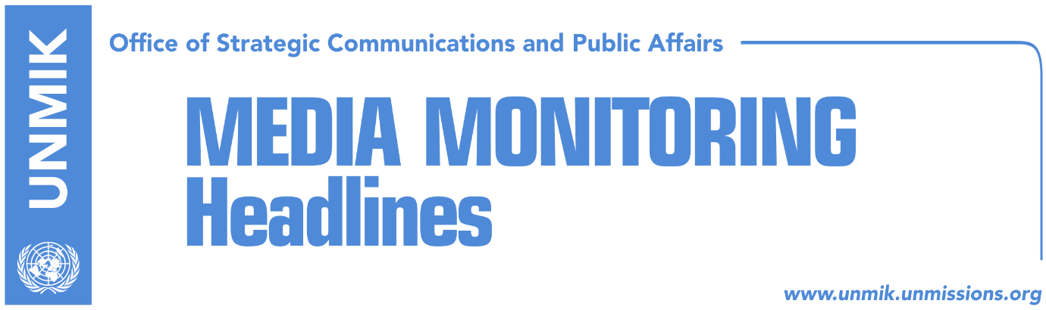

Main Stories 12 October 2016

- “Cold war” between Kosovo and Serbia begins (Koha Ditore)
- EU: Kosovo to decide if Trepca will be included in the dialogue (Zeri)
- Tahiri: Trepça will not be part of discussions in Brussels (Epoka e Re)
- Kosovo Assembly fails to adopt resolution on Thaci’s arrest (dailies)
- Kosovo government aims to pass demarcation by 27 October (Zeri)
- Danielsson: Kosovo should ratify demarcation with Montenegro (Epoka e Re)

Kosovo Media Highlights

“Cold war” between Kosovo and Serbia begins (Koha Ditore)
The paper writes on the front page that a “cold war” has begun between Kosovo and Serbia over the fate of the Trepca mining complex. Yesterday, the Government of Serbia decided to annul the draft law on the mines approved last week by the Government of Kosovo. At the same time, the Patriarch of the Serb Orthodox Church, Irinej, said “Kosovo was taken from Serbia by force and should be returned by force”. Serbian Prime Minister, Aleksandar Vucic, reacted to this saying that while he has immense respect for the Serb Orthodox cleric, he didn’t speak about violence. On the same day, a Kosovo delegation consisting of two deputy ministers canceled their participation in a security forum in Belgrade. Kosovo’s Deputy Prime Minister, Hajredin Kuci, said the Serbian Government’s decision to annul the approval of the law on Trepca has no legal effect and only demonstrates Serbia’s mindset towards Kosovo which, according to Kuci, is unchanged from that in the past.

EU: Kosovo to decide if Trepca will be included in the dialogue (Zeri)
Maja Kocijancic, spokesperson for EU Foreign Affairs and Security Policy, said on Tuesday that the European Commission is aware of the position taken by the Government of Serbia regarding Kosovo Assembly’s approval of Trepca Law. She reiterated that if Kosovo does not accept that this topic be part of the Pristina-Belgrade dialogue in Brussels, the EU alone and only with Serbia’s consent cannot do such a thing.

Tahiri: Trepça will not be part of discussions in Brussels (Epoka e Re)
Kosovo’s Minister without portfolio engaged in the Brussels dialogue between Pristina and Belgrade, Edita Tahiri, told the paper that Trepça will not be part of the discussions in Brussels. She said that in no case and under no circumstances would Kosovo state wealth be part of the dialogue. Tahiri said that Serbia’s reactions regarding the endorsement of the Law on Trepça are in vain. According to her, the Serbian party is not in a position to condition the decision on continuance of the discussions based on Trepça. She also rejected the possibility of pressure from the European Union on Kosovo to bring Trepça at the discussion table.

Kosovo Assembly fails to adopt resolution on Thaci’s arrest (dailies)
The four-hour session of the Kosovo Assembly yesterday regarding the arrest of Kosovo Police director for Mitrovica, Nehat Thaci, by Serbian authorities ended with no approval of a resolution that would reflect the stances presented by the MPs due to a lack of quorum. According to Koha Ditore, a resolution will be drafted and voted in a new session scheduled for today. Zëri writes that the lengthy debate was characterized by accusations directed at the government of Kosovo for not doing enough to secure Thaci’s release. Prime Minister Isa Mustafa said Thaci’s arrest was political and that Serbia continues to issue international arrest warrants for Kosovo citizens while Kosovo authorities have no access to Interpol. “This was the case with Haradinaj and can also happen to other officials because we have no access and Serbia is acting against the cooperating spirit”, said Mustafa. He however said that conditioning Thaci’s release with the process of dialogue is not in the interest of Kosovo. “We will continue the dialogue because we have many unresolved matters”, noted Mustafa.

Kosovo government aims to pass demarcation by 27 October (Zeri)
The paper reports in a front-page story that the Kosovo government is aiming to ratify the agreement on border demarcation with Montenegro between 25-27 October in order to achieve the necessary deadlines to obtain visa liberalisation this year. If this does not happen, the lifting of the visa regime will be postponed for another year. The paper claims to possess a document prepared by the Ministry of Foreign Affairs, which was distributed to the MPs and relevant institutions. According to this document, Kosovo must meet conditions for visa liberalisation by 27 October in order for this process to be completed this year. Meanwhile, opposition MPs insist that demarcation is not a determinative criteria for visa liberalisation.

Danielsson: Kosovo should ratify demarcation with Montenegro (Epoka e Re)
The Director General for Enlargement at the European Commission, Christian Danielsson, made it clear during the meeting with the President of the Assembly, Kadri Veseli, that Kosovo has to fulfill the remaining criteria for visa liberalization: ratification of the demarcation of the border with Montenegro as well as fighting corruption and organized crime. He said that the EU will continue to give full political and financial support to Kosovo on strengthening the rule of law and governance, in order to build a transparent public service.

Disclaimer
This media summary consists of selected local media articles for the information of UN personnel. The public distribution of this media summary is a courtesy service extended by UNMIK on the understanding that the choice of articles translated is exclusive, and the contents do not represent anything other than a selection of articles likely to be of interest to a United Nations readership. The inclusion of articles in this summary does not imply endorsement by UNMIK.

