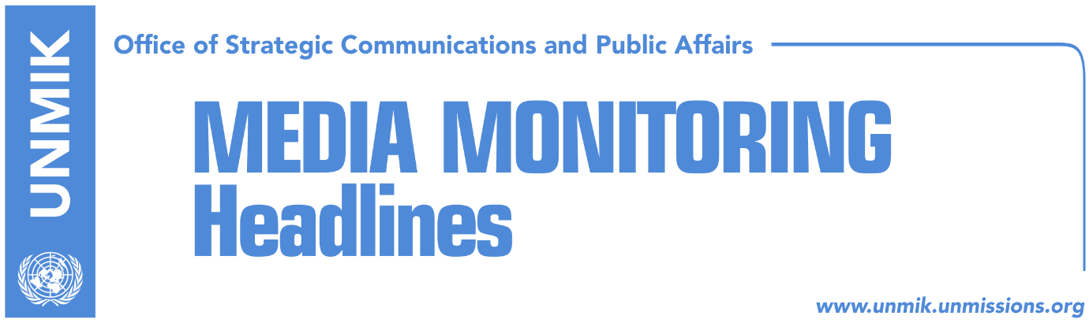

Main Stories 18 October 2016

- Assembly to ask EU not to condition visas with demarcation (Koha Ditore)
- Government appeals not to leave demarcation for next year (Epoka e Re)
- Justice, registration plates tackled in Pristina-Belgrade dialogue (Kosova Sot)
- Mustafa: Serbian List cannot impede Trepca Law (RTK)
- Government appropriates funds from independent agencies (Koha Ditore)
- Albania and Serbia “undo” Kosovo (Zeri)
Kosovo Media Highlights

Assembly to ask EU not to condition visas with demarcation (Koha Ditore)
The Kosovo Assembly is expected to ask EU member states to overlook the border demarcation criteria when deciding on whether to grant visa liberalisation for Kosovo. Assembly President Kadri Veseli said they plan to draft a joint statement to the EU asking its member states to show understanding and not condition the visa liberalisation process with ratification of the border demarcation agreement with Montenegro. Veseli did not however specify whether the government has given up on the idea to push for ratification of the current version of the agreement. “It would not be good for the citizens of Kosovo to be punished for demarcation as we have implemented absolute majority of the EU conditions,” Veseli said after a meeting with members of the Assembly Committee on Foreign Affairs.

Government appeals not to leave demarcation for next year (Epoka e Re)
Faton Abdullahu, adviser to the Prime Minister of Kosovo, has announced that the government will soon resubmit to the Assembly the agreement for the demarcation of the border with Montenegro. He said that the governing cabinet will respect the deadlines in order for the demarcation to proceed this year. He also stressed that the Prime Minister’s invitation for a meeting with the leaders of the opposition, remains open. Representatives of the opposition on the other hand said that any attempt of the government to resubmit demarcation will be in vain. According to them, this agreement died on 1 September when it did not gain the sufficient votes.

Justice, registration plates tackled in Pristina-Belgrade dialogue (Kosova Sot)
The Kosovo delegation met EU representatives yesterday in Brussels and expressed the need for the agreement on justice to begin implementation as soon as possible and added that Kosovo has made all preparations to extend the unified justice system to the north. Today, the Kosovo delegation will discuss the issue of registration plates and modalities for the implementation of this agreement. Kosovo’s Minister for Dialogue, Edita Tahiri, dismissed reports that the Trepca mine would be discussed in Brussels.

Mustafa: Serbian List cannot impede Trepca Law (RTK)
Head of Kosovo Assembly Committee for Economic Development, Muhamet Mustafa, said for Tribuna Channel that a letter has been sent to the Constitutional Court to clarify several issues regarding the Trepca Law. He said that the letter stresses facts that the Serb community was given space during the preparation of the Law, equally as to the other communities. The letter also offers dates of the meetings of the Committee, names of the participants and when did MPs of the Serbian List refuse to participate at these meetings. According to him, one of the representatives of the Serbian List has promised to bring some amendments after the initial reading of the Law, however he did not participate after this. According to him, the Serbian List never mentioned Belgrade during these meetings. “They cannot impede the Trepca Law. We are certain that the Law is in accordance with the Constitution,” Mustafa said.

Government appropriates funds from independent agencies (Koha Ditore)
On the front page the paper reports that the government of Kosovo has decided to appropriate more than two million euros from other institutions, mainly independent agencies. The funds are expected to be distributed between different government departments with the Ministry of Education being the largest beneficiary whereas the institutions mostly affected by the cuts include the Kosovo Judicial Council, Kosovo Prosecutorial Council and Ombudsperson.

Albania and Serbia “undo” Kosovo (Zeri)
The paper reports in a front-page story that the Government of Albania and Government of Serbia signed a cooperation protocol for the construction of highways and railway lines which pass through the territory of Kosovo, without the consent of the government of Kosovo. Such an action of the Albanian party hints the recognition of Serbian sovereignty over Kosovo, thus is being challenged by Kosovo officials, the paper writes. Kosovo’s Minister of Infrastructure, Lutfi Zharku, told the paper that Albania and Serbia cannot sign agreements on infrastructure projects which pass through the territory of Kosovo without the consent of the latter. Citing unidentified sources, the paper reports that Albania should annul the protocol for the construction of highways between Albania and Serbia, because there is no mentioning of Kosovo in that agreement.

Disclaimer
This media summary consists of selected local media articles for the information of UN personnel. The public distribution of this media summary is a courtesy service extended by UNMIK on the understanding that the choice of articles translated is exclusive, and the contents do not represent anything other than a selection of articles likely to be of interest to a United Nations readership. The inclusion of articles in this summary does not imply endorsement by UNMIK.

