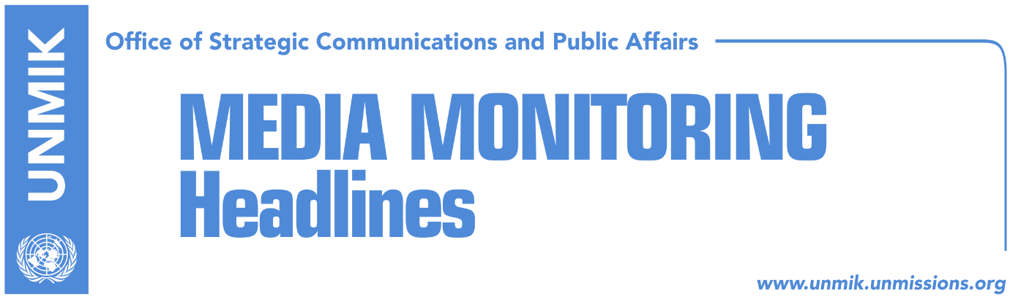

Main Stories 21 October 2016

- Pristina refuses to discuss Trepca in the Brussels dialogue framework (dailies)
- Simic: Return to Kosovo institutions at this time, meaningless (Zeri)
- EU Office head urges Serbian List to return to Kosovo institutions (Koha)
- Ruling coalition not working on government reshuffling (Koha)
- President Thaci comments on U.S. presidential elections (RTK)
- Djuric to boycott NATO seminar in Pristina (RTK/Gazeta Express)

Kosovo Media Highlights

Pristina refuses to discuss Trepca in the Brussels dialogue framework (dailies)
Kosovo’s Minister for Dialogue, Edita Tahiri, said that while the EU-facilitated dialogue has produced results, there are tensions at present mainly because Serbia has blocked the implementation of the telecom agreement and has arbitrarily arrested a senior Kosovo Police official. Furthermore, the Serbian delegation tried to raise the issue of the Trepca Law at the dialogue which the Kosovo side refused to do. Tahiri said Trepca is Kosovo’s asset and as such will not be discussed with anyone.

Simic: Return to Kosovo institutions at this time, meaningless (Zeri)
The Serbian List parliamentary group chief, Slavko Simic, told Radio Kosova on Thursday that Serbian List’s return to the Kosovo institutions is not a problem, but according to him, it is meaningless at this time. “First of all, there is no problem for the Serbian List to return to Kosovo institutions. The main problem is whether the return makes sense. Does it make sense when the laws and processes are made without consulting the Serbian List, Serb community and Serbian political representatives,” he said. “If someone still tries to go against the Serb community, then it makes no sense for us to return to the institutions,” Simic added.

EU Office head urges Serbian List to return to Kosovo institutions (Koha)
The head of the European Union Office in Kosovo, Nataliya Apostolova, during a meeting with the Serbian List parliamentary group chief, Slavko Simic, underlined the importance of Serbian List’s participation in the work of the Assembly so that important laws and regulations are passed with the active involvement of this party. She stressed the importance of the dialogue on the normalisation of relations between Pristina and Belgrade for both sides, including the necessity to implement all agreements reached within the dialogue. The two sides discussed also the EU’s multi-million euro financial assistance to the North of Kosovo as well as the Development Fund, and the need for a more proactive approach in implementing projects financed under these instruments.

Ruling coalition not working on government reshuffling (Koha)
The paper reports on its front page that Kosovo’s government is still one of the biggest governments in the region and Europe. The government reshuffling, announced earlier by Prime Minister Isa Mustafa and President Hashim Thaci, has yet to begin, and so has the performance of government ministers. Witnessing the lack of actions by the government in this respect, political analysts are arguing that government officials had intentionally opened the topic in order to shift the public’s attention away from accusations for the border demarcation agreement with Montenegro and the Association/Community of Serb-majority municipalities.

President Thaci comments on U.S. presidential elections (RTK)
In an interview for Jeta ne Kosove on Thursday evening, Kosovo President Hashim Thaci talked for the first time about his preferences in the U.S. presidential elections, saying he expects Hillary Clinton to win the election. Thaci also said he was happy to see that many Albanians in the U.S. are supporting Clinton’s candidacy. Thaci also mentioned a case when “a Prime Minister of an allied country of Kosovo called several Arab leaders to convince them to recognise Kosovo’s independence”. Thaci said Arab countries have difficulties recognising Kosovo because of their ties with Russia as well as their nostalgia over earlier relations with the former Yugoslavia.

Djuric to boycott NATO seminar in Pristina (RTK/Gazeta Express)
The head of the Serbian Government’s Office for Kosovo, Marko Djuric, is reported to have cancelled his participation at the upcoming NATO Rose-Roth seminar set to take place in Pristina after he was described as “Director of Office for Kosovo” instead of “Director of Office for Kosovo and Metohija”. Initially, organisers of the seminar, NATO Parliamentary Assembly, used the second denomination, but upon the insistence of the Kosovo Assembly it got changed to “Director of Office for Kosovo”.

Disclaimer
This media summary consists of selected local media articles for the information of UN personnel. The public distribution of this media summary is a courtesy service extended by UNMIK on the understanding that the choice of articles translated is exclusive, and the contents do not represent anything other than a selection of articles likely to be of interest to a United Nations readership. The inclusion of articles in this summary does not imply endorsement by UNMIK.

