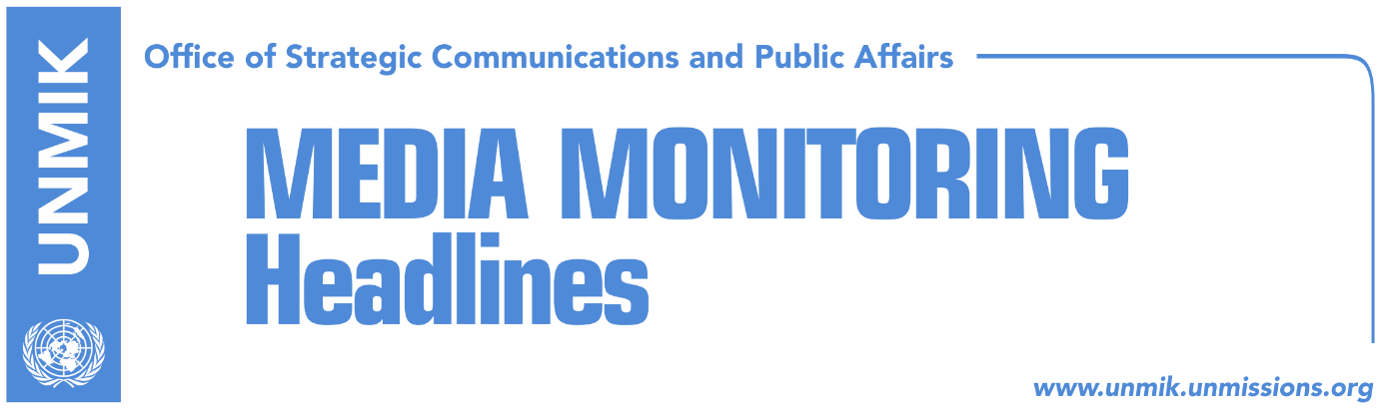

Main Stories 22 October 2016

- Tahiri hopeful telecom agreement will be unblocked (Koha)
- Veseli: Kosovo was never a hotbed of terrorism (Koha)
- Apostolova: It is unfortunate demarcation has been politicised (RTK/Koha)
- Alli: Kosovo’s future lies in its Euro-Atlantic integration (RTK)

Kosovo Media Highlights

Tahiri hopeful telecom agreement will be unblocked (Koha)
Kosovo’s Minister for Dialogue, Edita Tahiri, said upon return from Brussels that she was hopeful Serbia would unblock implementation of the telecom agreement whereby Kosovo is set to gain its dialing prefix. The Serbian side is reported to have presented two conditions in exchange for giving the green light for the International Telecommunication Union (ITU) to decide in favour of granting Kosovo a code: enable the Telecom of Serbia operator get full access to Kosovo territory and use Kosovo Telecom assets that Serbs are alleged to have been keeping unlawfully since the end of the conflict in 1999. The Kosovo side rejected both demands.

Veseli: Kosovo was never a hotbed of terrorism (Koha)
Kosovo Assembly President Kadri Veseli said at the NATO Parliamentary Assembly Rose-Ruth seminar taking place in Pristina that the people of Kosovo are pro-European and aspire to become part of the European Union. “Kosovo was never as is not a hotbed of terrorism”, said Veseli.

Apostolova: It is unfortunate demarcation has been politicised (RTK/Koha)
Head of the EU Office in Kosovo, Natalya Apostolova, said that the border demarcation was originally set as a technical requirement. “We introduced it as a technical issue and it can be easily resolved but was unfortunately politicized”, said Apostolova at the NATO’s Rose-Ruth seminar. She said the EU’s intention is not to keep Kosovo away from integration processes and has not invented more conditions to do so. “In the coming period, the EU would like to see progress in the fight and prevention of corruption”, said Apostolova.

Alli: Kosovo’s future lies in its Euro-Atlantic integration (RTK)
Vice President of NATO Parliamentary Assembly, Paolo Alli, said that the future of Kosovo lies in its Euro-Atlantic integration. In an address to the participants of the NATO Parliamentary Assembly Rose-Roth seminar that is taking place in Pristina, Alli said he hoped the seminar would help in strengthening of a better political climate in Kosovo. “Democratic principles have to prevail and the rule of law has to be respected”, said Alli. He also said it was regrettable that the Serbian delegation invited to the seminar cancelled its participation.

Disclaimer
This media summary consists of selected local media articles for the information of UN personnel. The public distribution of this media summary is a courtesy service extended by UNMIK on the understanding that the choice of articles translated is exclusive, and the contents do not represent anything other than a selection of articles likely to be of interest to a United Nations readership. The inclusion of articles in this summary does not imply endorsement by UNMIK.

