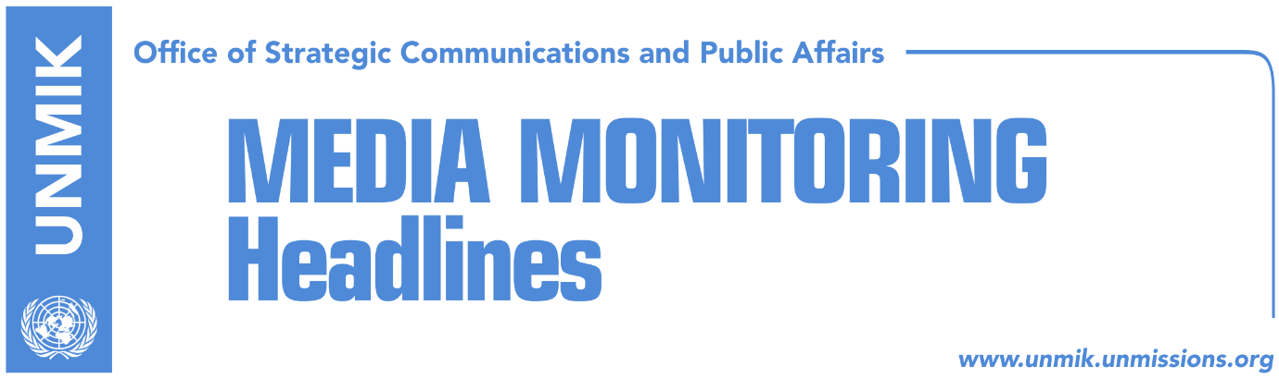

Main Stories 24 October 2016

- Thaci warns integration delays create space for dangerous ideologies (media)
- Delawie: KFOR will leave when Kosovo can protect itself (Zeri)
- Parallelism in Mustafa-led government (Koha Ditore)
- Tahiri: Serbia will recognize Kosovo (Zeri)
- Hoxhaj urges Spain to recognise Kosovo (RTK)
- Rugova: LDK ready for elections (Zeri)
Kosovo Media Highlights

Thaci warns integration delays create space for dangerous ideologies (media)
Kosovo President Hashim Thaci, during the 93rd Rose-Roth seminar of the NATO Parliamentary Assembly which is being held in Prishtina, said that Kosovo is not a source of instability, but is exporting peace and dialogue. However, according to him, delays of the EU and NATO to integrate the Western Balkans create space for dangerous ideologies. “It is very important for the region, and for the EU itself, not to delay the integration of the Western Balkans,” Thaci said. In regards to the Pristina- Belgrade dialogue, Thaci said Kosovo is ready to take this dialogue to the next level. “Thanks to commitment to dialogue and cooperation, the relations between Kosovo and Serbia today are not a threat to the stability in the region,” he said. “We are ready for a proper process of cooperation, of friendly and reconciliatory relations. We have never had a better opportunity, as a Kosovo, as a Serbia and as a region, than the coming months, to put our cooperation on safe tracks,” Thaci added. He also said that the establishment of Kosovo's Armed Forces is a major step to become part of NATO and the EU. President Thaci also spoke about the visa liberalisation process. He stressed that even though he did not agree to the EU’s condition for ratifying border demarcation before being granted visa-free travel to EU as there are even EU member states which have not yet finalized their borders, “I believe we have to fulfill it to enable the people of Kosovo to move freely.”

Delawie: KFOR will leave when Kosovo can protect itself (Zeri)
The United States Ambassador to Kosovo, Greg Delawie, during the 93rd Rose Roth seminar said that the transformation of Kosovo Security Force into an Armed Force must happen gradually. “NATO should not leave Kosovo if Kosovo is not ready to protect itself. There will be no vacuum, but there will be a transformation of the Kosovo Security Force into a Kosovo Armed Force. This transformation must happen according to constitutional order,” Delawie said. Meanwhile, Kosovo Security Force Minister Haki Demolli said that the Serbian List is preventing the transformation of the KSF into an Armed Force. “According to Ahtisaari’s package, we are ready to transform the KSF into an army. We have sent the Assembly and government two necessary laws. But, this has not happened because Serbian List MPs are not willing to vote,” Demolli said.

Parallelism in Mustafa-led government (Koha Ditore)
On the front page the paper reports that the government of Kosovo led by Prime Minister Isa Mustafa is being presented to European officials with diametrically opposing stances. Members of the government, namely ministers from the Serbian List, have launched a lobbying campaign in Brussels against the recently-adopted Trepca Law by the Kosovo Assembly but Kosovo’s Minister for Dialogue, Edita Tahiri, warned that the attempts to challenge Kosovo in Brussels will not be successful. Furthermore, Tahiri said that the visit of Kosovo Serb ministers to Brussels is unacceptable and unconstitutional. “I think they breached their job descriptions and the Constitution - this issue needs to be addressed by the Government”, Tahiri said. Meanwhile, Bajram Gecaj from PM Mustafa’s office said the actions of the Serbian List are damaging. “I believe Prime Minister Isa Mustafa will discuss this with Deputy Prime Minister Branimir Stojanovic in the coming days,” said Gecaj.

Tahiri: Serbia will recognize Kosovo (Zeri)
Kosovo’s Minister without portfolio, Edita Tahiri, said on Sunday that Serbia will recognize Kosovo as an independent state at the end of the Pristina-Belgrade dialogue. “We consider this dialogue as dialogue for good neighborly relations and its value is related to our Euro-Atlantic aspirations and our commitment to stability and peace. This means that at the end of dialogue there must be mutual recognition between the two countries,” Tahiri said. According to her, the Brussels dialogue is producing results.

Hoxhaj urges Spain to recognise Kosovo (RTK)
In an interview for the Spanish news agency EFE, Kosovo’s Foreign Minister, Enver Hoxhaj, said he expects opening of a new stage in relations between Kosovo and Spain. Hoxhaj said Kosovo is a sui generis case and should be treated according to its specific circumstances. “There is a long list of reasons and circumstances that we can explain to everyone in Spain as to why Kosovo is what it is and why it should be viewed differently,” said Hoxhaj.

Rugova: LDK ready for elections (Zeri)
The Democratic League of Kosovo (LDK) deputy leader, Haki Rugova, told the paper that the ruling coalition between the LDK and Democratic Party of Kosovo (PDK) is functioning very well. But according to him, if Kosovo must go to early elections, LDK is ready for this. “If we must go to early elections, it wouldn’t be a problem. But, we cannot break agreements just like that. We can discuss it, but I believe the ruling-coalition does not have any problems,” Rugova said. On the other hand, Vetevendosje Movement MP, Rexhep Selimi, told the paper that the opposition is ready for elections at any moment.

Disclaimer
This media summary consists of selected local media articles for the information of UN personnel. The public distribution of this media summary is a courtesy service extended by UNMIK on the understanding that the choice of articles translated is exclusive, and the contents do not represent anything other than a selection of articles likely to be of interest to a United Nations readership. The inclusion of articles in this summary does not imply endorsement by UNMIK.

