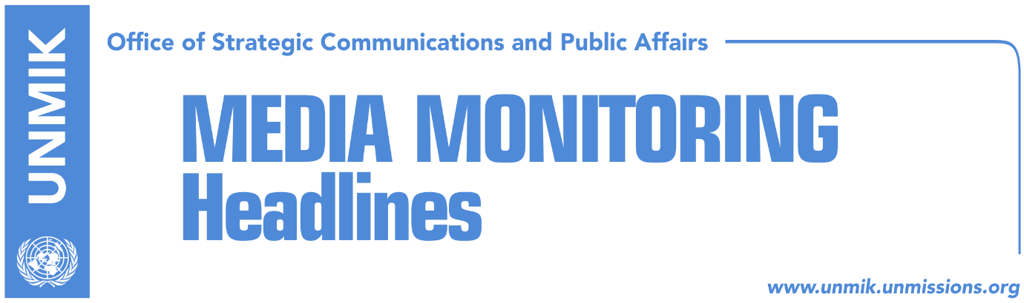

Main Stories 29 October 2016

- Limaj indicted on war crimes charges (media)
- Limaj: KLA General Staff claimed responsibility for the murders (Koha/RTK)
- EU and EULEX call for respect for judicial decisions (dailies)
- O’Connell: Pressure on judiciary, form of corruption (media)
- Nehat Thaci’s detention extended for one month (Indeksonline)

Kosovo Media Highlights

Limaj indicted on war crimes charges (media)
Kosovo Special Prosecution Office filed a war crimes indictment on Friday against the leader of the Initiative for Kosovo (NISMA), Fatmir Limaj. The indictment says Limaj was responsible for the killing of two civilians in November 1998. “The indictment charges the accused Fatmir Limaj that, as a member of the KLA and a commander of Brigade 121, did not take reasonable and necessary measures within his authority to prevent or halt the killing of Ramiz Hoxha and Selman Binishi,” reads a press release issued by the prosecution. Media recall that Limaj has been tried and found not guilty of war crimes several times in the past.

Limaj: KLA General Staff claimed responsibility for the murders (Koha/RTK)
The leader of the Initiative for Kosovo (NISMA), Fatmir Limaj, after being indicted for war crimes on Friday, said that the former Kosovo Liberation Army (KLA) General Staff had claimed responsibility for the murders and that he was not part of it at that time. He also said he has been investigated at least three times for this, twice by UNMIK and once by the ICTY. During an interview for the public broadcaster RTK, Limaj said the justice system is filled with prosecutors and judges who work to ruin certain people. He said that from now on, he is going to work to expose individuals and groups that are using institutions to destroy certain people.

EU and EULEX call for respect for judicial decisions (dailies)
The European Union Office in Kosovo and EULEX issued a joint statement on Friday saying that in a democracy, the Parliament is a place for political debate on issues of interest to the people. “In a democracy, the Parliament is a place for political debate on the main issues of interest to the people. This debate however should always be in full respect of the separation of judicial, executive and legislative powers, as the foundation of a democracy. Elected officials and public authorities, including members of parliament, should therefore refrain from calling into question court rulings as adherence to rule of law principles requires an unconditional respect for judicial decisions and the separation of powers,” notes the statement. The statement comes as a reaction to the Kosovo Assembly’s Resolution adopted yesterday, which pledges to endorse the Law on protection of the values of the Kosovo Liberation Army and its liberating war, within six months.

O’Connell: Pressure on judiciary, form of corruption (media)
The British Ambassador to Kosovo, Ruairi O’Connell, took to Facebook on Friday to say that political pressure on the judiciary, including attempts to avoid justice for those accused of crimes, is a form of corruption. “We recognise the history of Kosovo that led to the NATO intervention in 1999. Trying individuals for crimes allegedly committed during that period does not change that history or tarnish the image of an entire organization. How it responds to such allegations is a measure of the strength of a country’s democracy and institutions,” O’Connell said.
Nehat Thaci’s detention extended for one month (Indeksonline)
The Special Court in Belgrade has extended for another 30 days detention of the Kosovo Police regional director, Nehat Thaci. Thaci was arrested in September while entering Serbia, suspected of having committed war crimes. Kosovo’s Foreign Minister, Enver Hoxhaj, said that the court’s decision to extend Thaci’s detention was “unacceptable and harms the process of normalizing relations with Serbia.”

Disclaimer
This media summary consists of selected local media articles for the information of UN personnel. The public distribution of this media summary is a courtesy service extended by UNMIK on the understanding that the choice of articles translated is exclusive, and the contents do not represent anything other than a selection of articles likely to be of interest to a United Nations readership. The inclusion of articles in this summary does not imply endorsement by UNMIK.

