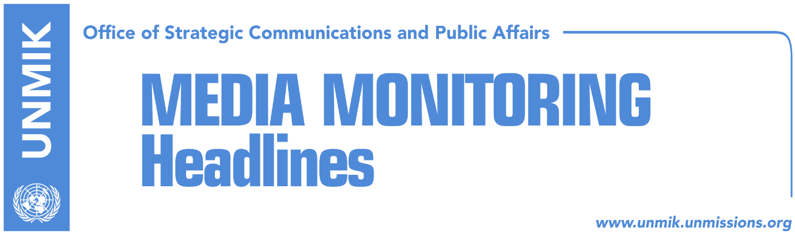

Main Stories 3 November 2016

- President Thaci doesn’t expect early elections (Kosova Sot)
- Special Court to raise first indictments by June 2017 (Koha)
- Great Britain continues to support Kosovo (Epoka e Re)
- AAK-NISMA coalition open to Pacolli (Lajmi)
- Thaçi requests respect for Albanians’ rights in Presevo Valley (Epoka e Re)
- Tahiri, Djuric to talk about Kosovo-Serbia dialogue (media)

Kosovo Media Highlights

President Thaci doesn’t expect early elections (Kosova Sot)
President of Kosovo, Hashim Thaci, said that Kosovo could head to early elections only if the government loses majority in the Assembly or there is a political agreement paving way for them. “At present, from what I see and understand, the majority has power both in the sense of numbers and politics,” Thaci said yesterday.

Special Court to raise first indictments by June 2017 (Koha)
The paper reports on its front page that the Parliament of the Kingdom of the Netherlands has voted in favour of ratifying the agreement on the special court that will address KLA war crimes allegations mentioned in Dick Marty’s report. Officials at the Dutch Embassy told the paper that the agreement will enter into force one month after this state notifies Kosovo about the decision-making process in parliament. Avis Benes, spokesperson for the special court, said on Wednesday that there will be no indictments until the agreements enters into force. Asked when the first indictments could be raised, Benes mentioned the first half of next year.

Great Britain continues to support Kosovo (Epoka e Re)
The Prime Minister of Kosovo, Isa Mustafa, met during his visit in the United Kingdom State Secretary for Foreign Affairs, Boris Johnson and Minister of the State for Europe and the United States at the Foreign Office, Alan Duncanin. Secretary Johnson expressed interest on the developments in Kosovo and stressed the will of the United Kingdom for further cooperation with Kosovo. Kosovo’s Minister for Finance Avdullah Hoti and Minister of Agriculture, Forestry and Rural Development, Memli Krasniqi, were also present at these meetings. PM Mustafa visited on Wednesday also the European Bank for Reconstruction and Development (EBRD) where he met the President of the Bank, Suma Chakrabarti.

AAK-NISMA coalition open to Pacolli (Lajmi)
The opposition coalition between the Alliance for the Future of Kosovo (AAK) and the Initiative for Kosovo (NISMA) has not ruled out the inclusion of the New Kosovo Alliance led by Behxhet Pacolli in the coalition. NISMA leader Fatmir Limaj told Tribuna Channel on Wednesday that their coalition has no red lines and left open the possibility of “cooperating with Pacolli and with anyone else that works in favour of Kosovo’s statehood”.

Thaçi requests respect for Albanians’ rights in Presevo Valley (Epoka e Re)
The President of Kosovo, Hashim Thaçi, said during a meeting with a delegation from Presevo Valley on Wednesday, that consolidation of Kosovo’s international position would increase possibilities for a better promotion of rights in the Presevo Valley. “Respect for minority rights is one of the main criteria for EU membership and no candidate state, including Serbia, can advance in processes without fulfilling the highest standards of respecting minorities,” Thaçi said.

Tahiri, Djuric to talk about Kosovo-Serbia dialogue (media)
Several news websites report that Kosovo’s Minister for Dialogue, Edita Tahiri, and Serbian Government’s Office for Kosovo Director, Marko Djuric, will talk about the Kosovo-Serbia dialogue during a peace forum in Beirut, Lebanon, today.

Disclaimer
This media summary consists of selected local media articles for the information of UN personnel. The public distribution of this media summary is a courtesy service extended by UNMIK on the understanding that the choice of articles translated is exclusive, and the contents do not represent anything other than a selection of articles likely to be of interest to a United Nations readership. The inclusion of articles in this summary does not imply endorsement by UNMIK.

