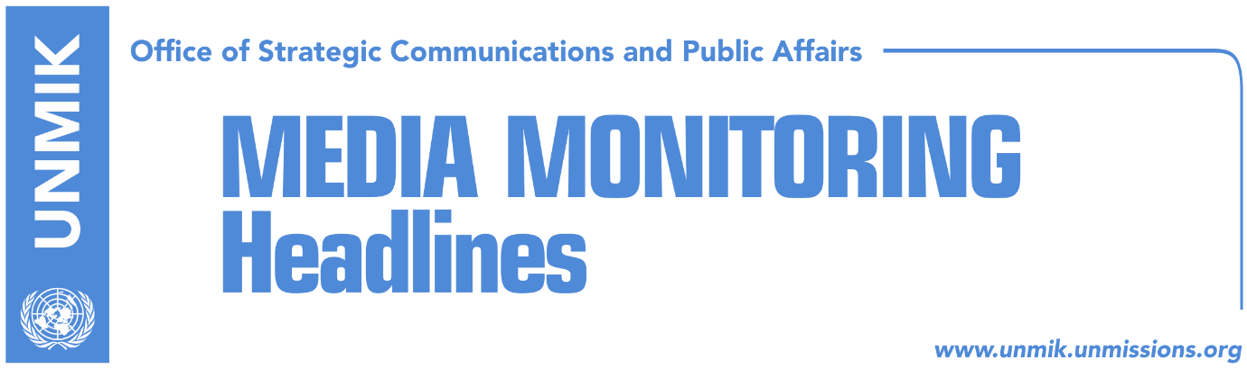

Main Stories 17 November 2016

- UN Security Council discusses quarterly report on Kosovo (media)
- Mustafa blames opposition for visa liberalisation (Kosova Sot)
- EU’s Apostolova meets heads of parliamentary groups (Kosova Sot)
- Government wants to reduce number of war veterans (Koha)
- Serwer: Kosovo is not getting used to democracy (Zeri)
- German Minister of Agriculture to visit Kosovo today (media)

Kosovo Media Highlights

UN Security Council discusses quarterly report on Kosovo (media)
All local media cover yesterday’s session of the United Nations Security Council that discussed the Secretary General’s quarterly report on Kosovo. RTK reports that in his address to the Council, the Special Representative of the Secretary-General and head of UNMIK, Zahir Tanin, said that many of the political expectations with which Kosovo began the year yielded fewer results than hoped, the agreement on the demarcation with Montenegro has not been ratified yet and he also noted that visa liberalisation has not yet been reached. “I would like to highlight President Thaçi’s recent engagement jointly with the family associations of both Albanian and Serb missing persons, and his emphasis on treating this issue on humanitarian, not political, grounds,” Tanin said. While in regards to the approval of Trepca Law, Tanin said the accelerated passage through parliamentary procedure of a new law on the Trepca industrial complex emerged as another obstacle to constructive dialogue. The report on Kosovo also mentions the unemployment situation, Kosovo’s European future, political developments and rule of law. “The death in custody of Vetevendosje activist, Astrit Dehari, has raised concerns, and has provoked indignation in many quarters. In light of the many questions that have been raised, an objective, thorough and transparent investigation into this incident is essential,” Tanin said. Tanin also mentioned the arrest of the suspects aimed to undertake terrorist attacks in Kosovo and the region. RTK reports that during her address to the Security Council, Kosovo’s Ambassador to the United States of America, Vlora Citaku, said there is religious tolerance in Kosovo. “Serbian forces destroyed 218 mosques in Kosovo. Religious tolerance is the pillar of our society. We have cases where the church and mosque share the same yard. It is only one Orthodox Church in Kosovo that we have problem with. And this one was built at the property of the University of Pristina by Milosevic’s regime. This church started to build in 1991 when our autonomy was abrogated and when the University of Pristina shut its doors for Albanian students and professors, including me. The Orthodox Church was built illegally, through violence, during the campaign of repression and we will keep it as such. Its destruction is not a solution. This building will stay there to remind us of the difficult times,” Çitaku said. “Kosovo is a secular republic, multi-religious, multicultural and we will do the utmost to keep it so. We have our constitutional right to safeguard cultural and religious heritage, it is even our moral obligation,” she said. In another article in RTK, Citaku is quoted as saying that Kosovo is no longer administered by the United Nations any more. “Since 17 February 2008, Kosovo is free, sovereign state, recognized by the majority of countries of the world. These are irreversible facts, the historical clock cannot be turned back, but we still come here every three months and listen to the Serbian colleagues from a parallel universe, that Kosovo state does not exist,” said Çitaku, adding that in the real world, Kosovo is free and sovereign. She stressed the verdict of the International Court of Justice, issued by Serbia’s request. “No country can use its territory to destroy the population, because these crimes return in disfavor of that country, because the state is constructed for the population not territory,” said Çitaku quoting the ICJ verdict. She stressed that Kosovo has undertaken tremendous measures on the alleged crimes, by establishing a special court in cooperation with the international community, while Serbian party has not undertaken any measures. “We in Kosovo do not hide from justice, because we have nothing to hide. Twenty thousand women were sexually abused during the last war in Kosovo, and number of the accused is zero. 1262 children were brutally killed; the number of the accused and sentenced is zero. There are thousands of missing and there are clear traces of the chain of command and the Serbian government has constructed buildings on top of those graves in order to lose track, and the number of the accused and sentenced is zero,” Çitaku said. She also spoke about the recent arrests of two Kosovo citizens, one of them a police commander. She said that the arrest happened based on the order of the Serbian authorities, and stressed that this is in contradiction with the agreement on freedom of movement reached in Brussels. She stressed that the issued Serbian list for arrests carries also the names of the world leaders of the western states, such as Bill Clinton, Madeleine Albright, Javier Solana, Tony Blair, Jacques Chirac and many others. Speaking about Trepca Law, she said that Trepca mines are in Kosovo, they belong to Kosovo and will be managed by Kosovo. She added that the Law is in full compliance with the Constitution of Kosovo. Before attending the UNSC session, Citaku wrote on her Facebook account: “there is no need to say that these meetings have lost their meaning after 17 February 2008. I am very much convinced that the United Nations could use their time and resources much better”. Pristina-based news website reports that in his address to the UNSC, Serbian Foreign Minister Ivica Dacic claimed that authorities in Pristina have unlawfully passed a law on the Trepca mining complex and called on the Security Council to annul it. “The law has been passed by institutions of self-government, without UNMIK, without Serb municipalities and without the inclusion of Serbs in Kosovo institutions,” Dacic said warning that this could lead to unrests in Kosovo and to the halting of its economic development. He also called for the establishment of the Association/Community of Serb-majority Municipalities which, he said, is being “intentionally delayed” by Pristina. Dacic also spoke about incidents targeting members of the Serbian community in Kosovo and noted that the protests against the Serb Orthodox Church in Pristina show that Kosovo’s membership in UNESCO cannot be endorsed. Koha Ditore quotes the French Ambassador to the UN, Francois Delattre, as saying that positive developments in Kosovo imply the restructuring of UNMIK. He also said that Kosovo’s future is not being decided at the Security Council but rather in the EU-brokered political dialogue between Pristina and Belgrade. “This is why we call on Serbian and Kosovo authorities to be more productive in dialogue so that both sides can achieve progress toward European integration. Kosovo also needs to continue the fight against organised crime and corruption,” Delattre said.

Mustafa blames opposition for visa liberalisation (Kosova Sot)
Prime Minister of Kosovo, Isa Mustafa, blamed opposition parties for visa liberalisation. He said that the opposition as well as a number of MPs from his own Democratic League of Kosovo (LDK) opposed agreement on border demarcation with Montenegro and this led to Kosovo not being granted visa-free travel to Europe. Mustafa also said the opposition parties have now aligned with the Serbian List in opposing, as he said, a very important element of Kosovo’s sovereignty.

EU’s Apostolova meets heads of parliamentary groups (Kosova Sot)
The Head of the EU Office in Kosovo and Special Representative, Nataliya Apostolova, met yesterday head of parliamentary groups. In a statement issued by the EU Office, Apostolova spoke about the current political and economic situation, rule of law, visa liberalisation and implementation of the Stabilisation and Association Agreement and the European Reform Agenda. “Apostolova appreciated leaders’ honest views how to bridge the current political stalemate in Kosovo and found it important and useful to listen to Assembly representatives,” the statement reads.

Government wants to reduce number of war veterans (Koha)
The paper reports on its front page that the Kosovo government has initiated substantial amendments to the law on the former members of the Kosovo Liberation Army. The status of the war veterans and their pension schemes will be redefined following the legal amendments. The paper claims to possess a copy of a draft document prepared by the government according to which the number of 46,000 war veterans and the budget cost for their pensions are both inflated.

Serwer: Kosovo is not getting used to democracy (Zeri)
Daniel Serwer, US expert on the Balkans, during an interview for the paper said currently Kosovo is not on the American agenda. He said that Russia remains the biggest threat for the US and this is also a problem for the Balkans and other countries. While counting the problems that Kosovo is currently facing, Serwer said that Kosovo is still not getting used to live in democracy. Serwer said that the border demarcation agreement with Montenegro is not an issue but it is being used to make people emotional. While in regards to the Association/Community of Serb-majority municipalities, Serwer said that this was the worst request of the Ahtisaari Plan, but that it must be implemented because Kosovo has many benefits from that plan.

German Minister of Agriculture to visit Kosovo today (media)
Several news websites report that the German Minister of Food and Agriculture, Christian Schmidt, will visit Kosovo today and meet Kosovo’s Minister for Agriculture, Forestry and Rural Development, Memli Krasniqi. Following their meeting, the two ministers will address a media conference.

Disclaimer
This media summary consists of selected local media articles for the information of UN personnel. The public distribution of this media summary is a courtesy service extended by UNMIK on the understanding that the choice of articles translated is exclusive, and the contents do not represent anything other than a selection of articles likely to be of interest to a United Nations readership. The inclusion of articles in this summary does not imply endorsement by UNMIK.

