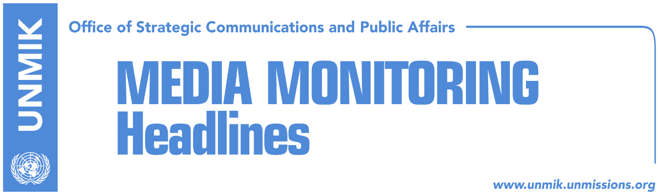

Main Stories 28 November 2016

- Pristina-Belgrade dialogue to resume this week (Koha)
- Northern municipalities approve Kosovo budget for 2017 (Koha)
- Union of Albanian municipalities takes shape in Tirana (Telegrafi)
- “Prime Minister, find bosses of casinos, racketeering and bribing” (Lajmi)
- Nikolic: Serbia wants to join EU but it cannot recognize Kosovo (Telegrafi)

Kosovo Media Highlights

Pristina-Belgrade dialogue to resume this week (Koha)
According to the Serbian delegation engaged in the EU-facilitated dialogue, Pristina and Belgrade will discuss next week the implementation of the reached agreements, the Association/Community of Serb-majority Municipalities, judiciary, telecommunication and freedom of movement. Government officials in Pristina however denied that the Association would be discussed during this round of talks. “This matter is not expected to be discussed prior to Kosovo’s obtaining of the telephone prefix by the ITU,” said Kosovo’s Minister for Dialogue, Edita Tahiri. She also added that next week the parties will only discuss implementation of the reached agreements.

Northern municipalities approve Kosovo budget for 2017 (Koha)
Four Kosovo northern municipalities for the first time approved next year’s budget based on Kosovo’s budgetary framework. The overall budget for the northern municipalities is just over €14 million. Prime Minister of Kosovo, Isa Mustafa, said the decision of the municipalities in the north is an important step towards integration.

Union of Albanian municipalities takes shape in Tirana (Telegrafi)
Mayor of Pristina, Shpend Ahmeti, announced on his Facebook page that Tirana, Pristina, Tetovo, Ulqin/Ulcinj and Presheva/Presevo have begun exchanging experiences in a number of fields including urbanism, innovation, environment, culture, and investment. “The meeting of Albanian municipalities union is underway,” Ahmeti wrote.

“Prime Minister, find bosses of casinos, racketeering and bribing” (Lajmi)
After an announcement of the Prime Minister of Kosovo Isa Mustafa regarding the reduction of the unemployment rate, the Alliance for the Future of Kosovo came out with a press release which requests from the Prime Minister to find bosses of the casinos who are involved in racketeering and to stop spreading vague claims. “Prime Minister, why are you dealing with vague claims and not with those 70 files that you have for prosecution, about you, your friends and your sons? Do something worthy with your life! Start from your own yard!” the press release noted. Prime Minister Mustafa replied later saying that the development is the result of Kosovo’s final free breathing from bosses of the casinos and racketeering.

Nikolic: Serbia wants to join EU but it cannot recognize Kosovo (Telegrafi)
Serbia’s President, Tomislav Nikolic, said on Sunday that Serbia wants to join the European Union, but “there are two conditions that cannot be met: the recognition of Kosovo and not to be in good relations with countries with which the EU is in conflict.” He also said that NATO had attacked Serbia unjustly and confirmed that the Serbian people do not want membership in the North Atlantic Alliance. “We have been attacked and bombed by NATO in 1999, without any reasons. This has had a huge effect on our economy, but also in the attitude of our citizens towards NATO. I sure speak on behalf of the majority of people when I say that Serbia will never be in NATO,” Nikolic said in an interview with Al Jazeera. While in regards to Pristina-Belgrade dialogue, Nikolic said that Serbia wants peace and security for Serbs in Kosovo. “Brussels and Pristina use the dialogue to promote and strengthen the independence of Kosovo,” he said.

Disclaimer
This media summary consists of selected local media articles for the information of UN personnel. The public distribution of this media summary is a courtesy service extended by UNMIK on the understanding that the choice of articles translated is exclusive, and the contents do not represent anything other than a selection of articles likely to be of interest to a United Nations readership. The inclusion of articles in this summary does not imply endorsement by UNMIK.

