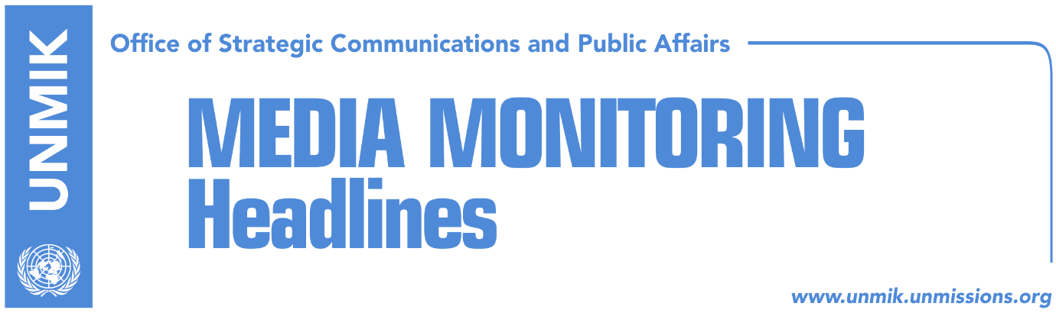

Main Stories 12 December 2016

- Kosovo PM Mustafa meets Montenegrin counterpart Markovic (dailies)
- Rakic: Wall will not be demolished, only shortened (Zeri)
- Parliamentary foreign affairs committee to discuss Mitrovica wall (RTK)
- Opposition calls for interruption of dialogue (Epoka e Re)
- Ahmeti: The wall is a symbol of division not reunification (Kosovapress)
- EU: Kosovo and Serbia implement agreement on justice (Epoka e Re)
- Telephone code for Kosovo* (Koha Ditore)
- FYROM elections: Close battle between Gruevski and Zaev (Telegrafi)

Kosovo Media Highlights

Kosovo PM Mustafa meets Montenegrin counterpart Markovic (media)
Most media report that Kosovo’s Prime Minister, Isa Mustafa, met Montenegro’s Prime Minister, Dusko Markovic in Albania on Sunday. Mustafa and Markovic discussed cooperation between Kosovo and Montenegro and agreed to increase their cooperation especially on economic developments. According to a press release issued by Mustafa’s office, the two prime ministers also discussed other current developments in the region. Several media have highlighted that the government did not mention if demarcation was part of the meeting. However, Klan Kosova reports that reliable sources close to Prime Minister Mustafa said the topic of discussion was the issue of border demarcation between Kosovo and Montenegro.

Rakic: Wall will not be demolished, only shortened (Zeri)
The Mayor of Mitrovica North, Goran Rakic, said on Sunday that the wall that is being built in the northern side of Ibar River will not be demolished, “but only shortened for around 70 centimeters”. According to him, this was the result of the agreement for redesigning the wall, reached between both parties at the EU Office in Pristina. On the other hand, the Mayor of Mitrovica South, Agim Bahtiri, continues to ensure the citizens that the wall will be demolished. “The wall will be demolished entirely because it is not in accordance with the project. I guarantee you that the wall will be demolished and the bridge will be opened on 20 January,” Bahtiri said.

Parliamentary foreign affairs committee to discuss Mitrovica wall (RTK)
The news website reports that the Kosovo Assembly’s foreign affairs committee will discuss today the recently-built wall near the main bridge over the Ibar River. RTK notes that Kosovo’s Ministry for Environment and Spatial Planning has said that activities related to the construction of the wall are illegal, as everything is being done without a permit. Kosovo’s Minister for Dialogue, Edita Tahiri, also said that Mitrovica North officials are violating the law by building the wall.

Opposition calls for interruption of dialogue (Epoka e Re)
The paper reports that Vetëvendosje MP Ismajl Kurteshi, AAK MP Time Kadrijaj and head of the National Council of the Initiative for Kosovo (NISMA) Jakup Krasniqi, have called on the Kosovo Government to urgently interrupt talks with Serbia. All three MPs told the paper that the construction of the wall in Mitrovica North is the last alarm for Kosovo to reconsider its participation in the EU-brokered dialogue in Brussels. They even argued that the process of talks is “unprepared, not transparent, corrupt and compromised”.

Ahmeti: The wall is a symbol of division not reunification (Kosovapress)
Mayor of Pristina municipality, from Vetëvendosje movement, Shpend Ahmeti, said on Sunday that the wall in Mitrovica North is a symbol of division not of reunification. “Stairs or not, the wall remains a wall! They can even paint it beautifully, but it remains a wall,” Ahmeti wrote on his Facebook page.

EU: Kosovo and Serbia implement agreement on justice (Epoka e Re)
The European Union commended both Pristina and Belgrade for taking the final steps for the full implementation of the Justice Agreement, notes a press release issued by the European Union. “The notification by Serbia on 9 December of the termination of employment of Judges, Prosecutors and administrative staff with effect on 10 January 2017 allows for their integration on that day into the Kosovo Judiciary. The appointment on 10 January of Judges, Prosecutors and administrative staff will enable an improved delivery of justice across Kosovo. The European Union commends the parties for this important achievement,” reads the press release.

Telephone code for Kosovo* (Koha Ditore)
The paper reports on its front page that there is no definite answer yet on whether the telephone code for Kosovo will be a state code or a ‘geographic code’ as Serbia has requested for ‘its province of Kosovo and Metohija’. The European Union meanwhile insists that regardless of what Serbia wrote in its letter to the International Telecommunications Union, ‘Serbia only gives its consent’ whereas the request for Kosovo’s code was made by Austria. According to EU officials, the ITU will very soon publish in its official bulletin the decision to give Kosovo the ++383 telephone code.

FYROM elections: Close battle between Gruevski and Zaev (Telegrafi)
The Pristina-based news website reports that the State Election Committee in the Former Yugoslav Republic of Macedonia (FYROM) has yet to announce the results of Sunday’s parliamentary elections, but from the procession of 98 percent of data published in the official website of the committee, the governing coalition VMRO-DPMNE has won over 437,000 votes (or over 37 percent), followed by the opposition’s Social-Democratic League with over 420,000 votes (or over 36 percent), the BDI has won over 84,000 votes (over 7 percent), the BESA movement with over 56,000 votes, the Alliance for Albanians with over 34,000 votes and the PDSH with 30,000 votes. Several foreign news agencies meanwhile are reporting that both sides, the VMRO-DPMNE and the SDMS, are claiming victory in the early elections.

Disclaimer
This media summary consists of selected local media articles for the information of UN personnel. The public distribution of this media summary is a courtesy service extended by UNMIK on the understanding that the choice of articles translated is exclusive, and the contents do not represent anything other than a selection of articles likely to be of interest to a United Nations readership. The inclusion of articles in this summary does not imply endorsement by UNMIK.

