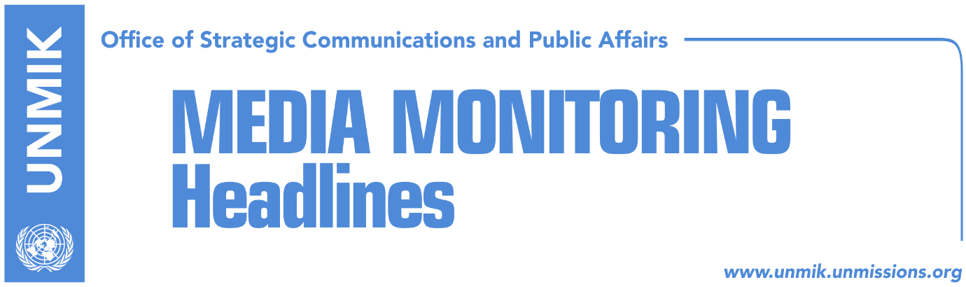

Main Stories 30 December 2016

- Mustafa: Narrow political interests cost us visa liberalisation (Bota Sot)
- Thaci: 2016 was a year of historic achievements (Epoka)
- Veseli: Assembly has managed to safeguard functioning democracy (Epoka)
- Haradinaj: Elections could be held early next year (Epoka)
- Demolli: Everything ready for KSF transformation (Kosova Sot)
- Lladrovci sworn in as Drenas/Glogovac mayor (Kosova Sot)

Kosovo Media Highlights

Mustafa: Narrow political interests cost us visa liberalisation (Bota Sot)
In an interview for the festive edition of the paper, Prime Minister of Kosovo Isa Mustafa, said he believed all political forces in Kosovo should take the time to reflect on the facts and positions of the international community regarding border demarcation process with Montenegro followed by the measuring of the Kosovo territory and paving way for free movement of the citizens. “For 17 years Kosovo build an excellent spirit of unity on crucial issues relating to the interests of the people which today are not being respected for narrow political interests,” said Mustafa.

Thaci: 2016 was a year of historic achievements (Epoka)
Kosovo President, Hashim Thaci, said in an interview for the paper that in 2016, Kosovo achieved progress in almost all areas. “The entering into force of the Stabilisation/Association Agreement, membership in international conventions, membership in UEFA and FIFA, Majlinda [Kelmendi] winning the gold medal in the Olympics … have made us all proud,” Thaci said. “No one can deny that we had expected even more, especially with visa liberalisation. This in fact was the biggest disappointment of the year. And the disappointment gets even bigger knowing that this was a result of internal politics more than anything else”. Thaci said the ruling coalition and the opposition must find common ground to resolve problems that are of interest to the country. He said he was optimistic that early next year political parties will successfully conclude the border demarcation with Montenegro and the Association/Community of Serb-majority municipalities. Thaci also promised that as President, he will continue to safeguard the independence, sovereignty and integrity of Kosovo.

Veseli: Assembly has managed to safeguard functioning democracy (Epoka)
Kosovo Assembly President and leader of the Democratic Party of Kosovo (PDK), Kadri Veseli, said in an interview for the paper that 2016 was a challenging year for the people and institutions of Kosovo. He said that despite challenges, the Assembly managed to implement its legislative agenda. Commenting on the relations between the ruling coalition and the opposition in the Assembly, Veseli said that there were some scenes that should never be part of Kosovo’s political culture. “Teargas has brought no benefits to anyone that loves Kosovo. Those scenes have embarrassed us in the eyes of the world and our people felt bad and disappointed. We live in a democracy and we must understand that non-democratic methods can never produce positive results,” he added. Commenting on the work of the ruling coalition, Veseli said his party was doing its share of the job with the highest responsibility. He also said that the PDK is ready whenever new elections will be held. “Elections are a fundamental process for democracy and as such they must be held either according to the legal timeframe or in specific cases as required by the immediate interest of the people. Elections are not a matter of personal egos for power. This is a principle that I respect in my political and institutional engagement. The Democratic Party of Kosovo is prepared in all levels to carry out its role as the biggest political party in the country and with the highest responsibility toward the state and the people”.

Haradinaj: Elections could be held early next year (Epoka)
Ramush Haradinaj, leader of the Alliance for the Future of Kosovo (AAK), told the paper in an interview that the first weeks of 2017 could change the dynamics of events in Kosovo and lead the country to early parliamentary elections. Haradinaj said his party was working hard on the field and preparing for the early elections. He also said that according to a survey, the AAK enjoys 15 percent of the electorate’s support. “We will this support will keep growing,” he said. Haradinaj also argued that if the New Kosovo Alliance (AKR) joins the AAK-NISMA coalition, the three parties stand a good chance of winning the early elections.

Demolli: Everything ready for KSF transformation (Kosova Sot)
Kosovo Security Force Minister, Haki Demolli, said in an end-year press conference that the main objective of the ministry he leads is transformation of the KSF into a Kosovo Armed Force. Demolli said they have made all necessary preparations to this end and that the decision is now with the Assembly of Kosovo.

Lladrovci sworn in as Drenas/Glogovac mayor (Kosova Sot)
Ramiz Lladrovci from the Democratic Party of Kosovo (PDK) got sworn in yesterday as the new mayor of Drenas/Glogovac. He said on the occasion that the guiding principles of his work will include transparency and accountability.

Disclaimer
This media summary consists of selected local media articles for the information of UN personnel. The public distribution of this media summary is a courtesy service extended by UNMIK on the understanding that the choice of articles translated is exclusive, and the contents do not represent anything other than a selection of articles likely to be of interest to a United Nations readership. The inclusion of articles in this summary does not imply endorsement by UNMIK.

