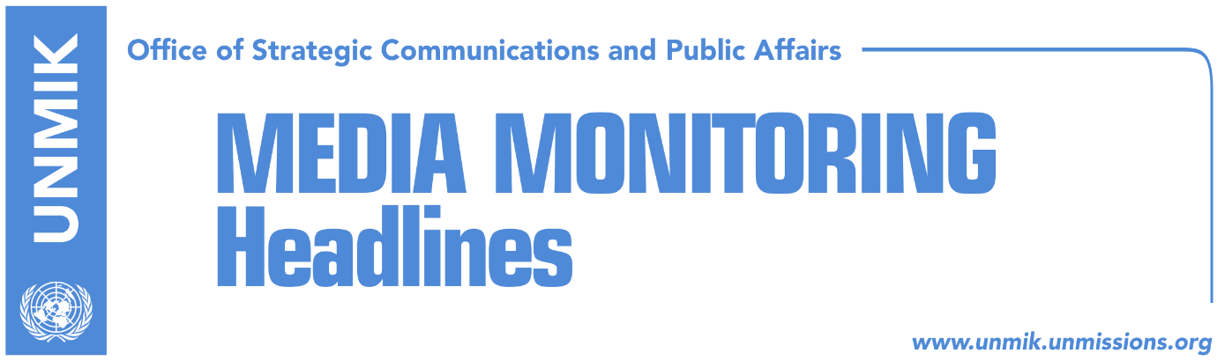

Main Stories 4 January 2017

- Tahiri: In 2017, dialogue will enter final phase (Epoka)
- “Mitrovica North wall issue to be resolved through dialogue” (Zeri)
- Serbian List demands establishment of Association/Community (Kosova Sot)
- Ymeri: Right path this year will start with government’s resignation (Epoka)
- Thaci congratulates new UN chief Guterres (Lajmi)
- 2017, the year of the Special Court (Koha)

Kosovo Media Highlights

Tahiri: In 2017, dialogue will enter final phase (Epoka)
Kosovo’s Minister for Dialogue, Edita Tahiri, told Radio Free Europe that the EU-facilitated dialogue between Pristina and Belgrade will enter its final phase this year. Tahiri said dialogue has enabled Kosovo to set up an international border with Serbia, to dissolve Serb parallel structures in northern Kosovo and it has helped the integration of Serbs in Kosovo’s state institutions. “Kosovo has also won its international telephone code which the International Telecommunications Union allocated following Austria’s application. We believe this is a major achievement because this is the first time that our state has its own telephone code,” she added. Tahiri also said that this year, the dialogue will focus on the implementation of agreements and that it will enter its final phase. “Other topics of discussion will be the mutual recognitions and the border demarcation between the two countries, the compensation of war damages, the issue of missing persons and pensions,” Tahiri said.

“Mitrovica North wall issue to be resolved through dialogue” (Zeri)
Serbian List leader Slavko Simic told the paper that the Kosovo Assembly’s resolution calling for demolition of the wall in Mitrovica North will only deepen tensions between the Albanian and Serb community. Simic said it is damaging for legislative institutions such as the Assembly to deal with issues he said are of local character. According to him, the wall issue can be resolved when the two parties sit together and discuss a solution. At the same time, Bajram Gecaj, advisor to PM Isa Mustafa, said the government of Kosovo has always been open to listen to concerns of the Serbian side. “The door is open whenever they decide to return to the institutions for which they ran in elections,” Gecaj said. Vetevendosje MP, Albulena Haxhiu, considers however that the government of Kosovo should have acted before the Assembly passed the resolution. “If we had a normal government, the wall in the north would not be allowed to be constructed in the first place,” Haxhiu said.

Serbian List demands establishment of Association/Community (Kosova Sot)
Serbian List leader Slavko Simic said that it is final time for Pristina authorities to establish the Association/Community of Serb-majority municipalities and that the EU should tell Kosovo leaders that there are no justifications for the delays in the process. “Institutions and political leaders in Kosovo should bear responsibility for prolongations and political obstructions they are continuously imposing through opposition parties to marginalize the Brussels dialogue,” Simic told Belgrade news agency Beta.

Ymeri: Right path this year will start with government’s resignation (Epoka)
In a front-page interview for the paper, Vetevendosje leader Visar Ymeri said that together with the citizens, civil society and the media, the Vetevendosje Movement will do everything to take Kosovo to early parliamentary elections this year. Ymeri argued that “the government should resign due to numerous failures and because it has violated the Constitution”. Ymeri said some of the main the reasons why the government should resign are its attempt to set up the Association/Community of Serb-majority municipalities, the border demarcation with Montenegro and its inability and lack of readiness to transform the Kosovo Security Force into the Kosovo Armed Forces.

Thaci congratulates new UN chief Guterres (Lajmi)
President of Kosovo, Hashim Thaci, has sent a cable to the new UN Secretary-General Antonio Guterres on assuming the top UN post. Thaci said Kosovo continioues to contribute to peace in the region and is committed to increase cooperation with neighbouring countries. Furthermore, Thaci said Kosovo institutions pledge to cooperate with the new UN chief and “remain committed in the country’s path towards United Nations membership.”

2017, the year of the Special Court (Koha)
In its leading front-page story, the paper reports that the formation of the Special Court is the biggest failure of the judicial system in Kosovo and the EU Rule of Law Mission (EULEX), “because the formation of Kosovo’s specialised chambers in The Hague means that Kosovo lacks the capacities to conduct high-level trials”.

Disclaimer
This media summary consists of selected local media articles for the information of UN personnel. The public distribution of this media summary is a courtesy service extended by UNMIK on the understanding that the choice of articles translated is exclusive, and the contents do not represent anything other than a selection of articles likely to be of interest to a United Nations readership. The inclusion of articles in this summary does not imply endorsement by UNMIK.

