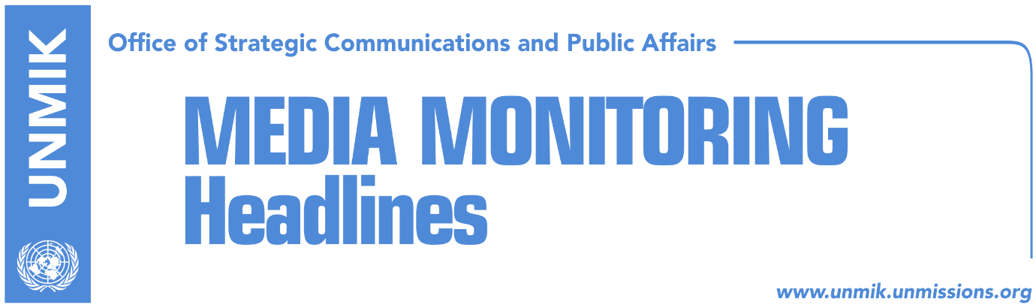

Main Stories 18 January 2017

- Thaci: Kosovo to respond to Serbia’s invitation for war peacefully (Zeri)
- Fungo: Only KFOR is authorized army in Kosovo (Koha Ditore)
- The U.S. Embassy supports Kosovo on stopping the train (Epoka e Re)
- Ymeri: Serbia has not changed its approach towards Kosovo (VOA)
- Viets: Kosovo should control its own borders (Koha Ditore)
- Former EU High Representative Ashton awarded presidential medal (Zeri)
- Ferati: Brussels should interfere about the wall in Mitrovica (KTV)
Kosovo Media Highlights

Thaci: Kosovo to respond to Serbia’s invitation for war peacefully (Zeri)
In an interview with the paper, President of Kosovo Hashim Thaci said that the decision to send Kosovo Police to the north to prevent the arrival of the Serbian train was taken by relevant Kosovo authorities and that the international community was informed of the decision after it was taken. “We are a sovereign country, we take decisions independently and in a sovereign manner. This is what the international community requires of us and supports this mature action of Kosovo,” Thaci said. He said Serbia’s provocations towards Kosovo are not coincidental and are part of a bigger scenario aimed at dividing the country. However, he said Kosovo will respond to Serbia’s invitation for war peacefully. “Provocation from the state of Serbia will continue until it recognizes Kosovo and renounces its hegemonic and nationalist policy. However, despite Serbia’s obstructions, Kosovo institutions have managed to extend their sovereignty throughout the territory of Kosovo, including the northern part.”

Fungo: Only KFOR is authorized army in Kosovo (Koha Ditore)
KFOR Commander Giovanni Fungo, was asked in a written interview of the paper, to comment on the war-inducing comments of the Serbian President Tomislav Nikolić, who threatened to send the army to Kosovo. Fungo said that the force that he commands is the only army that can act in Kosovo. He added that this was also decided by the Kumanovo peace agreement, signed between NATO and Serbia in 1999. He also stressed that during the tensions of the last weekend, KFOR was in the state of alert. However, he informed that in such situations, KFOR’s involvement comes after the engagement of the Kosovo Police and EULEX, as the third responding force. Fungo admitted that the recent events were concerning and stressed that problems should be resolved through dialogue and with constraint.

The U.S. Embassy supports Kosovo on stopping the train (Epoka e Re)
The paper carries a press release issued by the Embassy of the United States of America to Kosovo, which notes that “Kosovo is a sovereign, independent country and we respect the right of Kosovo to manage who and what crosses its borders. We are pleased that there were no confrontations at the border, but the increase of nationalism benefits no one. The U.S. strongly supports the EU-moderated Dialogue as the best way forward for Kosovo-Serbia relations and we urge all sides to avoid dangerous rhetoric and continue to work for the normalization of relations and the improvement of the lives of the citizens of both countries. Today we celebrate the birth of Dr. Martin Luther King Jr., who said, “the time is always right to do what is right;” now is the right time to work for cooperation and against confrontation,” the press release reads.

Ymeri: Serbia has not changed its approach towards Kosovo (VOA)
Vetevendosje leader Visar Ymeri said in an interview with Voice of America in Albanian that the political language of Serbian leadership towards Kosovo shows that Serbia has not changed and that leaders in Kosovo should realize that there can be no peace until Serbia changes its approach. Ymeri said the Kosovo Police action in the north was positive and necessary but that it was not something miraculous because this kind of work would have to be customary for a police force. He said the response to President of Serbia’s Tomislav Nikolic’s threats for use of military in the north would have to be coordinated between Kosovo and Albania jointly. “It is necessary for Kosovo and Albania to function as one when it comes to joint interest, namely the national interest,” Ymeri said.

Viets: Kosovo should control its own borders (Koha Ditore)
The German Ambassador to Kosovo, Angelika Viets, told the paper that as an independent state, Kosovo has the right to decide who enters from the border points. “Germany has recognized Kosovo, but this is valid for the entire Kosovo, including the north of the country,” Viets said. Speaking about the wall in Mitrovica North, Viets said that she feels sorry that the government of Kosovo has to deal continuously with problems which are imposed to them. “I hail the moderated reactions of the government of Kosovo in the current situation and I hope that a peaceful solution about the wall will be found soon,” Viets said.

Former EU High Representative Ashton awarded presidential medal (Zeri)
The former EU High Representative for Foreign Affairs and Security Policy, Catherine Ashton, was awarded yesterday in Pristina with the presidential medal of merits for her contribution to normalization of relations between Kosovo and Serbia. Upon awarding Ashton this honour, President of Kosovo Hashim Thaci stressed that European vision will triumph in the region despite temporary tensions. “The future of Kosovo and the Western Balkans is the Euro-Atlantic perspective,” Thaci said.

Ferati: Brussels should interfere about the wall in Mitrovica (KTV)
Kosovo Assembly MP from the Democratic League of Kosovo, Sadri Ferati, said in an interview for the broadcaster that the wall in Mitrovica North should be demolished, however he added that this should be done based on Kosovo laws. “I was surprised that the wall became the matter of an entire Assembly session. There was no need for the wall to become an issue of the entire Kosovo. Brussels should play a very important role on demolition of the wall. It should not appear as a wall, because it sends a bad message, Ferati said.

Disclaimer
This media summary consists of selected local media articles for the information of UN personnel. The public distribution of this media summary is a courtesy service extended by UNMIK on the understanding that the choice of articles translated is exclusive, and the contents do not represent anything other than a selection of articles likely to be of interest to a United Nations readership. The inclusion of articles in this summary does not imply endorsement by UNMIK.

