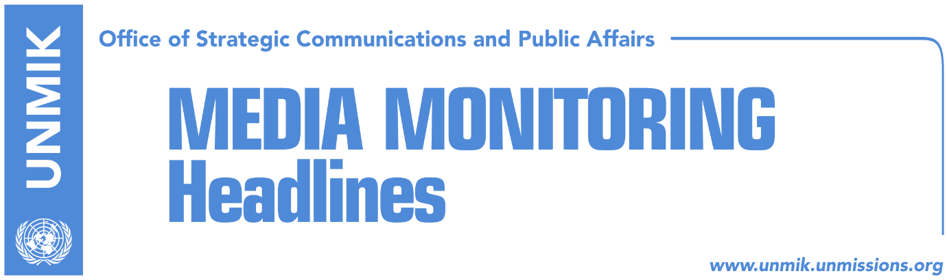

Main Stories 01 April 2017

- Thaci: Political murders should not be used for election campaign (RTK, Lajmi)
- OSCE helps process of Serbian presidential elections in Kosovo (RTK)
- Recica: Creation of army, only through constitutional changes (RTK)
- Discussions on Association to start next week (Koha Ditore)

Kosovo Media Highlights

Thaci: Political murders should not be used for election campaign (RTK, Lajmi)
The President of Kosovo, Hashim Thaci, told RTK on Friday that there have been murders of different political personalities or journalists, professors or other personalities that belonged to some political spectre, or the civil society, after the war. “To me, these were always condemning actions, therefore I have requested from the chief prosecutor to have this as priority in his list of work in order for our society to be liberated from these action. You can see that each time during the election campaign, there is a political party that tries to win elections based on these acts that happened, making in this manner the lives of those families and of the entire society more difficult. It is of ethical importance to enlighten the truth. I have initiated this and I expect support of everyone involved to work on enlightening the truth and bring the perpetrators in front of the justice,” Thaci said.
During the same interview, Thaci also said that Kosovo will sue the Serbian state for committing genocide.

OSCE helps process of Serbian presidential elections in Kosovo (RTK)
The OSCE Mission in Kosovo will conduct a collection of votes operation, opening four collection centres with associated branches throughout Kosovo, with OSCE staff presence, on Sunday, 2 April 2017, in the context of the Serbian Presidential Elections.
The OSCE has made arrangements for an appropriate geographic distribution of these centres and branches, which ensures a sufficient coverage of areas with eligible voters.
The OSCE Mission’s field presence has made information available on the locations to be used for the operation.
Upon completion of the process, the OSCE will transport the collected ballots to Raška and Vranje and hand them over to the Republican Election Commission (RIK) for follow up procedures.

Recica: Creation of army, only through constitutional changes (RTK)
Continuous appeals of the U.S. and NATO senior officials for the Kosovo institutions not to rush with creation of army, have convinced the Kosovo political spectre not to proceed with establishment of army only through amendment of the law. Kosovo Assembly MP from the Democratic Party of Kosovo, Elmi Recica, said that transformation of the Kosovo Security Force into an army will only happen through constitutional changes. “It is the position of all parties to definitely go with constitutional changes and in a way, to discuss with Kosovo Serbs here. Both us and our international partners will be part of this very important process for all of us,” Recica said. Asked if this process would take time, Recica said that it depends on the engagement of the parties involved, in this case Kosovo institutions and international strategic partners.
Recica also said that the issue of the Agreement for demarcation of the border with Montenegro will be returned for adoption at the Assembly very soon.

Discussions on Association to start next week (Koha Ditore)
The government of Kosovo is planning to start discussions for the establishment of the Association of Serb-majority Municipalities next week. Deputy Minister of Local Government, Bajram Gecaj, confirmed the news. “After the return of Kosovo Serbs to the institutions, we will discuss this issue next week,” Gecaj said.
The Prime Minister of Kosovo, Isa Mustafa, announced last month that he has initiated the process of drafting the statute for the Association of Serb-majority Municipalities, however Serb representatives did not respond to his invitation at that time.

Disclaimer
This media summary consists of selected local media articles for the information of UN personnel. The public distribution of this media summary is a courtesy service extended by UNMIK on the understanding that the choice of articles translated is exclusive, and the contents do not represent anything other than a selection of articles likely to be of interest to a United Nations readership. The inclusion of articles in this summary does not imply endorsement by UNMIK.

