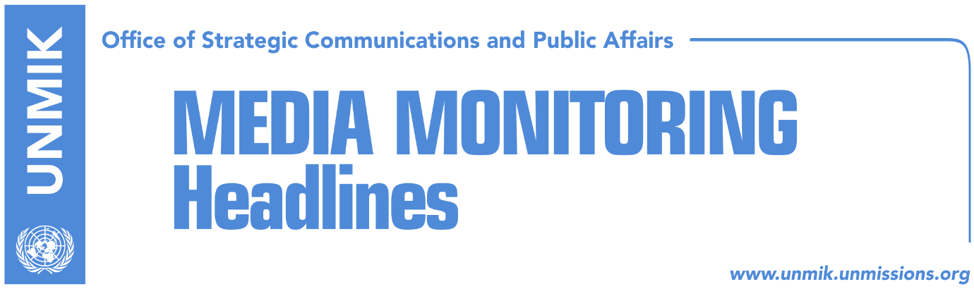

Main Stories 14 April 2017

- Thaci meets Senator McCain (Lajmi.net)
- Gecaj: There is no room for misinterpretation of demarcation (Lajmi.net)
- Simic: All Serbian List MPs against the army (Klan Kosova)
- The U.S. Embassy: Heightened Caution During Religious Holidays (Lajmi, Klan Kosova, Telegrafi, Koha)

Kosovo Media Highlights

Thaci meets Senator McCain (Lajmi.net)
The President of Kosovo, Hashim Thaci, hosted today a meeting with the U.S. Senator and friend of Kosovo, John McCain. The U.S. Ambassador to Kosovo, Greg Delawie, also participated in the meeting. In this occasion, President Thaci honored the U.S. Senator with the “Order of Freedom” award.
McCain, met yesterday with the Prime Minister of Kosovo, Isa Mustafa, Assembly President, Kadri Veseli, and he also addressed the Kosovo Assembly MPs. During his speech in front of the Kosovo lawmakers, McCain said that the army of Kosovo should be created through constitutional changes. He also said that the dialogue between Kosovo and Serbia is crucial for the path toward European integrations.

Gecaj: There is no room for misinterpretation of demarcation (Lajmi.net)
Bajram Gecaj, Deputy Minister and political adviser to the Prime Minister of Kosovo said that the message of the U.S. Senator McCain and of the German Foreign Minister Sigmar Gabriel, with regards to the demarcation of the border with Montenegro, was clear. He added that opponents of demarcation do not want to accept this fact because this reveals meaninglessness of their cause. Gecaj took to Facebook to comment the statements of the opposition representatives that they would not give up on objecting the demarcation, writing that no room for misinterpretation of the Demarcation has been left.

Simic: All Serbian List MPs against the army (Klan Kosova)
The leader of the Serbian List, Slavko Simic, denied the claims of the Kosovo Assembly MP from the Alliance for the Future of Kosovo (AAK), Daut Haradinaj, that some of the Serb MPs are not against creation of the army of Kosovo. Simic said for Vojvodina Radio Television that all MPs from the Serbian List have agreed not to support creation of Kosovo’s armed forces, be it through the amendment of law or constitutional changes.

The U.S. Embassy: Heightened Caution During Religious Holidays (Lajmi, Klan Kosova, Telegrafi)
The U.S. Embassy in Pristina has issued a press release which urges U.S. citizens to exercise particular caution during upcoming religious holidays and at large festivals or events. “Terrorists in the region have previously sought to attack soft targets, to include churches and other places of worship, pedestrian malls, sports arenas, concert halls, and public gatherings,” notes the press release.
Klan Kosova quotes Kosovo’s Deputy Minister for Internal Affairs, Milan Radojevic as saying to the Serbian news agency, Tanjug, that Kosovo Police operation plan to increase police presence around monasteries in Kosovo is already in force.
Telegrafi website claims to possess a Kosovo Police document which orders police officers to wear bulletproof wests. The same portal reports that Kosovo Police has arrested in Peja/Pec Rakip Abdyli, who was calling through social networks for terrorist attacks.
Telegrafi also reports that Kosovo Police officials said that there is no reason for panic and that the security situation in Kosovo is stable. The Minister of Justice Dhurata Hoxha, explained that the meeting of Kosovo’s Security Council was regular.
Asked about the possibility of some terrorist attack, Assembly President, Kadri Veseli, called today after the meeting of Assembly Presidency on Kosovo, on people to be vigilant and not allow for Kosovo to become pray of any special war. “Kosovo is a stabile country oriented toward Europe,” Veseli said.

Disclaimer
This media summary consists of selected local media articles for the information of UN personnel. The public distribution of this media summary is a courtesy service extended by UNMIK on the understanding that the choice of articles translated is exclusive, and the contents do not represent anything other than a selection of articles likely to be of interest to a United Nations readership. The inclusion of articles in this summary does not imply endorsement by UNMIK.

