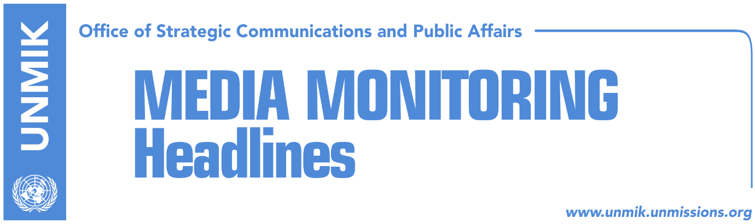

Main Stories 29 April 2017

- Thaci expresses dissatisfaction for EU delays in relation to Kosovo (Koha)
- Stefanovic: The World is supporting Kosovo, Serbia is forgotten (B92, Lajmi.net)
- Daut Haradinaj: Serbian List, Serbia’s extended hand (Lajmi.net)
- Gecaj: I hope my partners will not become pray of opposition games (Lajmi.net)
- NATO report: Western Balkans in danger, it needs strong support (Lajmi, European Western Balkans)

Kosovo Media Highlights

Thaci expresses dissatisfaction for EU delays in relation to Kosovo (Koha)
The President of Kosovo Hashim Thaci, hosted on Friday a meeting with Angelina Eichhorst, European External Action Service Director for Western Europe, Western Balkans and Turkey. They discussed the current political developments inn Kosovo with regards to the EU integration. Thaci expressed once again his disappointment “ for the European Union’s unfair treatment and completely unnecessary delays in the process of EU integration of Kosovo and its citizens.” He added that despite the obstacles, Kosovo will persistently work towards the only alternative – integration in Euro-Atlantic structures.

Stefanovic: The World is supporting Kosovo, Serbia is forgotten (B92, Lajmi.net)
Serbia’s Deputy Prime Minister, Nebojsa Stefanovic, said on Friday that he is concerned about lack of the reaction from Europe and the World with regards to the messages of the Albanian leadership in Serbia, concretely Jonuz Musliu’s statements on ‘Greater Albania.’
He said that he does not understand why there is no serious reaction and added that it has been proven several times now that Serbia cannot count on any support. He said that he cannot say anything after 3the political decision” of the French Court in Colmar to release Ramush Haradinaj. “There is nothing positive to say after the political, unfriendly decision towards Serbia.”

Daut Haradinaj: Serbian List, Serbia’s extended hand (Lajmi.net)
Kosovo Assembly MP from the Alliance for the Future of Kosovo, Daut Haradinaj, said today during a roundtable organized by the Kosovo Youth Atlantic Treaty Association, that the Serbian List is the obstacle on creation of the army of Kosovo. “It is Serbia’s extended hand and it does not agree with the constitutional changes reauired for establishment of the army,”

Gecaj: I hope my partners will not become pray of opposition games (Lajmi.net)
Bajram Gecaj, adviser to the Prime Minister of Kosovo, continued with his criticism of the opposition with regards to the rejection of the adoption of the agreement on demarcation of the border with Montenegro. “The only weapon of the opposition, ever since the beginning of this mandate, has been flagrant abuse of national feelings, in a most primitive and dishonest manner possible. Let us hope and believe that coalition MPs, especially my partners, do not become pray of these filthy and devious games,” Gecaj wrote.

NATO report: Western Balkans in danger, it needs strong support (Lajmi, European Western Balkans)
Economics and Security Committee of NATO Parliamentary Assembly has issued a draft report “Economic transition in the Western Balkans: An assessment” in April 2017. The draft report was written by Richard Benyon, rapporteur for Economics and Security Committee and the UK Member of Parliament from the Conservative Party.
The NATO Parliamentary Assembly (PA) is an intergovernmental organisation of NATO and associate countries – body which directly interacts with the parliamentary structures of national governments of the member states. The main objective of the PA is to create political policy agenda for the NATO Council through reports of its five committees, after which they are discussed, amended and adopted at the PA Annual Session in autumn.
The draft report on the assessment of the economic transition in the Western Balkans gives a political and economic insight of the region, with a brief history background. The report states that the Western Balkans remains an area of special concern for NATO, which is currently present in the region as the Kosovo Force (KFOR) and Operation Althea, with a notion that only Serbia and Republika Srpska have not shown interest in becoming a part of the NATO.
Although NATO acknowledges that the EU has been a key player in maintaining the region’s stability, it also considers economic crisis which “seems to have opened the door for anti-EU populist and nationalist movements to challenge difficult reforms.”
The process of EU integration of the region has been shaken up by numerous political and economic issues within the countries, but from the external factors as well – one of the main issues which caused disturbance throughout the region was the current instability of the EU, which has caused bloom of nationalist and authoritarian movements.
Kosovo has been frequently dealing with tensions regarding the relations with Serbia, for which the Report states have been on the rise over the past year, ever since “Belgrade sent a train painted with the slogan “Kosovo is Serbia” to the border.” Relations got even worse when Prishtina announced a wish to form a regular army. As for Montenegro, the country which is soon-to-be NATO member state has been dealing with planned coup d’état and with the opposition which is currently boycotting parliament, while the situation in Macedonia is “even more discouraging,” with the President refusing to give a mandate to opposition leader Zoran Zaev to form a government. Overall, political tensions between the countries of the Western Balkans are not calming down, even with the urge of the EU.
Aside from the internal issues, the Western Balkans is facing a high unemployment rate, especially among the youth, which leaves them “more vulnerable to demagoguery and misinformation.” As for the state of democracy, the Report mentions the 2016 Nations in Transit report, which notes that the level of democratic development in the Western Balkans has regressed six years in a row. The rule of law has been undermined by the political elite which is using this leverage for personal gain.
The report goes further into the problems of the Western Balkans by stating that throughout the region “corruption, clientelism, vote rigging and fraud are all linked to the problem of state capture by elites with little interest in advancing the substance of democracy even though the form of democracy suits their purposes.”
It also touches the subject of Russia’s relations with the Western Balkans, which seems to be “a fertile ground to challenge NATO and EU influence.”
The report concludes that it is a very high risk for the Western Balkans to slide back to nationalist ideology, adding that authoritarianism is not a “formula for success where the problem has been the absence rather than a surfeit of democracy.”

Disclaimer
This media summary consists of selected local media articles for the information of UN personnel. The public distribution of this media summary is a courtesy service extended by UNMIK on the understanding that the choice of articles translated is exclusive, and the contents do not represent anything other than a selection of articles likely to be of interest to a United Nations readership. The inclusion of articles in this summary does not imply endorsement by UNMIK.

