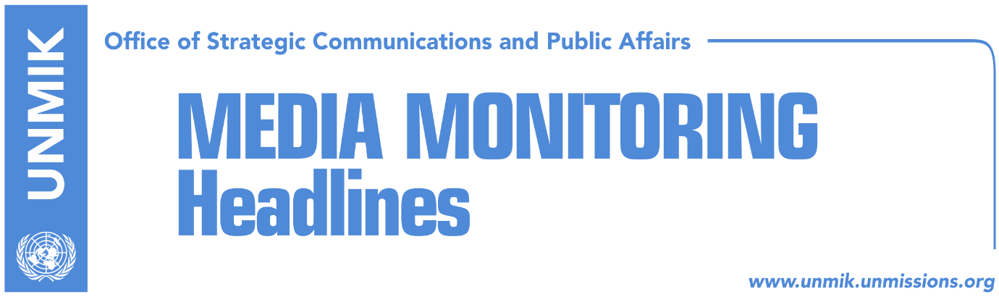

Main Stories 20 May 2017

- 26 political entities to participate on 11 June elections (RTK)
- Ymeri: Acceptance of election results depends on their flow (Lajmi)
- Hoyt Yee writes to Arbana Xharra (Lajmi.net)
- The chaotic western Balkans take sudden turn for the better (The Economist)

Kosovo Media Highlights

26 political entities to participate on 11 June elections (RTK)
The Central Election Commission (CEC) official, Valmir Elezi, informed that the deadline to apply for certification of the political entities willing to participate on the early elections for the Assembly of Kosovo, is reached. He said that during the period 11 to 19 May, five coalitions, 19 political parties and two citizens’ initiatives applied for participation in 11 June elections. Most of the political parties submitted on Friday the lists of the candidates for Kosovo Assembly MPs, just a few minutes before the deadline. Media widely speculate on the names of the candidates included in these lists as well as on those who were left out of the lists this time.

Ymeri: Acceptance of election results depends on their flow (RTK)
Visar Ymeri, leader of the Vetevendosje movement, told RTK that acceptance of the 11 June election results would depend on their flow. He said that Kosovo does not benefit from the coalitions of the political parties reached at the very last minute. According to him, these elections represent a referendum for the future of Kosovo. Asked about the post-election coalitions, Ymeri said they would see after 11 June with which ones they could build cooperation bridges. Speaking about the demarcation of the border with Montenegro, Ymeri said that the agreement should be reached with Montenegro but it should not harm Kosovo. He also said that the Association of the Serb-majority Municipalities was halted through the protests of the people and sustainability of Kosovo Assembly MPs. He added that the Constitutional Court of Kosovo also decided that the Association is in contradiction with the Constitution of Kosovo.

Hoyt Yee writes to Arbana Xharra (Lajmi.net)
The former journalist now member of the Democratic Party of Kosovo (PDK), Arbana Xharra, took to Facebook to publish the letter of the U.S. Deputy Assistant Secretary for European and Eurasian Affairs, Hoyt Brian Yee, written after the attack on her by unknown persons near her home in Pristina.
“I wish to extend my deepest sympathies for the injuries you suffered in the horrific attack and to offer my best wishes for a speedy recovery. We have spoken out strongly and publicly to condemn the attack and to join the call on Kosovo authorities to ensure that your assailants are brought to justice.
Your persistence, courage and service to your country through your journalism and activism reflect the highest ideals of democracy. The United States will continue to support the fearless work of journalists, political and civil society leaders like you, who are determined to build a better future for Kosovo,” is written in the letter.

The chaotic western Balkans take sudden turn for the better (The Economist)
FOR months, Kosovo, Macedonia and Albania have each been embroiled in crises of varying kinds. But over the past few days, the political landscapes in each of these countries have suddenly shifted, and for the better. Kosovar politicians who normally despise one another have struck a deal to campaign together in an election on June 11th. In Albania, a party that had been threatening for months to boycott elections agreed to take part. And Macedonia’s president at last agreed to let an opposing party form a government, ending a five-month-long impasse that had led to brawling in the streets and inside the country’s parliament itself.

http://www.economist.com/news/europe/21722356-compromises-strike-all-once-kosovo-macedonia-and-albania-chaotic-western-balkans-take

Disclaimer
This media summary consists of selected local media articles for the information of UN personnel. The public distribution of this media summary is a courtesy service extended by UNMIK on the understanding that the choice of articles translated is exclusive, and the contents do not represent anything other than a selection of articles likely to be of interest to a United Nations readership. The inclusion of articles in this summary does not imply endorsement by UNMIK.

