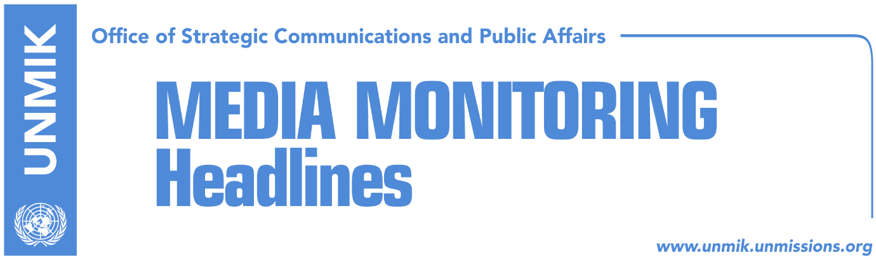

Main Stories 03 June 2017

- Haradinaj: No dialogue with Serbia without America (Klan Kosova)
- Lunacek: PDK, LDK should tell coalitions that they accepted demarcation agreement (DW)
- Petrele: Elections, opportunity to demonstrate democratic maturity (Koha)
- Jahjaga: Serbia breeched Brussels agreement (RTK)
- Eliot Engel writes to Mogherini: Serbia is not ready for EU (media)

Kosovo Media Highlights

Haradinaj: No dialogue with Serbia without America (Klan Kosova)
Ramush Haradinaj, current candidate of PDK-AAK-NISMA coalition for Prime Minister, told Klan Kosova that the United States of America should be involved in order to have a more constructive and delivering dialogue between Kosovo and Serbia.

“Dialogue is an instrument of resolving issues among neighbors however we will not accept an unequal dialogue without reciprocity. Internal matters of Kosovo cannot be discussed in the dialogue with Serbia,” Haradinaj said.

“I cannot run after someone only because I am invited to a dialogue, without knowing first what citizens, civil society and the country in general say about it. Europe cannot solve any problem on its own. America should return at the dialogue between Kosovo and Serbia,” he added.
Speaking about the demarcation of the border with Montenegro, Haradinaj said that there is a possibility for the Assembly to bring the agreement down. “However, there is also the possibility of establishing a new commission, and preparation of a proper version of the border, which is at Cakor. We should also negotiate with Montenegro, they are aware of the truth,” Haradinaj said.

He added that it is nonsense to relate the matter of the demarcation with visa liberalization for Kosovo. According to him, visa liberalization is a matter that will be resolved within weeks or months.

Lunacek: PDK, LDK should tell coalitions that they accepted demarcation agreement (DW)
The EU Special Rapporteur for Kosovo, Urlike Lunacek, told Deutche Welle that no matter who wins the elections in Kosovo, they would have to fulfill the two required criteria in order to gain visa liberalization.

“The two conditions are ratification of the agreement for demarcation of the border between Kosovo and Montenegro. The Prime Minister and representatives of the Democratic League of Kosovo (LDK) and the Democratic Party of Kosovo (PDK) agreed and signed ratification of this agreement in Vienna in August 2015. The other condition is conviction of high ranking individuals involved in organized crime and corruption. Demarcation of the border with Montenegro is one of these two conditions. PDK and LDK which are now in lists with other parties, have signed this agreement in 2015. They should clearly tell their coalition partners that this condition should be fulfilled and that the agreement should ratify,” Lunaced said.

Petrele: Elections, opportunity to demonstrate democratic maturity (Koha)
During a press conference in Pristina, the Chief Observer of the EU Election Observation Mission in Kosovo and Member of the European Parliament for Slovenia, Alojz Peterle, called for a peaceful campaign and credible elections.

“I call on all stakeholders to play their part in ensuring the peaceful conduct of the rest of the campaign, and not to miss this opportunity to ensure credible elections for all the people of Kosovo,” he said.
During his two-day visit to Kosovo, Mr Peterle met with the head of the Central Election Commission Valdete Daka, acting Prime Minister Isa Mustafa, acting Foreign Minister Enver Hoxhaj as well as representatives of political entities, civil society and the international community.
While acknowledging the challenges posed to the election administration by the short timeframe of 30 days for the 11 June early legislative elections, Peterle said they nevertheless represented “an excellent opportunity to demonstrate democratic maturity.”

He also urged all political actors to “refrain from any language or forms of pressure and intimidation that could undermine the integrity of the electoral process.” This includes allowing the media to offer a platform to political entities without interference.

Jahjaga: Serbia breeched Brussels agreement (RTK)
Former President of Kosovo told RTK that her traveling at the “Miredita-Dobardan” festival in Belgrade was made impossible due to the lack Serbian authorities’ readiness to secure her participation.

“This was expected. I expected such behavior of Serbian politicians. We as institutions of the Republic of Kosovo have followed all the required institutional steps through our Ambassador there at the Liaison Office in Belgrade, in accordance with the reached Agreement in Brussels. This is very harsh breach of the Brussels Agreement,” she said, adding that she has once again sent the request to participate at the festival.

Jahjaga was scheduled to take part in the event and speak about victims of sexual abuse during the 1999 conflict in Kosovo.

Eliot Engel writes to Mogherini: Serbia is not ready for EU (media)
Most of Kosovo media report that the U.S. Ranking Member of the House of Committee on Foreign Affairs, Eliot Engel, condemned on Friday Serbian authorities for stopping former President of Kosovo, Atifete Jahjaga to enter Serbia. Engel wrote to the European Union High Representative Frederica Mogherini, arguing “Serbia’s unwillingness to face its past crimes which is the reason to slow the country’s process of joining EU.“

“I fully respect the accession process of aspirant members of the European Union and the critical decisions that you and your colleagues must make along the way. Unfortunately, I must ask that you strongly consider suspending Serbia’s accession process at this point. For a Balkan country – Serbia, no less – to avoid discussion and acceptance of responsibility for war-time crimes represents a very serious problem. If not addressed, it could result in a repetition of past behavior. Frankly, Belgrade simply is not ready to join EU’s community of democracies if it does not fully accept the past and if there is no accountability for war crimes,¨ Engel wrote.

Disclaimer
This media summary consists of selected local media articles for the information of UN personnel. The public distribution of this media summary is a courtesy service extended by UNMIK on the understanding that the choice of articles translated is exclusive, and the contents do not represent anything other than a selection of articles likely to be of interest to a United Nations readership. The inclusion of articles in this summary does not imply endorsement by UNMIK.

