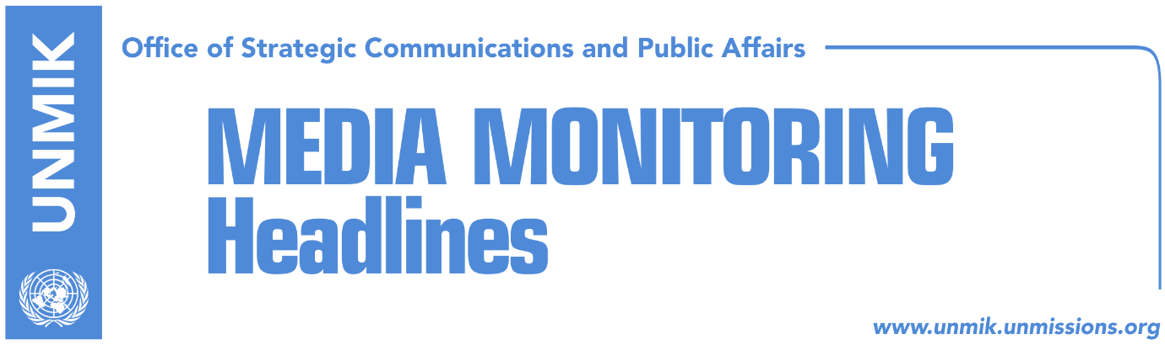

Main Stories 31 July 2017

- PAN: Assembly President and Government to be voted on same day (Koha)
- Mustafa: Resolving Serb issue in Kosovo, knot in our European future (Koha)
- Vucic: Serbs and Albanians must live like friends (media)
- Palokaj: No normalization of relations without mutual recognition (Koha)
- Hoyt Yee: Balkans must be very careful from Russian influence (Kosova Sot)
- Kucan: Western Balkans remains a powder keg (Epoka e Re)
- “We have lost €90 million!” (Zeri)

Kosovo Media Highlights

PAN: Assembly President and Government to be voted on same day (Koha)
The coalition consisting of the Democratic Party of Kosovo (PDK), Alliance for the Future of Kosovo (AAK) and Initiative for Kosovo (NISMA), wants both the Assembly President and the Prime Minister to be voted in Parliament on August 3, the paper reports on the front page. PDK leader Kadri Veseli, the likeliest candidate for the post of Assembly President, and Ramush Haradinaj, PAN’s candidate for Prime Minister, will not have the support of the Vetevendosje Movement, the Democratic League of Kosovo (LDK) and its coalition partners. PAN needs at least 61 votes in parliament to elect Veseli and Haradinaj.PDK spokesman Blerand Stavileci told the paper on Sunday: “everything will be voted on the same day [August 3] with the sufficient number of votes that meets the constitutional and legal requirements for the election of new institutions”.

Mustafa: Resolving Serb issue in Kosovo, knot in our European future (Koha)
Kosovo’s outgoing Prime Minister, Isa Mustafa, commented on a recent statement by Serbian President Aleksandar Vucic who called for an internal dialogue in Serbia to resolve pending problems with Albanians. Mustafa posted on his Facebook account: “resolving the Serb issue in Kosovo and problems with Serbia is a knot in our European future and long-term stability. No one uses the position of political strength or dominance, such as the case of the Serbian President, to initiate internal dialogue; but we can use our diverse political thinking to find the best common solution. There are some topics that we cannot overcome divided. Major state issues are resolved with great caution and wide-ranging political consensus, with stable institutions and people that think about the state, and in cooperation with the United States of America and the European Union”.

Vucic: Serbs and Albanians must live like friends (media)
Several media cover an interview that Serbian President Aleksandar Vucic gave to Swiss daily newspaper Blick, highlighting his remark that Serbia needs to open a new chapter and find a solution to the Kosovo problem. Vucic said Serbs and Albanians must live like friends. “I want a new path for Serbia. I want to initiate direct and fair discussions for resolving the Kosovo dispute. Even if Serbs are not ready yet, I will not give up. This debate will have a healing effect on all of us despite the results that we will achieve … We are ready to find a good compromise and to make progress,” Vucic said. Zeri quotes Vucic on the front page as saying, “Kosovo and Serbia must both give up on something before reconciliation”.

Palokaj: No normalization of relations without mutual recognition (Koha)
The paper’s Brussels-based correspondent, Augustin Palokaj, argues in an opinion piece that “Kosovo and Serbia, Belgrade and Pristina, Brussels and Berlin can try different formulas to normalize relations between Kosovo and Serbia, but none of these formulas will help achieve normalization without recognizing the sovereignty and territorial integrity of Kosovo. Kosovo cannot fall in the trap of talks ‘on Kosovo’s status’ because this is a closed chapter”.

Hoyt Yee: Balkans must be very careful from Russian influence (Kosova Sot)
Deputy Assistant Secretary for European and Eurasian Affairs Hoyt Yee said the United States remains strongly committed to the Balkans, the paper reports on page two. “We are taking measures wherever it is possible to strengthen the countries of the Western Balkans in the face of ill-will intentions be they from Russia or other countries and factors. The Balkans countries must be cautious, they need to follow carefully what Russia is doing and we are doing the same thing,” he added.

Kucan: Western Balkans remains a powder keg (Epoka e Re)
Milan Kucan, former President of Slovenia, told Montenegrin newspaper Pobjeda that the West is still keeping its eyes shut before the fact that the Western Balkans remains a powder keg. “I have the impression that Brussels is not aware of the situation in the Western Balkans, and the policy that it implements is not always based on principles,” Kucan said.

“We have lost €90 million!” (Zeri)
Ruud Vermeulen, the International Monetary Fund’s resident representative in Kosovo, talked to the paper about the IMF funding package that will expire on August 4, confirming that the final allocation of around €15 million will not take place due to the failure to elect a new government. The paper recalls that in July 2015, Kosovo had agreed to a €184 million two-year funding package with the IMF and the final review was expected to take place in June. This however was postponed due to early elections in July. IMF said in a statement that the fund was “not unilaterally cancelling the program” but that as the deal expires on August 4, there would be no time for a final review given that a new government was not elected.

Disclaimer
This media summary consists of selected local media articles for the information of UN personnel. The public distribution of this media summary is a courtesy service extended by UNMIK on the understanding that the choice of articles translated is exclusive, and the contents do not represent anything other than a selection of articles likely to be of interest to a United Nations readership. The inclusion of articles in this summary does not imply endorsement by UNMIK.

