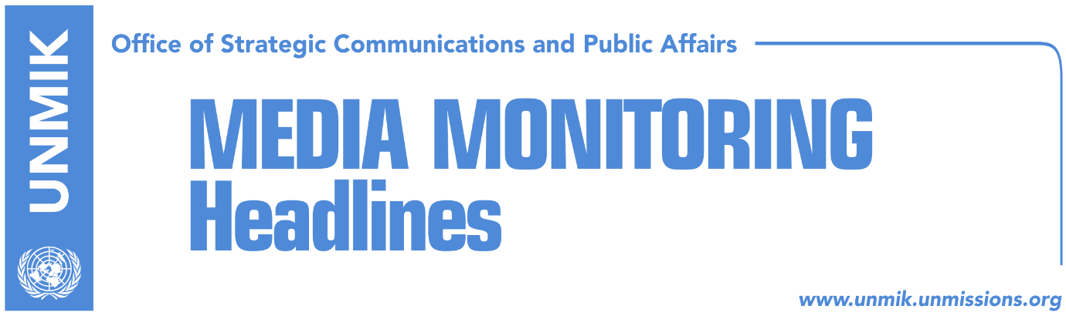

Main Stories 27 July 2017

- Stavileci: We have secured enough votes for new institutions (Epoka e Re)
- Mustafa: PAN doesn’t have enough votes (media)
- Contradiction over votes within PAN (Koha)
- Kurti: Vetevendosje to heal peoples’ wounds (Epoka e Re)
- Collaku: Dacic’s ideas, dangerous to regional stability (Epoka e Re/RFE)
- Non-profit foundation gives USD 1.5 million for prevention of extremism (Zeri)

Kosovo Media Highlights

Stavileci: We have secured enough votes for new institutions (Epoka e Re)
Blerand Stavileci, member of the chairmanship of the Democratic Party of Kosovo (PDK), said in an interview to the paper that the PDK-AAK-NISMA (PAN) coalition has secured enough votes to form the new Assembly and government. Stavileci said all dilemmas on the matter would be removed on August 3 at the constitutive session of the Assembly. According to Stavileci, the new government will also be voted on the same day.

Mustafa: PAN doesn’t have enough votes (media)
Kosovo’s outgoing Prime Minister and LDK leader, Isa Mustafa, said on Monday that the PDK-AAK-NISMA coalition lacks the required number of votes to form a new government. “PAN has neither the votes nor the people. In the elections, they won a quarter of the votes and this does not represent a majority to elect the new institutions. In this society, everyone must be held accountable for their actions,” Mustafa wrote.

Contradiction over votes within PAN (Koha)
The paper reports on its front page that there is uncertainty and contradiction even within the PDK-AAK-NISMA coalition about their votes in the Assembly, three days before the constitutive session. NISMA MPs said on Monday that they don’t know if PAN has secured 61 votes, adding that this responsibility rests with PDK leader Kadri Veseli and PAN’s candidate for Prime Minister, Ramush Haradinaj. NISMA MP Zafir Berisha told the paper that even within PAN there are voices that favor going to new elections but only after the formation of the new Assembly. “In case the government is not elected, Kosovo will go to extraordinary elections. This is very likely to happen, because even the PDK favors going to elections in order to avoid this situation,” Berisha said.

Kurti: Vetevendosje to heal peoples’ wounds (Epoka e Re)
Vetevendosje’s candidate for prime minister, Albin Kurti, said victory in Kosovo politics has been misunderstood and is being degraded into an electoral win. He said the purses of Kosovo people have become like onions: “when you open it, it makes you cry”’ whereas those of government officials have reached millions. “We will heal peoples’ wounds”, declared Kurti on Facebook and added that a government run by Vetevendosje would unite the citizens.

Collaku: Dacic’s ideas, dangerous to regional stability (Epoka e Re/RFE)
Chief of staff to Kosovo President Hashim Thaci, Bekim Collaku, told Radio Free Europe that officials in Serbia should refrain from “dangerous” political statements about partition of Kosovo. Collaku said Kosovo welcomes any internal dialogue in Belgrade which would go towards acceptance of the reality in Kosovo but warned that the discourse cannot “serve as platform to promote all kinds of ideas”. “These ideas, wherever they come from, are outdated and do not contribute to the stability in the region”, said Collaku. His reaction came to an interview the Serbian Foreign Minister Ivica Dacic gave to Serb media where he suggested a type of a demarcation for Albanians and Serbs.

Non-profit foundation gives USD 1.5 million for prevention of extremism (Zeri)
Kosovo’s Ministry of Internal Affairs announced that the Swiss-based Global Community Engagement and Resilience Fund (GCERF) has published a call for expression of interests for non-governmental organisations in Kosovo to gain funds for implementation of projects aimed at preventing extremism in five municipalities: Gjilan/Gnjilane, Ferizaj/Urosevac, Mitrovica, Pristina, and Prizren.

Disclaimer
This media summary consists of selected local media articles for the information of UN personnel. The public distribution of this media summary is a courtesy service extended by UNMIK on the understanding that the choice of articles translated is exclusive, and the contents do not represent anything other than a selection of articles likely to be of interest to a United Nations readership. The inclusion of articles in this summary does not imply endorsement by UNMIK.

