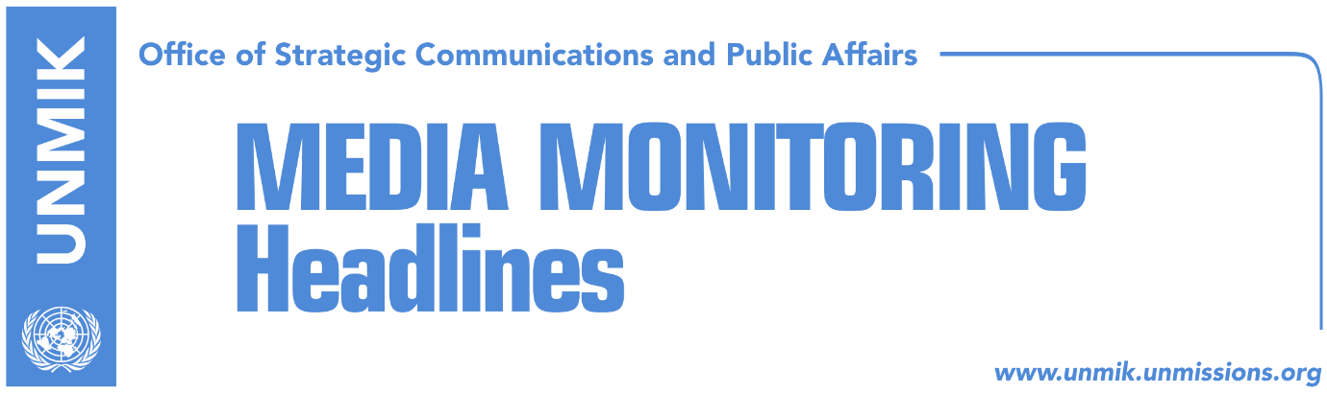

Main Stories 11 August 2017

- Pacolli is seen as a partner of PAN (Koha Ditore)
- Pacolli, PAN’s “ace card” (Zeri)
- Pacolli: I don’t give ultimatums, we are seeking a solution (Bota Sot)
- EU: Kosovo has no time to lose in forming new institutions (Kosova Sot)
- Mikullovci: Deadlock could last until October (Zeri)
- Ferati: Two solutions: Voting PAN candidate or new elections (Epoka)
- Thaci: Kosovo-Serbia dialogue could start in September (Epoka)
- Tahiri: Dialogue to resume after new institutions are formed (Lajmi)

Kosovo Media Highlights

Pacolli is seen as a partner of PAN (Koha Ditore)
The paper reports on its front page that Behxhet Pacolli and his party, the New Kosovo Alliance (AKR), are already seen as partners of the PDK-AAK-NISMA coalition (PAN). The paper further notes that Pacolli, who is currently in a coalition with the Democratic League of Kosovo (LDK) and Alternativa, gave a 10-day ultimatum to the Vetevendosje Movement (VV) and LDK to prove they have an agreement and that they have secured a majority of votes in parliament. Pacolli’s ultimatum is seen as an excuse to change political camps. Pristina-based analyst, Imer Mushkolaj, told the paper that an agreement between VV and LDK is hardly possible if not impossible at this point. “Pacolli knows this and he sees the current situation as an opportunity to make his move,” Mushkolaj added. “It seems that Pacolli has already decided to join PAN in the government, regardless of the fact that he has four MPs thanks to the coalition with the LDK. Otherwise, he [Pacolli] could not have made it over the election threshold”. The paper also reports that PAN will continue to boycott any Assembly session that could be held before Pacolli’s ultimatum expires.

Pacolli, PAN’s “ace card” (Zeri)
The paper reports that winning over the support of Behgjet Pacolli’s New Kosovo Alliance (AKR) is the only hope PAN coalition has in its effort to elect Assembly speaker and form new government. Although the Democratic League of Kosovo (LDK) tried to downplay Pacolli’s statement that he would reconsider his staying with LAA coalition if it fails to secure majority of votes, analysts consider it to be the first sign of AKR’s intention of joining PAN in forming new institutions.

Pacolli: I don’t give ultimatums, we are seeking a solution (Bota Sot)
Leader of the New Kosovo Alliance (AKR), Behgjet Pacolli, said in a Facebook post that his party has not changed its position and that he gave no ultimatum to the Democratic League of Kosovo (LDK) and Vetevendosje but simply asked finalise an agreement that would end the current political crisis. “AKR has not changed its position and we are coherent in our proposals we gave from day one,” Pacolli wrote.

EU: Kosovo has no time to lose in forming new institutions (Kosova Sot)
European Commission spokesperson, Maja Kocijancic, told Gazeta Observer news website that Kosovo Assembly needs to be constituted as soon as possible and called on the political parties to respect the Constitution of Kosovo. Kocijancic said Kosovo has no time to lose and should move quickly in forming new institutions.

Mikullovci: Deadlock could last until October (Zeri)
Kosovo Assembly constitutive session chairman, Adem Mikullovci, told the paper that he does not plan on calling any other consultative meetings of parliamentary parties and that PAN is only trying to buy time by boycotting constitutive sessions. He said the deadlock could last as long as October when Kosovo heads to local elections. “I could be wrong, this is just my observation, but I think they will try to delay this until local elections”, Mikullovci said of PAN.

Ferati: Two solutions: Voting PAN candidate or new elections (Epoka)
Sadri Ferati, member of the General Council of the Democratic League of Kosovo (LDK), called on all parties to reflect towards the creation of the institutions of Kosovo. He said during the interview that there are two solutions: voting the candidate proposed by PAN, or going for new elections. Speaking about creation of the government, Ferati said that if PAN candidate is not voted within 15 days, then the other group has the right to come forward with their candidate, although he added that this is under discretion of the President. Speaking about Pacolli’s recent request made to LDK and Vetevendosje, Ferati said that he saw Pacolli’s call more as an appeal to unblock the institutions.

Thaci: Kosovo-Serbia dialogue could start in September (Epoka)
The President of Kosovo, Hashim Thaci, told Swiss newspaper Blick, that reconciliation between Kosovo and Serbia should happen and that there is no alternative to the dialogue. Thaci said that dialogue will enter into a new phase, that of complete normalization of the relations between Kosovo and Serbia. He believes that dialogue could start in September.

Tahiri: Dialogue to resume after new institutions are formed (Lajmi)
Kosovo’s Minister for Dialogue, Edita Tahiri, said that Kosovo’s top priority at the moment is creating new institutions and only then will it continue internal and external agenda, including dialogue for normalization of relations with Serbia. She added that the dialogue contributes to furthering Kosovo’s Euro-Atlantic integration and establishing good neighbourly relations with Serbia.

Disclaimer
This media summary consists of selected local media articles for the information of UN personnel. The public distribution of this media summary is a courtesy service extended by UNMIK on the understanding that the choice of articles translated is exclusive, and the contents do not represent anything other than a selection of articles likely to be of interest to a United Nations readership. The inclusion of articles in this summary does not imply endorsement by UNMIK.

