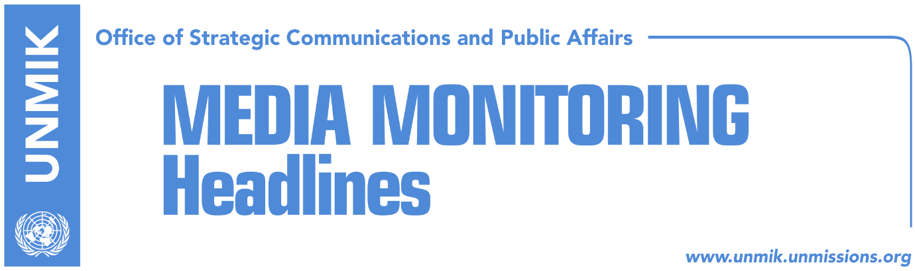

Main Stories 25 August 2017

- Kosovo Assembly remains blocked (media)
- Hoti: LDK will not attend sessions until situation clarifies (Epoka)
- Haliti: New government in beginning of September (Epoka)
- EU appeals for creation of institutions as soon as possible (Telegrafi)
- “If no government by September, mass numbers expected to flee Kosovo” (Koha)
- Albania to host meeting of Prime Ministers of the region (RTK)
- Families of missing persons don’t trust President Thaci (Koha)
- FYROM with a new decision on Kosovo’s membership at UNESCO (RTK)

Kosovo Media Highlights

Kosovo Assembly remains blocked (media)
The leading story in all media is the failure of the sixth constitutive session to form the new Assembly on Thursday. Koha Ditore reports on its front page that due to the lack of a majority in the Assembly, the political party Alternativa has called for a roundtable between all political parties aimed at finding a solution to the formation of institutions. The Democratic League of Kosovo (LDK) and the Vetevendosje Movement meanwhile have not changed their position – they refuse to negotiate at any forum that includes the Democratic Party of Kosovo (PDK). The latter is conditioning the formation of institutions with Kadri Veseli’s election as Assembly President. The paper further notes that the Vetevendosje Movement and the LDK are not showing signs of cooperation and have stepped up accusations. As a result, New Kosovo Alliance (AKR) leader Behxhet Pacolli implied in a statement on Thursday that he could change political camps. Epoka e Re reports on its front page that unlike the previous assembly sessions, PDK-AAK-NISMA (PAN) representatives admitted on Thursday that they lack the required votes and called for another 10-day deadline to form a majority in parliament. The paper also notes that following a harsh polemic between PDK leader Kadri Veseli and Vetevendosje MP Albin Kurti, Assembly chair Adem Mikullovci was forced to conclude the constitutive session. Kosova Sot argues that a technical government is needed to make capital decisions for Kosovo. Bota Sot on its front page criticizes Kosovo President Hashim Thaci “for his silence” toward the institutional stalemate.

Hoti: LDK will not attend sessions until situation clarifies (Epoka)
Head of the parliamentary group of the LDK-AKR-Alternativa (LAA) coalition, Avdullah Hoti, said that his party will not participate at the Assembly sessions until the situation is clarified. He said that proposal of the PAN coalition to postpone the session shows clearly that they do not have the sufficient votes. “With today’s unlimited delay of the session, the country is entering a deep institutional crisis. We will not participate in any session similar to this one,” Hoti said. Speaking about the Democratic Party of Kosovo, (PDK), Hoti said that they have cooperated with the Alliance for the Future of Kosovo (AAK) and the Initiative for Kosovo (NISMA), to bring the government down. “Within the Assembly, Veseli did not undertake any action to impede stacks. He allowed the tear gas at the Assembly. We in LDK are determined not to allow taking of power through violence and blackmails,” he said.

Haliti: New government in beginning of September (Epoka)
Kosovo Assembly MP from the Democratic Party of Kosovo (PDK), Xhavit Haliti, told Klan Kosova that that the PAN coalition will create the government in the beginning of September. “The right of our coalition is to prepare better on election of the Assembly President and creation of the government,” Haliti said adding that they are having discussions of senior political level.

EU appeals for creation of institutions as soon as possible (Telegrafi)
Spokesperson of the European Union Office in Kosovo, Dinka Zhival, told Telegrafi that the EU’s Special Representative to Kosovo, requests from the political parties to act responsibly and fulfill their duties deriving from the Constitution and laws. “Kosovo faces many challenges: high rate of unemployment, low performance on education, corruption, weak rule of law, which impede attraction of sustainable investments which help economic development. Therefore it is important for the political leaders to take these challenges seriously and to act in accordance with the best interest of Kosovo’s population,” said Zhival.

“If no government by September, mass numbers expected to flee Kosovo” (Koha)
A Western European diplomat in Skopje told INA news agency that Kosovo citizens are increasingly disappointed with the political crisis and that a large of number of youths are preparing to flee the country. “We have information from certain services that a new wave of Kosovo citizens are preparing to leave the country in September, because of the irresponsibility of Kosovo politicians who have blocked the formation of institutions over their personal and clan interests. If a new government is not formed by September, we cannot rule out a mass wave of people fleeing out of disappointment,” the diplomat said.

Albania to host meeting of Prime Ministers of the region (RTK)
The office of the Prime Minister of Albania, has issued a press release which informs that “Prime Minister of Albania, Edi Rama will host in Durrës, an informal meeting of the Western Balkans Prime Ministers, on the subject of deepening regional integration with focus on economy and trade. Prime Minister of Serbia, Ana Brnabic, Prime Minister of Kosovo, Isa Mustafa, Chairman of the Council of Ministers of Bosnia and Herzegovina, Denis Zvizdic, Prime Minister of Macedonia, Zoran Zaev, Prime Minister of Montenegro Dusko Markovic as well as Commissioner Johannes Hahn and Cyril Muller, World Bank Vice President for Europe and Central Asia will attend the meeting. The one-day event will be composed of different working sessions during which topics on trade, services, investments and digital economy will be discussed. It is expected that the Western Balkans Prime Ministers will further discuss and will provide strong high level commitment to the implementation arrangements of the Multi-Annual Action Plan for the Regional Economic Area which was agreed upon in Trieste Summit. Furthermore, it is expected that the results Berlin Process yielded so far and the future prospects of Western Balkans regional cooperation will be one of the subjects of discussion.”

Families of missing persons don’t trust President Thaci (Koha)
Families of missing persons do not trust a recent statement by Kosovo President Hashim Thaci who said he would personally engage to resolve the fate of the missing, the paper reports on page two. They argue that Thaci has held senior positions for 18 years and that he has done nothing on the matter. Nysrete Kumnova, chairman of the association “Mothers’ Cries” told the paper: “Thaci was Prime Minister, he held key positions, he participated in talks with the Serbian side in Brussels, but he never address this issue seriously. We are disappointed by approach of our politicians and institutions toward the issue of missing persons,” Kumnova said. “We don’t think his statement is serious, he made for the sake of the conference and it will be forgotten immediately. Politicians don’t know the pain we are experiencing for 18 years now and they haven’t done anything to reveal the truth and alleviate our pain”. Bajram Qerkimi, chairman of the Resource Center for Missing Persons, said they often received promises from state representatives, but that results were always lacking. “I don’t have expectations from any of them, God knows how often the leaders made promises and we are fed up. Neither they nor internationals have addressed this issue,” he added.

FYROM with a new decision on Kosovo’s membership at UNESCO (RTK)
Mile Bosnjakovski, spokesperson at the government of the Former Yugoslav Republic of Macedonia, said that Prime Minister Zoran Zaev has promised to the Serbian PM Ana Brnabic that his country will remain neutral on the matter of Kosovo’s membership at UNESCO. “We do have an official position,” he said and added that their position will be led by that of the majority of European Union’s countries.

Disclaimer
This media summary consists of selected local media articles for the information of UN personnel. The public distribution of this media summary is a courtesy service extended by UNMIK on the understanding that the choice of articles translated is exclusive, and the contents do not represent anything other than a selection of articles likely to be of interest to a United Nations readership. The inclusion of articles in this summary does not imply endorsement by UNMIK.

