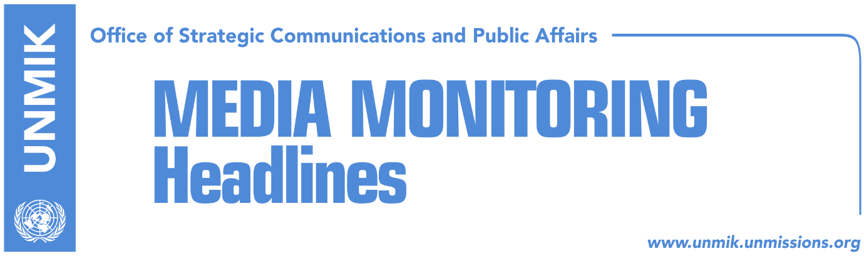

Main Stories 4 September 2017

- “Agreement between PAN and AKR, reached” (Epoka e Re)
- PAN ready for 7 September (Zeri)
- No clarity in dialogue without new government in Kosovo (Koha)
- Missing persons issue will not be tackled in Pristina-Belgrade dialogue (Zeri)
- Tahiri dismisses possibility of Russia’s involvement in dialogue (Telegrafi)
- Thaci and Mustafa clash over Houston flooding relief proposal (Zeri)

Kosovo Media Highlights

“Agreement between PAN and AKR, reached” (Epoka e Re)
PDK-AAK-NISMA coalition and the New Kosovo Alliance (AKR) have reached on Sunday the agreement to co-govern, the paper reports on the front page. Sources of the paper within the PAN coalition confirmed the news. “This agreement will be soon confirmed for the public opinion,” said the source. Deputy leader of the Alliance for the Future of Kosovo (AAK), Pal Lekaj, expressed optimism that the Assembly will be constituted and the government will be created during this week. He excluded on Sunday the possibility of continuance of the political crisis and holding of extraordinary elections. “There will be positive developments this week. Starting from Monday, the week will be quite dynamic on creation of institutions,” Lekaj said.

PAN ready for 7 September (Zeri)
The paper reports on the front page that PAN coalition representatives have given assurances that the Kosovo Assembly speaker will be elected this week paving way for the forming of new institutions following elections in June. MP from the Democratic Party of Kosovo (PDK), Xhavit Haliti, said he believed new institutions would be established by the end of the week while Rasim Selmanaj from the Alliance for the Future of Kosovo (AAK) mentioned 7 September as a likely date for the election of the Assembly speaker.

No clarity in dialogue without new government in Kosovo (Koha)
The paper reports on its front page that after the latest meeting between the presidents of Kosovo and Serbia in Brussels, it is apparent that the format of dialogue is being changed to put presidents at the helm of the process. European Union officials in Brussels say that there will be more clarity in the process after the formation of a new government in Kosovo, "because the government is the one that implements the agreement and that without their implementation dialogue is senseless".

Missing persons issue will not be tackled in Pristina-Belgrade dialogue (Zeri)
The new round of talks at the level of Kosovo and Serbia presidents is not likely to address the issue of missing persons, advisor to Kosovo President Hashim Thaci, Ardian Arifaj told Indeksonline. Arifaj said the upcoming meeting of presidents will focus on implementation of agreements reached by the parties so far. Arifaj also said that President Thaci does not want the issue of missing persons to be politicized but to be treated as a humanitarian issue where all relevant mechanisms should be engaged to determine the fate of the missing persons.

Tahiri dismisses possibility of Russia’s involvement in dialogue (Telegrafi)
Kosovo’s Minister for Dialogue, Edita Tahiri, has dismissed the possibility of Russia getting involved in the EU-backed dialogue for normalization of relations between Pristina and Belgrade. Tahiri’s reaction comes after reports published in Serbian media saying that “new players” could get involved in the dialogue. She said that while a possible engagement of the U.S. and Germany would be welcomed by the Kosovo side, Russia’s would be “unacceptable.”

Thaci and Mustafa clash over Houston flooding relief proposal (Zeri)
The recent flooding that has hit Houston, Texas, has become a source of clash between Kosovo President Hashim Thaci and Prime Minister Isa Mustafa, reports the paper on page 2. In a Facebook post, Thaci urged the government of Kosovo to allocate USD 100,000 for relief efforts in Houston which prompted Prime Minister Mustafa to react and say that Facebook is not the adequate platform to tackle serious issues such as the Houston flooding. Furthermore, Mustafa added, Facebook is not the right channel of communication between a president and prime minister and that this should be done through institutional lines. Meanwhile, officials from President’s cabinet, said Thaci will officially present a request to the government to come to the assistance of families affected by flooding in the U.S.

Disclaimer
This media summary consists of selected local media articles for the information of UN personnel. The public distribution of this media summary is a courtesy service extended by UNMIK on the understanding that the choice of articles translated is exclusive, and the contents do not represent anything other than a selection of articles likely to be of interest to a United Nations readership. The inclusion of articles in this summary does not imply endorsement by UNMIK.

