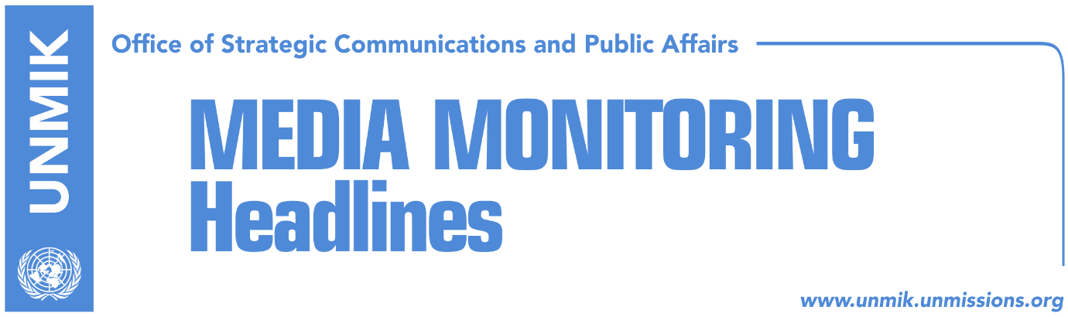

Main Stories 6 September 2017

- New Kosovo government and parliament to be formed by Friday (Zeri)
- A big, fragmented and difficult-to-control government (Koha)
- Pacolli: News on nomination of ministers is a speculation (RTK)
- Pacolli says he was hurt by LDK (Koha)
- “Lack of LDK’s and Vetevendosje’s actions led us towards PAN” (Koha)
- Mogherini: Pristina-Belgrade dialogue was at a standstill (Zeri)
- Police refute media reports of people trying to flee Kosovo (Telegrafi)
- President Thaci to meet Pope Francis this month (RTK)

Kosovo Media Highlights

New Kosovo government and parliament to be formed by Friday (Zeri)
The new Kosovo Assembly and government will be formed by the end of this week, PAN officials told the paper. They said the likeliest date for the election of the Assembly speaker is 7 September while the government led by Ramush Haradinaj is expected to be formed a day after. However, chairman of the Assembly’s constitutive session, Adem Mikullovci, said he has not yet been asked by PAN to call the next session.

A big, fragmented and difficult-to-control government (Koha)
In a front-page article, the paper quotes political analysts as saying that the coalition agreement between the PDK-AAK-NISMA (PAN) coalition, the New Kosovo Alliance (AKR) and minority communities, will most probably result in “a fragile and difficult-to-control” government which will be faced with a strong opposition. The PANA coalition together with the minority communities will have 63 votes in parliament, the Vetevendosje Movement has 32 MPs and the LDK-Alternativa coalition 25 MPs. The paper further notes that the Pacolli-led AKR has won the biggest share of power as with only four MPs it will lead five ministries: the Ministry of Foreign Affairs, Ministry of Interior Affairs, Ministry of Environment and Spatial Planning, Ministry of Agriculture and Ministry for Economic Development. In addition to the ministries and the post of principal deputy prime minister, AKR leader Behxhet Pacolli has also managed to secure the post of President after Hashim Thaci’s mandate expires in 2021. The Democratic Party of Kosovo (PDK), the biggest partner in the ruling coalition with 23 MPs, will have only one ministry more than the AKR. The PDK will have the post of deputy prime minister and the Ministry of Finance, Ministry of Justice, Ministry of European Integration, Ministry of Diaspora, Ministry of Culture and Ministry for Dialogue. The Alliance for the Future of Kosovo (AAK) will get the post of Prime Minister, the Ministry of Health, Ministry of Infrastructure, and the Ministry of Kosovo Security Force.

Pacolli: News on nomination of ministers is a speculation (RTK)
The leader of the New Kosovo Alliance (AKR), Behxhet Pacolli, took to Facebook to write that the news that his party has nominated the eventual ministers for the new government is a speculation, “perhaps an intentional one.” “According to the statute of the party, each proposal has to be approved by the leadership,” wrote Pacolli, adding that all the procedures will be completed after the constitution of the Assembly of Kosovo.

Pacolli says he was hurt by LDK (Koha)
New Kosovo Alliance (AKR) leader Behxhet Pacolli told KTV on Tuesday evening that his party was completely ignored by the Democratic League of Kosovo (LDK). “I did not betray anyone, neither the Vetevendosje Movement nor the LDK, I have worked only for the interest of the people of Kosovo. For three months I called on them to set aside their interests and to form a broad-based government … No one can call this treason, because I have worked with my country’s interests in mind. Kosovo has lost a lot,” Pacolli was quoted as saying.

“Lack of LDK’s and Vetevendosje’s actions led us towards PAN” (Koha)
Chairman of the Assembly of the New Kosovo Alliance (AKR), Fatmir Matoshi, told the paper that lack of actions of the Democratic League of Kosovo (LDK) and Vetevendosje Movement, to create a parliamentarian majority, made AKR join the PAN coalition. He said that these two political parties set interest of their parties in front of those of Kosovo. According to Matoshi, sectors led by his party will be the most successful ones in the new government.

Mogherini: Pristina-Belgrade dialogue was at a standstill (Zeri)
The EU’s High Representative for Foreign Affairs and Security Policy, Federica Mogherini, said at the Bled Strategic Forum that her goal is to see concrete progress in the Western Balkans towards EU integration. “I’ve made it my personal goal that by the end of the current European Commission mandate in two years, we will see practical and measurable progress for all of our six partners in the Western Balkans,” Mogherini said. Speaking about the dialogue for normalization of relations between Belgrade and Pristina, Mogherini admitted the process was at a standstill but that it is now picking up momentum with renewed efforts of the highest level of the two parties.

Police refute media reports of people trying to flee Kosovo (Telegrafi)
Kosovo Police has refuted reports by a number of media outlets that the bus station in Pristina has been packed in the last few days with people trying to flee Kosovo after PAN and AKR reached a power sharing deal. KP said such reports are untrue and there is no room for concern. “There is also no confirmation from any EU country that there is an increase of number of asylum requests from Kosovo,” KP said in a statement.

President Thaci to meet Pope Francis this month (RTK)
The President of Kosovo, Hashim Thaci, wrote on his Facebook page that he will meet Pope Francis, during this month. “I am happy that during this month I will have the opportunity to tell Pope Francis about the consecration of the Cathedral and about all the pledges and achievements of Kosovo population,” he wrote.

Disclaimer
This media summary consists of selected local media articles for the information of UN personnel. The public distribution of this media summary is a courtesy service extended by UNMIK on the understanding that the choice of articles translated is exclusive, and the contents do not represent anything other than a selection of articles likely to be of interest to a United Nations readership. The inclusion of articles in this summary does not imply endorsement by UNMIK.

