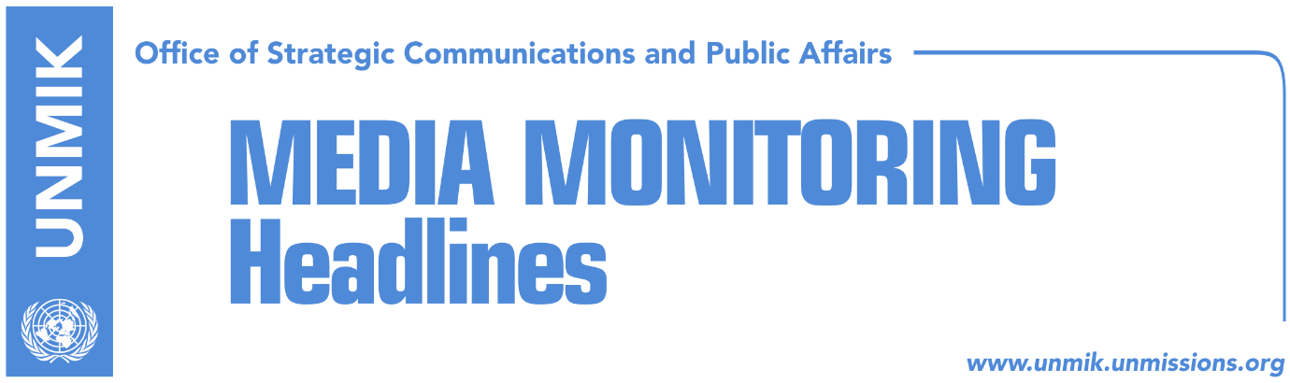

Main Stories 12 September 2017

- Haradinaj dismisses border demarcation committee (media)
- EU: Nothing changed – visa liberalization conditions remain the same (Koha)
- The general without an army (Zeri)
- Rakic: We joined government to ensure better life for Serbs (media)
- Women’s Network criticizes low representation of women in government (media)
- Serbia stops every bus from and to Kosovo (Koha)

Kosovo Media Highlights

Haradinaj dismisses border demarcation committee (media)
Most media report that Prime Minister Ramush Haradinaj’s first decision in office on Monday was to dismiss the state committee on the border demarcation with Montenegro. Haradinaj has tasked Shpejtim Bulliqi to create a team that will assume responsibilities to appoint a new state committee on demarcation. Bulliqi, member of the Democratic League of Kosovo (LDK), was one of the biggest opponents of the current border demarcation with Montenegro. “We cannot have any delays in this respect. As the mandate of the previous committee has expired, I suggest it is dismissed and for Shpejtim Bulliqi to assume the responsibility for creating a new committee … The relevant institutions are in contact with Montenegro. The goal is to have clarity and no delays in this respect. We must in no way endanger our relations with Montenegro,” Haradinaj said at the government meeting on Monday. All ministers, except for those from the Serbian List, voted in favor of dismissing the committee.

EU: Nothing changed – visa liberalization conditions remain the same (Koha)
An unnamed source in the EU in Brussels told the paper that two conditions for visa liberalization for Kosovo remain the same: the ratification of the border demarcation agreement with Montenegro and evidence for a successful fight against high-level organized crime, including court sentences. Asked if the ratification of the border deal remains a condition or an effective progress, EU spokeswoman Maja Kocijancic told the paper that “ratification remains a condition”.

The general without an army (Zeri)
The paper reports on its front page that Ramush Haradinaj, former KLA general and now Prime Minister of Kosovo, will find it very difficult to transform the Kosovo Security Force (KSF) into the Kosovo Armed Forces during his mandate. The Serbian List, an important partner in the ruling coalition, according to Marko Djuric, has managed to remove the formation of the army from the government document. Meanwhile, KSF Minister Rrustem Berisha told the paper on Monday that the formation of the armed forces will be a priority for the new government.

Rakic: We joined government to ensure better life for Serbs (media)
Goran Rakic, leader of the Serbian List, told TV Pink on Monday that their decision to join the Haradinaj-led government was to ensure a better life for Serbs living in Kosovo. “Unfortunately, Serbs were not in a position to elect the political representatives of Albanians, but what makes us happy is the fact that Albanians could not choose the political representatives of Serbs,” Rakic said. “We will fight for a better life for Serbs, including economic development and IDP returns”.

Women’s Network criticizes low representation of women in government (media)
Several media report that the Pristina-based Kosovo Women’s Network criticized on Monday the low representation of women in the new government. Only two out of 25 ministerial posts will be held by women. “The composition of the new government once again confirms that promises made by current political leaders that the new government will include more women were not true,” the Women’s Network said.

Serbia stops every bus from and to Kosovo (Koha)
KTV reported on Monday that since midnight on Sunday several buses have remained blocked several meters away from the Merdare crossing point, on Serbian territory. Although there is no official information on the matter yet, bus drivers said Serbian police told them they have received orders to block every bus from or to Kosovo as a reciprocity measure to Kosovo’s decision to stop the Pristina-Belgrade travelling line.

Disclaimer
This media summary consists of selected local media articles for the information of UN personnel. The public distribution of this media summary is a courtesy service extended by UNMIK on the understanding that the choice of articles translated is exclusive, and the contents do not represent anything other than a selection of articles likely to be of interest to a United Nations readership. The inclusion of articles in this summary does not imply endorsement by UNMIK.

