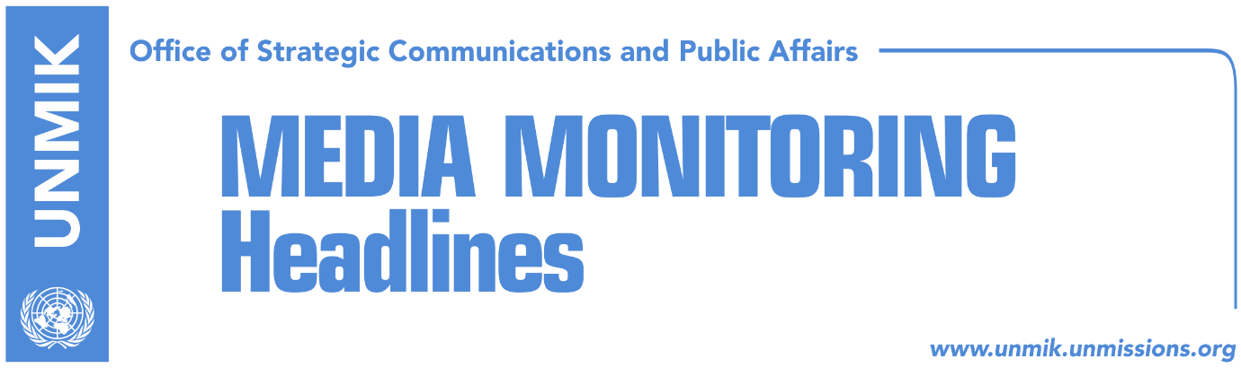

Main Stories 13 September 2017

- Government cannot change rules on demarcation (Koha)
- U.S. does not support any other version of border demarcation agreement (Zeri)
- Bulliqi: We will soon form working group on demarcation (Lajmi)
- Delawie: KSF transformation through constitutional changes (Zeri)
- Vucic: 99 percent of Albanians voted for Kosovo’s independence (media)
- NISMA forms own parliamentary group (Zeri)
- Constitutional Court rejects Serbian banks’ claims on Trepca (Kosova Sot)

Kosovo Media Highlights

Government cannot change rules on demarcation (Koha)
The paper reports on its front page that the Haradinaj-led government will wait for the new committee to conclude its work before it decides if it will turn down in the Assembly the border demarcation agreement with Montenegro. Arber Vllahiu, political advisor to Prime Minister Ramush Haradinaj, told the paper on Tuesday: “the Kosovo government’s decision to dismiss the committee and the Prime Minister’s request to engage Shpejtim Bulliqi, an expert, to appoint a new committee is the starting point for resolving this issue. After the new committee concludes its work and makes the assessments, the government, in coordination with other institutions, will act in accordance with the law”.

U.S. does not support any other version of border demarcation agreement (Zeri)
Officials from the U.S. Embassy in Pristina said that they do not support any other version of the border demarcation agreement with Montenegro except for the one signed in 2015, the paper reports on the front page. The U.S. embassy further noted that it expects the issue is swiftly resolved by preserving positive and constructive relations between Kosovo and Montenegro.

Bulliqi: We will soon form working group on demarcation (Lajmi)
Shpejtim Bulliqi, the biggest opponent of the current border demarcation agreement with Montenegro, was recently tasked by Prime Minister Ramush Haradinaj to form a new committee on the border delineation. Bulliqi told Pristina-based Lajmi news website on Wednesday: “We are starting our work and we will inform you and be transparent throughout the process. This is only the beginning and there is nothing more I can say today.”

Delawie: KSF transformation through constitutional changes (Zeri)
The U.S. Ambassador to Kosovo, Greg Delawie, said in a meeting with the new Minister of Kosovo Security Force Rrustem Berisha, that his country supports the transformation of the KSF into an armed force but maintains that this should be done through changing the Constitution of Kosovo. Furthermore, the process should be inclusive for all communities in Kosovo, Delawie added.

Vucic: 99 percent of Albanians voted for Kosovo’s independence (media)
Serbian President Aleksandar Vucic told a press conference on Wednesday that in October he will initiate a new phase of internal dialogue on Kosovo, adding that the time has come for Serbia to start talking about Kosovo, because this will be key to Serbian politics and its future. “Depending on our position vis-à-vis Kosovo, we will have a better life, not only now but also in the future,” Vucic said in his address. He also said he supports the decision of the Serbian List to join the new government in Kosovo.

NISMA forms own parliamentary group (Zeri)
The paper reports that Initiative for Kosovo (NISMA) has decided to split from the so-called PAN coalition and function as a single parliamentary group in the Assembly of Kosovo. NISMA MP, Milaim Zeka, said however that the decision will not affect the coalition deal in forming the new government of Kosovo. NISMA’s parliamentary group is expected to be led by MP, Bilall Sherifi.

Constitutional Court rejects Serbian banks’ claims on Trepca (Kosova Sot)
Kosovo’s Constitutional Court has rejected the claim of four Serbia-based banks which disputed the law on Trepca mining complex. The court declared that the banks do not constitute an authorized party to seek constitutional assessment of the legality of the Law on Trepca.

Disclaimer
This media summary consists of selected local media articles for the information of UN personnel. The public distribution of this media summary is a courtesy service extended by UNMIK on the understanding that the choice of articles translated is exclusive, and the contents do not represent anything other than a selection of articles likely to be of interest to a United Nations readership. The inclusion of articles in this summary does not imply endorsement by UNMIK.

