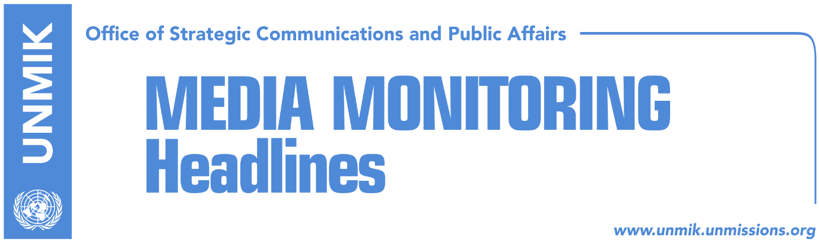

Main Stories 15 September 2017

- Haradinaj tones down on Association/Community (Koha)
- Eichhorst: EU supports current border demarcation agreement (Zeri)
- Thaci: Unity team for dialogue with Serbia (Zeri)
- Haradinaj: No official information that Rikalo mistreated citizens (media)
- Online petition launched calling for Rikalo’s dismissal (Koha)
- LDK MP Osmani: What Haradinaj is doing is shameful (Bota Sot)
- Koci: Rikalo was a close associate of Albin Kurti (media)

Kosovo Media Highlights

Haradinaj tones down on Association/Community (Koha)
The paper reports on its front page that it remains unclear what path newly-elect Prime Minister Ramush Haradinaj will choose for the Association/Community of Serb-majority municipalities. The new government did not say whether it will annul the Brussels agreement on the Association; the Constitutional Court of Kosovo found 23 violations in the agreement. Arber Vllahiu, political advisor to Haradinaj told the paper on Thursday that all actions on the matter will be in accordance with the Constitution, laws and the decision of the Constitutional Court. “Prime Minister Haradinaj’s focus however at this point is on the government program, to start implementing decisions related to problems with the Kosovo Power Corporation and institutional consolidation,” he added. The paper notes that the government program entitled “The program principles of the Government of the Republic of Kosovo 2017 – 2021” talks in general terms about topics that Haradinaj will address, but it does not mention the Association/Community of Serb-majority municipalities. The paper recalls that while he was in opposition, Haradinaj had called for the annulment of the agreement and to start the whole process from scratch.

Eichhorst: EU supports current border demarcation agreement (Zeri)
The Director for Western Europe, Western Balkans and Turkey at the European External Action Service, Angelina Eichhorst, said yesterday in Pristina that the EU supports the current border demarcation agreement between Kosovo and Montenegro. “You know our position, it has not changed. We consider important for the agreement to be ratified at the Assembly,” Eichhorst said.

Thaci: Unity team for dialogue with Serbia (Zeri)
President of Kosovo, Hashim Thaci, said in a conference organised by the Kosovo Democratic Institute (KDI) that he plans to set up a “unity team” to represent Kosovo in what he said is the final stage of dialogue with Serbia. “The unity team will consist from the presidency, the government, the assembly including all political parties, but there will also be representatives of the civil society, the media, academia, and whoever can contribute to this political process,” Thaci said. He expressed belief that the ultimate outcome of talks will be “a new quality of relations between Kosovo and Serbia.”

Haradinaj: No official information that Rikalo mistreated citizens (media)
Kosovo Prime Minister, Ramush Haradinaj, said on Thursday that there is no official information into allegations by some citizens of Pristina that they were mistreated by now Agriculture Minister, Nenad Rikalo, during the 1998-99 conflict. Haradinaj said in a press release that he requested information from the State Prosecution, the Kosovo Intelligence Agency and Police, about allegations that Rikalo was involved in the mistreatment of citizens. “From the responses I received, through official channels, from these three state institutions, there is no information that he [Rikalo] was involved in such activities,” Haradinaj said.

Online petition launched calling for Rikalo’s dismissal (Koha)
An online petition has been launched calling for the dismissal of the Minister of Agriculture, Forestry and Rural Development, Nenad Rikalo, after he was accused by his former neighbours in Pristina of being part of Serb paramilitary troops. The petition was launched by Rrezeart Galica, artist, and states that Rikalo’s presence at the government is a direct insult to the people of Kosovo and calls on the prosecution to urgently investigate allegations against Rikalo.

LDK MP Osmani: What Haradinaj is doing is shameful (Bota Sot)
Vjosa Osmani, MP from the Democratic League of Kosovo (LDK), slammed the “hastiness” of the Kosovo government to declare that the Minister of Agriculture from the Serbian List, Nenad Rikalo. Osmani questioned the way the government managed to verify Rikalo’s past without investigating allegations against him or interviewing witnesses who claim he was part of Serb paramilitary units and participated in mistreatment of a couple of students in Pristina during the 1998-99 conflict. “This is shameful to the victims and unforgivable for institutions of Kosovo,” Osmani wrote saying that the least PM Ramush Haradinaj should have done was to suspend Rikalo until all allegations against him were investigated.

Koci: Rikalo was a close associate of Albin Kurti (media)
Several news websites report that Gani Koci, member of the Democratic Party of Kosovo (PDK) and former Deputy Minister for Economic Development, claimed on Thursday that Nenad Rikalo, Minister for Agriculture, was a close associate of Vetevendosje’s Albin Kurti. Rikalo is accused by some citizens of Pristina for taking part in the mistreatment of Albanians during the 1998-99 conflict. Koci posted on his Facebook account: “Nenad Rikalo, Albin Kurti and Shkelzen Gashi were the founders of the KAN movement which later transformed into the Vetevendosje Movement. Everything will be revealed soon”.

Disclaimer
This media summary consists of selected local media articles for the information of UN personnel. The public distribution of this media summary is a courtesy service extended by UNMIK on the understanding that the choice of articles translated is exclusive, and the contents do not represent anything other than a selection of articles likely to be of interest to a United Nations readership. The inclusion of articles in this summary does not imply endorsement by UNMIK.

