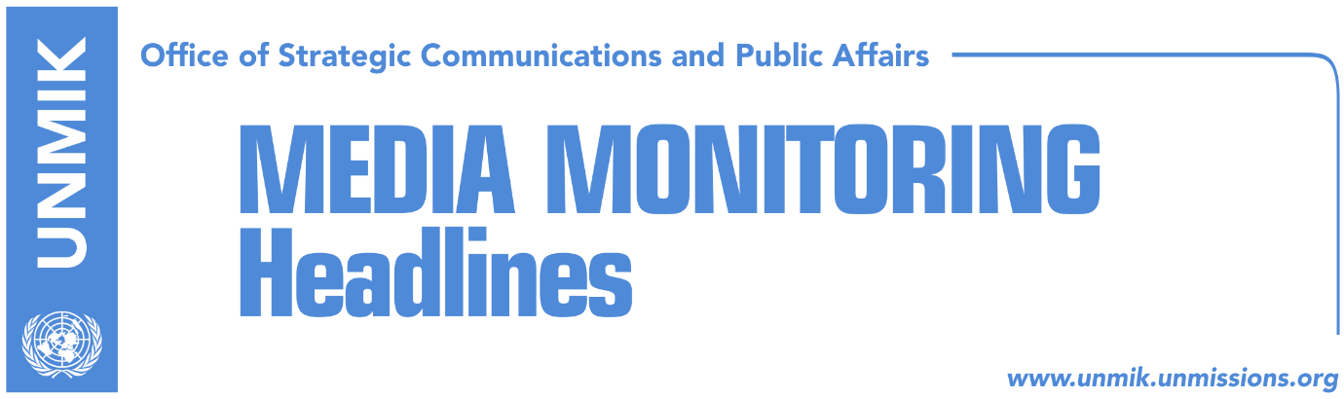

Main Stories 18 September 2017

- Government undecided how to proceed with Kosovo army issue (Koha Ditore)
- NATO: Kosovo army in line with Constitution (Zeri)
- Montenegro not expected to be willing to renegotiate border deal (Zeri)
- Kosovo government slams Serbia’s UNESCO documentary (Epoka e Re)
- Serbian List supports its minister, Rikalo (RTK)

Kosovo Media Highlights

Government undecided how to proceed with Kosovo army issue (Koha Ditore)
Although transformation of the Kosovo Security Force (KSF) into a Kosovo army has been acknowledged as one of the top priorities for the Ramush Haradinaj-led government, his cabinet did not say what will be the path they will pursue to achieve this objective. Government spokesperson, Arber Vllahiu, said armed forces will be set up in accordance with the Constitution of Kosovo and through inter-institutional and international cooperation without specifying what actions the government plans to take to secure the support from the Serbian List.

NATO: Kosovo army in line with Constitution (Zeri)
Chairman of the NATO Military Committee, General Petr Pavel, said Kosovo army should be established in accordance to Kosovo’s Constitution and applicable legislation. “We are not saying Kosovo has no right to an army but it has to be in line with constitutional timeframes and obligations,” General Pavel said.

Montenegro not expected to be willing to renegotiate border deal (Zeri)
Montenegro is not expected to show readiness to renegotiate the border demarcation agreement with Kosovo, the paper quotes experts as saying. Geography professor, Florim Isufi, said Montenegro considers the border to be a closed issue and that what Kosovo right now needs a “coolheaded” person to gather the best experts and review the current agreement. However, Isufi added that he was not yet sure what will be the mandate of the commission on border demarcation recently set up by Prime Minister Ramush Haradinaj and whether it will only review the agreement or even propose a new document.

Kosovo government slams Serbia’s UNESCO documentary (Epoka e Re)
The government of Kosovo has condemned Serbia’s campaign to prevent it from joining UNESCO. In a statement, the government said the documentary film produced by Serbia and aired to ambassadors of UNESCO member states in Paris is an attempt to “denigrate” Kosovo and “appropriate” its cultural heritage. Furthermore, such a move is against the principles of the process for normalization of relations, the Kosovo government said adding: “Kosovo’s efforts to be part of international organisations, including UNESCO, are legitimate and the state of Kosovo will continue to fulfill its requirements in line with its international legitimacy recognised by more than 110 world countries and with the International Court of Justice ruling.”

Serbian List supports its minister, Rikalo (RTK)
Serbian List has rejected allegations against Minister of Agriculture, Forestry and Rural Development, Nenad Rikalo, of being part of Serb paramilitary units saying they were “ungrounded” and “condemnable.” The Serbian List said such attacks instigated by “opposition parties” damage interethnic trust and stability in Kosovo.

Disclaimer
This media summary consists of selected local media articles for the information of UN personnel. The public distribution of this media summary is a courtesy service extended by UNMIK on the understanding that the choice of articles translated is exclusive, and the contents do not represent anything other than a selection of articles likely to be of interest to a United Nations readership. The inclusion of articles in this summary does not imply endorsement by UNMIK.

