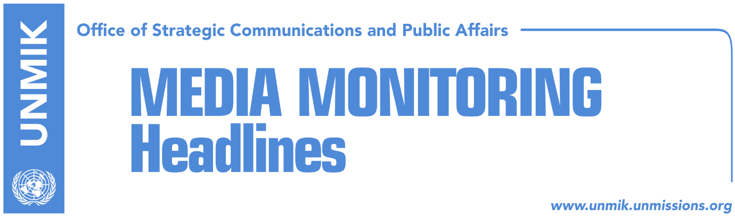

Main Stories 19 September 2017

- Haradinaj government adopts program for 2017-2021 (media)
- Haradinaj: Border demarcation will not remain unresolved (Klan Kosova/RFE)
- Brnabic: I would meet Haradinaj if necessary (Lajmi)
- EU leaves Association/Community to Kosovo and Serbia (Kosova Sot)
- Thaci expects to meet U.S. President Trump during NY visit (media)
- Hoxhaj: On capital issues, PDK seeks national consensus (Zeri)
- Hoti: Unity team idea for dialogue with Serbia, pointless (Koha)
- France supports Kosovo Armed Forces (Zeri)
- Pacolli: I did not say Albanians committed war crimes (Zeri)

Kosovo Media Highlights

Haradinaj government adopts program for 2017-2021 (media)
Most media report that the Haradinaj-led government adopted on Monday its program for the 2017-2021 period. Koha Ditore reports on its front page that among the points listed in the government program are the formation of the Association/Community of Serb-majority municipalities according to the Brussels Agreement, the transformation of the Kosovo Security Force into the Kosovo Armed Forces with a law that is expected to be adopted in November, a 5-7 percent economic growth, the formation of the National Bureau of Investigations and a new vetting process. The program has three main pillars: the rule of law, economic development and employment and foreign policies and Euro-Atlantic integration. The paper quotes Prime Minister Ramush Haradinaj as saying that the program is not final and that it will be complemented following discussions at the Assembly and with other parties involved in the process. All government ministers voted in favor of the program, except for Minister of Agriculture, Nenad Rikalo, who abstained.

Haradinaj: Border demarcation will not remain unresolved (Klan Kosova/RFE)
Prime Minister of Kosovo, Ramush Haradinaj, said in an informal meeting with journalists that the issue of the border demarcation process with Montenegro will not be left unresolved. He said that Montenegro could agree to renegotiate the issue and if no solution is found, the court of arbitration would address it. “This issue will not be left without an epilogue,” Haradinaj said.

Brnabic: I would meet Haradinaj if necessary (Lajmi)
Prime Minister of Serbia, Ana Brnabic, said that if necessary she would agree to meet her Kosovo counterpart, Ramush Haradinaj, but that an imminent meeting between the two has not been scheduled. Brnabic made the statement during an interview to Radio Television of Vojvodina.

EU leaves Association/Community to Kosovo and Serbia (Kosova Sot)
David McAllister, the European Parliament’s Rapporteur on Serbia, said on Monday that negotiations for Serbia’s membership in the European Union require constant movements toward better relations with Kosovo. Asked if the European Union will pressure Pristina into forming the Association/Community of Serb-majority municipalities, McAllister said that the EU will force neither Serbia nor Kosovo to undertake the initiative. “Belgrade and Pristina are talking about future relations and the EU is mediating the process. A sustainable normalization of relations will never be achieved through force but with the consent of all parties involved,” he said.

Thaci expects to meet U.S. President Trump during NY visit (media)
Kosovo’s President Hashim Thaci will head a delegation that will follow the 72nd session of the United Nations General Assembly in New York. A press release issued by the Office of the President notes that Thaci is scheduled to have a brief meeting with United States President, Donald Trump. Koha Ditore notes that Kosovo is not a member of the United Nations and therefore Thaci is not entitled to speak at the General Assembly. Thaci however said he will use the opportunity to lobby for more recognitions for Kosovo’s independence.

Hoxhaj: On capital issues, PDK seeks national consensus (Zeri)
Kosovo’s Deputy Prime Minister, Enver Hoxhaj, told RTV Dukagjini on Monday that the Democratic Party of Kosovo (PDK) will seek national consensus on capital issues such as the transformation of the Kosovo Security Force into the Kosovo Armed Forces, the border demarcation with Montenegro, visa-free travel, the formation of the Association/Community of Serb-majority municipalities, and dialogue with Serbia, which according to Hoxhaj must conclude with Kosovo’s membership in the United Nations or with mutual recognition and historic reconciliation. “I have no will to come out against the world and am not doing this for the sake of opposing everyone but someone has made a mistake in the past,” said Haradinaj speaking about his decision to dismiss the government’s commission on border demarcation and appoint a new one instead.

Hoti: Unity team idea for dialogue with Serbia, pointless (Koha)
Head of the Democratic League of Kosovo (LDK) parliamentary group, Avdullah Hoti, said President Hashim Thaci’s proposal to set up a so-called unity team for dialogue with Serbia is pointless as Kosovo recently elected its institutions and representatives. “This is 2017 and it would be pointless to seek a Unity Team because this is why elections are held: to elect a parliament, a government and country institutions which should assume responsibility for all Kosovo state affairs,” Hoti said.

France supports Kosovo Armed Forces (Zeri)
The paper runs a front-page interview with the French Ambassador to Kosovo, Didier Chabert, quoting him as saying that Kosovo is an independent and sovereign state and that it is entitled to have its armed forces. Chabert also said that this process should happen at the right time, while taking account the sensitivity of the whole Kosovo society, and to make sure that the armed force will be multiethnic and accepted by all parts of society. He also added that such a decision must be coordinated with NATO and Kosovo’s allies.

Pacolli: I did not say Albanians committed war crimes (Zeri)
Kosovo’s Ministry of Foreign Affairs issued a press release on Monday clarifying Foreign Minister Behxhet Pacolli’s remarks during an interview to SRF. The statement said the interview covered in the local media had some inaccuracies as Pacolli never said that Albanians had committed war crimes.

Disclaimer
This media summary consists of selected local media articles for the information of UN personnel. The public distribution of this media summary is a courtesy service extended by UNMIK on the understanding that the choice of articles translated is exclusive, and the contents do not represent anything other than a selection of articles likely to be of interest to a United Nations readership. The inclusion of articles in this summary does not imply endorsement by UNMIK.

