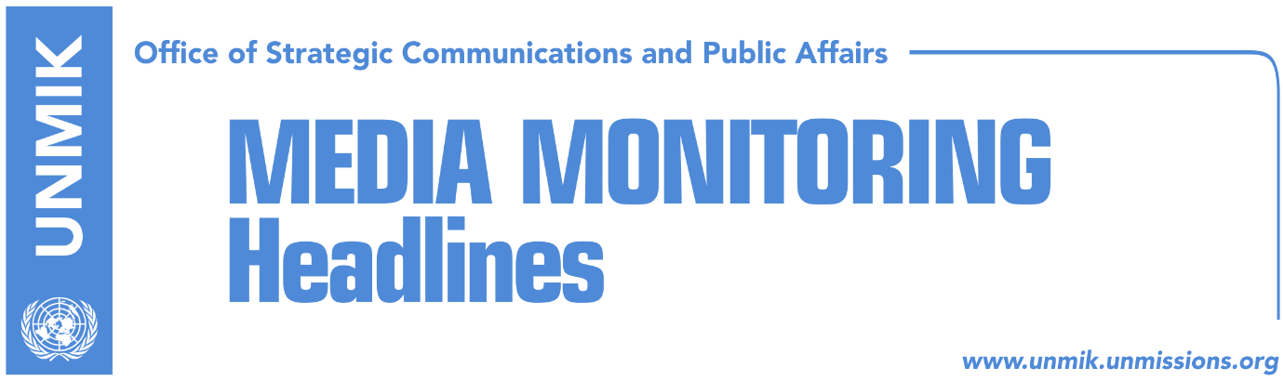

Main Stories 20 September 2017

- Delays in integration of courts in the north could destabilize situation (Koha)
- President of Kosovo to be at forefront of dialogue with Serbia (Koha Ditore)
- President Thaci begins meeting foreign officials in New York (dailies)
- Police launch investigation into allegations against Rikalo (Koha)
- Lekaj: No conditioning from Serbian List on Kosovo army (RTK)
- EU invests €1.2 million in the north (Zeri)

Kosovo Media Highlights

Delays in integration of courts in the north could destabilize situation (Koha)
Albanian and Serb judges and prosecutors warned in a debate held in Mitrovica that delays in implementation of the justice agreement for the north of Kosovo could lead to the deterioration of the security situation, the paper reports on the front page. Following the expiration of several deadlines, the parties have now agreed to begin implementation process on 17 October but apart from the date, Serb judges have no additional information about what lies ahead. “We still do not know whether we are Serbia’s or Kosovo’s judges. This issue cannot be defined through a regulation unless the legislation is changed,” said Jelena Krivokapic, judge from the Basic Court in Mitrovica.

President of Kosovo to be at forefront of dialogue with Serbia (Koha Ditore)
The paper reports that Prime Minister of Kosovo, Ramush Haradinaj, has agreed for Kosovo President Hashim Thaci to be at the forefront of dialogue for normalization of relations with Serbia. Kosovo government has not appointed any minister for dialogue this time around and its coordinator for dialogue, Blerim Shala, is now reported to have been hired by Thaci in the capacity of advisor for dialogue with Serbia. However, in a written response to the paper, the Office of the Prime Minister said that both the president and the government will be engaged in the process of dialogue, “depending on the topics discussed.”

President Thaci begins meeting foreign officials in New York (dailies)
President of Kosovo, Hashim Thaci, met UK’s Foreign Secretary, Boris Johnson, at the margins of the UN General Assembly. In a Facebook post, Thaci said that he received confirmation of UK’s full support for Kosovo’s consolidation, its Euro-Atlantic perspective, and the dialogue for normalization of relations with Serbia. President Thaci and Foreign Minister Behgjet Pacolli also met in New York the President of the European Council, Donald Tusk. Thaci said Kosovo remains committed in its European integration path and has made important steps to join the European family. “Kosovo’s integration into European Union needs to be stepped up with concrete actions. It is vital for our country and the whole region to have the EU remain engaged in the Western Balkans,” Thaci said. Furthermore, Thaci also met Turkish President Recep Tayyip Erdogan. “Turkey has been an important strategic partner in our efforts to obtain recognition in world stage,” Thaci tweeted after the meeting.

Police launch investigation into allegations against Rikalo (Koha)
The paper reports that the Kosovo Police have launched an investigation into allegations against the Minister of Agriculture, Forestry and Rural Development, Nenad Rikalo, that he was part of Serb paramilitary units during the Kosovo conflict. While the Kosovo Police have not confirmed the start of investigation, KTV reported that one of the key witnesses in the case surrounding Rikalo has already been interviewed by the police. The witness, a former neighbour of Rikalo, said he gave a three-hour testimony to the police.

Lekaj: No conditioning from Serbian List on Kosovo army (RTK)
Minister of Infrastructure, Pal Lekaj, said that the Serbian List has presented no conditions in exchange for its support to the establishment of a Kosovo army. “I assure the citizens of Kosovo that we would not enter into any coalition that would damage the state of Kosovo,” Lekaj said.

EU invests €1.2 million in the north (Zeri)
The Head of the EU Office in Kosovo and Special Representative, Nataliya Apostolova, inaugurated yesterday three projects in the north of Kosovo worth €1.2 million. “I am very happy to see that EU funds, taxpayers’ money from member states, improve the lives of the people,” Apostolova said.

Disclaimer
This media summary consists of selected local media articles for the information of UN personnel. The public distribution of this media summary is a courtesy service extended by UNMIK on the understanding that the choice of articles translated is exclusive, and the contents do not represent anything other than a selection of articles likely to be of interest to a United Nations readership. The inclusion of articles in this summary does not imply endorsement by UNMIK.

