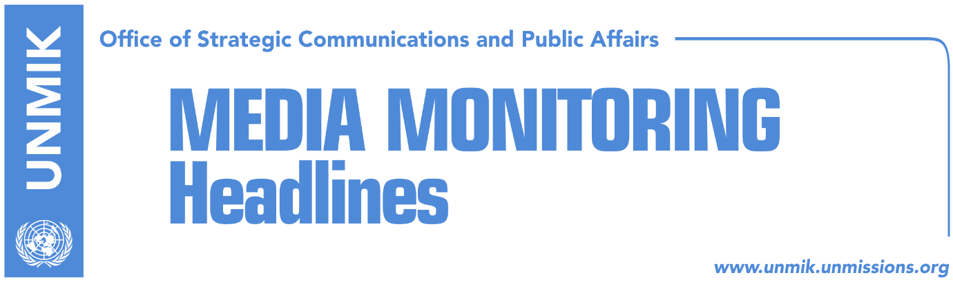

Main Stories 25 September 2017

- Pacolli: UNMIK to be transformed into a UN political office (Kosovapress)
- Powerful lobbying in New York (Epoka)
- Albanian PM calls for Kosovo recognition and UN membership (Koha)
- Serbian paper “reveals” Vucic-Pacolli conversation at UN (Koha)
- Haradinaj: Issue of missing persons requires urgent epilogue (media)
- Jevtic: Association/Community will be formed in 2018 (media)
- Tahiri: Brussels agreement on judiciary will be implemented soon (Epoka)
- Kosovo ready to accept decisions of parallel courts (Koha)
- Analysts: Incapacity of Kosovo institutions to join Interpol (Zeri)
- Former EULEX prosecutor Bamieh under investigation (Bota Sot)

Kosovo Media Highlights

Pacolli: UNMIK to be transformed into a UN political office (Kosovapress)
Kosovo’s Deputy Prime Minister and Foreign Minister, Behgjet Pacolli, said the Kosovo delegation met in New York the President of the UN General Assembly, Miroslav Lajcak, and said it was time for the UN Security Council to consider transformation of UNMIK into a UN political office. In a Facebook post, Pacolli said a political office would assist Kosovo in achieving aspirations to join the UN. “We also asked for the present format of discussions on Kosovo to change and the sessions of the Security Council reduce from four to one or two a year and take place in a closed environment,” Pacolli said.

Powerful lobbying in New York (Epoka)
The President of Kosovo, Hashim Thaci and Principal Deputy of the Prime Minister of Kosovo, Behgjet Pacolli, are meeting in New York with many world leaders of the countries that have and have not recognized Kosovo. During these meetings they requested support for consolidation of the position of Kosovo in the global political scene, new recognitions and membership at significant international organisations. Pacolli met with more than 20 state representatives. During the last day of his visit to New York, Pacolli met with his Armenian counterpart Eduard Nalbandyan. On the closure of his visit, Pacolli expressed optimism that Kosovo will very soon become member state of the United Nations.

Albanian PM calls for Kosovo recognition and UN membership (Koha)
Albanian Prime Minister Edi Rama, during his meeting with the United Nations Secretary General Antonio Guterres, talked about Kosovo’s membership of the UNESCO and other international organizations, the paper reports. Rama said Kosovo’s recognition by all countries would directly contribute to the security and stability of the whole region.

Serbian paper “reveals” Vucic-Pacolli conversation at UN (Koha)
The paper quotes an article published in the Belgrade-based Blic daily about an accidental meeting between the Kosovo and Serbian delegations at the United Nations Headquarters in New York. Serbian President Aleksandar Vucic reportedly ran into Kosovo President Hashim Thaci and Deputy Prime Minister Behgjet Pacolli. Vucic, according to the article, asked Pacolli where he found the alleged votes for Kosovo’s membership of UNESCO. “You lost once and you will lose again,” Vucic reportedly told Pacolli.

Haradinaj: Issue of missing persons requires urgent epilogue (media)
The Prime Minister of Kosovo, Ramush Haradinaj, met with the head of the delegation for talks on missing persons, Ibrahim Makolli. Haradinaj expressed his interest to receive from Makolli the most recent information on the flow of these discussions and on what are the urgent matters required to address with regards to this painful issue for Kosovo’s society, in order to reach the epilogue. Makolli on the other hand requested undertaking of immediate steps to replace the UNMIK representative with an EU one.

Jevtic: Association/Community will be formed in 2018 (media)
Kosovo’s Deputy Prime Minister, Dalibor Jevtic, told Belgrade-based TV Pink that the Association/Community of Serb-majority municipalities has been included for the first time in the program of the Kosovo Government. Jevtic, who is also Minister for Returns and Communities, said the Serbian List joined the Kosovo Government in order to resolve the problems of Serbs living in Kosovo. He said the Association/Community will be established in line with the Brussels agreement. “The plan is next year to start with concrete steps, to draft the statute and for the Association/Community to be formed in 2018,” Jevtic said.

Tahiri: Brussels agreement on judiciary will be implemented soon (Epoka)
Kosovo’s Minister of Justice, Abelard Tahiri, said on Sunday that the Brussels agreement on the judiciary will be implemented soon. Tahiri posted on Facebook on Sunday saying that one of the biggest challenges after the declaration of independence was to wield Kosovo’s sovereignty and integrity especially in the northern part of the country. “The Brussels agreement on the judiciary will be implemented soon and in addition to police and prosecution, judges too will soon start their work in the courts in the north so that Kosovo’s citizens can have access to the judicial system in accordance with Kosovo’s laws and legal order. The implementation of this agreement is a very important step and it will end every foreign interference in our judicial system,” Tahiri wrote.

Kosovo ready to accept decisions of parallel courts (Koha)
The paper reports on its front page that decisions taken by Serb parallel courts since 1999, which were so far considered illegal, will not be rejected automatically. A special committee, consisting of Serbs and Albanians, will be set up to verify these decisions. Government officials, involved in the Brussels dialogue, have kept secret the formation of the committee and have not said what will happen with decisions issued by the parallel courts after February 2008, when Kosovo declared independence. Jelena Krivokapic, a judge with the Basic Court in Mitrovica North, said they were told that decisions issued after 1999 will be accepted but she said she was skeptical that this process could be automatic.

Analysts: Incapacity of Kosovo institutions to join Interpol (Zeri)
Kosovo government’s decision against applying for Interpol membership is seen by analysts as incapacity on the part of Kosovo to join international organizations. International law professor, Afrim Hoti, told the paper that Kosovo’s withdrawal from Interpol membership bid can produce negative effects but that it was the right decision under the present circumstances. At the same time, Artan Murati from the Kosovo Democratic Institute (KDI) said although it was too soon to talk about the performance of the new Kosovo government, withdrawal from Interpol application is an indicator of institutions “incapacity” to deal with the issue of international organization membership. Kosovo’s former interior minister, Skender Hyseni, said Kosovo did have the necessary votes to join Interpol and that the decision to back down has “extremely damaged” Kosovo’s vote next time around.

Former EULEX prosecutor Bamieh under investigation (Bota Sot)
Basic Prosecution in Pristina is reported to be heading an investigation against the former EULEX prosecutor and whistleblower, Marie Bamieh, on suspicion of abuse of official position. Lawyer Besnik Berisha confirmed that Bamieh was under investigation in a case involving former Kosovo government officials, Ilir Tolaj and Bujar Bukoshi.

Disclaimer
This media summary consists of selected local media articles for the information of UN personnel. The public distribution of this media summary is a courtesy service extended by UNMIK on the understanding that the choice of articles translated is exclusive, and the contents do not represent anything other than a selection of articles likely to be of interest to a United Nations readership. The inclusion of articles in this summary does not imply endorsement by UNMIK.

