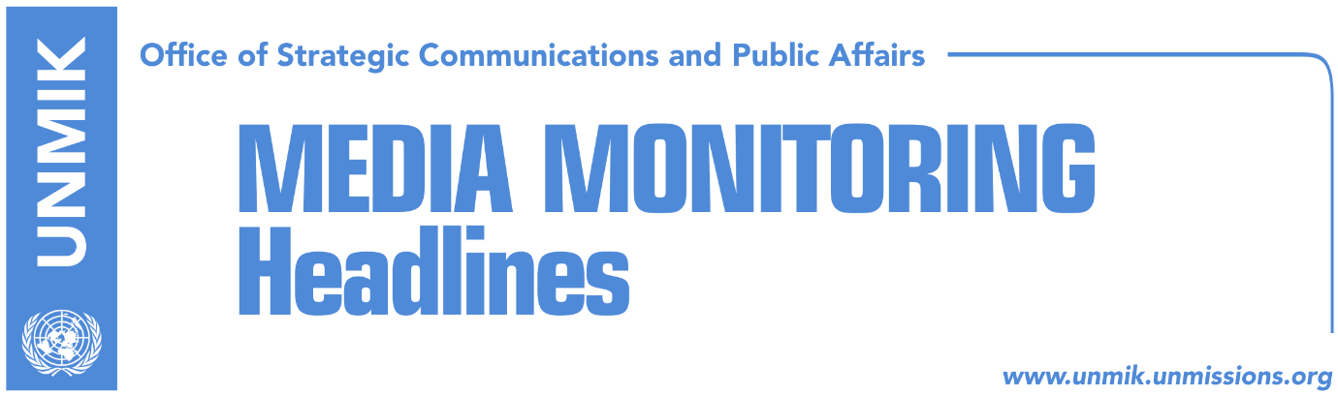

Main Stories 26 September 2017

- Montenegro: Demarcation is a finished process (Koha)
- Border demarcation commission waiting for government’s guidance (RFE/Zeri)
- Haradinaj insists: The border is in Cakorr and Kulle (media)
- Haradinaj: Kosovo has been damaged in dialogue (RTK)
- President Thaci will resubmit draft law on army to Assembly (Koha)
- “Special court to issue first indictments in December” (Zeri)
- Pacolli to visit Brussels, meet with Hahn and Mogherini (media)

Kosovo Media Highlights

Montenegro: Demarcation is a finished process (Koha)
Kosovo’s Foreign Minister, Behgjet Pacolli, will visit Montenegro today where he will meet senior government officials to discuss the agreement on the border delineation, the paper reports on its front page. Pacolli is scheduled to meet his Montenegrin counterpart, Srdjan Darmanovic, Deputy Prime Minister and Minister of Justice Zoran Pazin, Assembly President Ivan Brajovic and President Filip Vujanovic. Pacolli will also meet leaders of Albanian political parties in Montenegro. According to the paper, Pacolli’s visit is not expected to change Montenegro’s position on the border demarcation agreement. Meanwhile, officials from the Office of Prime Minister Ramush Haradinaj did not rule out a visit by Haradinaj to Podgorica in the near future. “The Republic of Kosovo and Montenegro have very good relations and in this respect Prime Minister Haradinaj could visit Podgorica in the near future,” Haradinaj’s office told the paper. Asked if Haradinaj informed his Montenegrin counterpart about the formation of a new comission on border demarcation, Haradinaj’s office replied: “The Republic of Kosovo is a sovereign state and it is not obliged to notify other countries in the region about its internal processes. We assume that given that the border demarcation agreement with Montenegro has not been ratified by the Kosovo Assembly, Podgorica is aware of the process”. The paper recalls an earlier statement by Montenegro’s Foreign Minister, Darmanovic, who said that for Montenegro the border delineation with Kosovo is a finished process.

Border demarcation commission waiting for government’s guidance (RFE/Zeri)
The chairman of the Kosovo government’s commission on border demarcation with Montenegro, Shpejtim Bulliqi, said they are waiting to be issued with competencies by the government in order to begin work on analyzing the current demarcation agreement. “You are aware that the previous commission prepared a report and if the government expects us to take that report, analyse it and draw our conclusions, we need this request to be presented to us in an official manner,” Bulliqi said. Meanwhile, Halil Matoshi from PM Ramush Haradinaj’s press office said that they are looking into all modalities to determine the future course of action but stressed that “the process will not be prolonged.”

Haradinaj insists: The border is in Cakorr and Kulle (media)
Kosovo’s Prime Minister, Ramush Haradinaj, said on Monday that the border between Kosovo and Montenegro is in Cakorr and Kulle. In an interview to RTK, Haradinaj also said that he does not want to be an obstacle to the visa liberalization process for Kosovo and that he hopes that the demarcation issue will be resolved soon.

Haradinaj: Kosovo has been damaged in dialogue (RTK)
In an interview to RTK, Prime Minister of Kosovo Ramush Haradinaj, said there needs to be an ongoing internal discussion in Kosovo on the issue of dialogue with Serbia and that Kosovo was damaged in the process considering that Serbia moved forward in its EU integration path thanks to the dialogue while Kosovo’s progress stalled. “There can be no dialogue with one country moving forward and the other one stalling,” Haradinaj said. Asked about Interpol’s membership bid and the decision to postpone application, Haradinaj said that Kosovo had an inter-ministerial task force for all major issues but had none for Interpol and there was no coordination of actions between the relevant institutions.

President Thaci will resubmit draft law on army to Assembly (Koha)
Kosovo President Hashim Thaci will resubmit to the Assembly, within a three-month period, the draft law for the transformation of the Kosovo Security Force into the Kosovo Army, if Serbs continue to block the implementation of the process through constitutional amendments. Bekim Collaku, chief of staff and chief advisor to President Thaci, said the legal initiative for the army was interrupted in order to give one final chance to all stakeholders, especially the Serb community in Kosovo, to join the process, in hope that Serb MPs will agree to vote in favor of constitutional amendments for the formation of the Kosovo Army. Collaku told the paper: “We are currently implementing the plan prepared by the Office of the President and in this respect we will intensify our actions in the coming weeks. We will have to wait and see if serious efforts by Kosovo’s institutions to convince Serb MPs will be successful. We are going to be serious, pragmatic and ready to address the rational demands of Kosovo Serb political representatives in exchange for their support to form the Kosovo Army through constitutional amendments”.

“Special court to issue first indictments in December” (Zeri)
Specialist chambers are expected to issue the first indictments against former Kosovo Liberation Army (KLA) leaders in December, the paper reports quoting sources. A group of prosecutors is going to visit Kosovo on November to interview some of the suspects, the sources added. Officials at the Specialist Chambers did not provide any detail on the timing of the upcoming indictments but noted that the court is fully functional and is ready to receive indictments from the prosecution.

Pacolli to visit Brussels, meet with Hahn and Mogherini (media)
Kosovo’s Deputy Prime Minister and Foreign Minister, Behgjet Pacolli, will visit Brussels on Thursday and Friday. According to a press release issued by the EU, Pacolli is scheduled to meet EU Enlargement Commissioner Johannes Hahn and Foreign Policy and Security Chief Federica Mogherini. Talks will focus on Kosovo’s European agenda, the implementation of the Stabilization/Association Agreement, visa liberalization for Kosovo, regional integration and EU-brokered dialogue with Serbia.

Disclaimer
This media summary consists of selected local media articles for the information of UN personnel. The public distribution of this media summary is a courtesy service extended by UNMIK on the understanding that the choice of articles translated is exclusive, and the contents do not represent anything other than a selection of articles likely to be of interest to a United Nations readership. The inclusion of articles in this summary does not imply endorsement by UNMIK.

