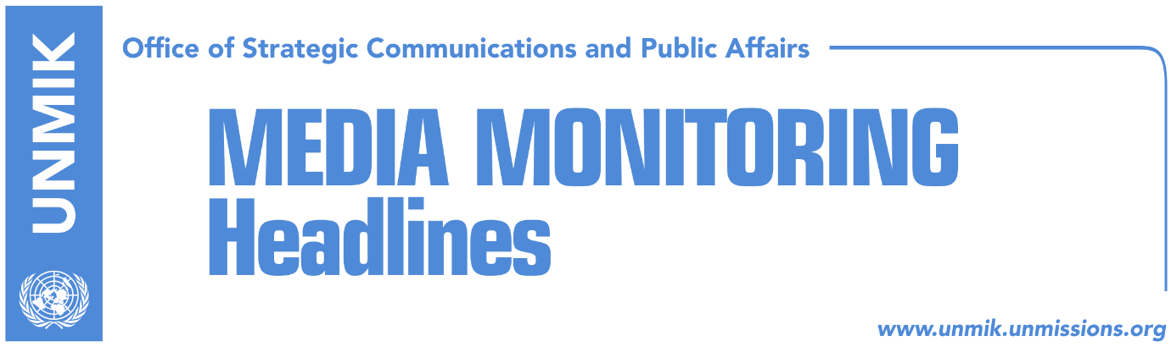

Main Stories 28 September 2017

- Hoxhaj indicates turning point in dialogue with Serbia (media)
- O’Connell: Supreme Court enabled “criminals” to run for election (Zeri)
- Justice Minister Tahiri supports current border demarcation agreement (Koha)
- KSF Minister Berisha meets COMKFOR Major General Fungo (Zeri)
- Kosovo fails to meet 22 priorities agreed upon with EU in 2016 (Koha)

Kosovo Media Highlights

Hoxhaj indicates turning point in dialogue with Serbia (media)
Several media cover an interview that Kosovo’s Deputy Prime Minister Enver Hoxhaj gave to Austrian newspaper Wiener Zeitung highlighting his remark that 2018 could mark a turning point in dialogue between Kosovo and Serbia. Hoxhaj said he does not expect meetings between the two sides this year. He also said there could be no reconciliation between Kosovo and Serbia without mutual recognitions. “It would be naïve to believe that without mutual recognitions there can be a reconciliation process between Kosovo and Serbia. There are many examples in European history that show that first political agendas must be changed by countries that have brought about conflict,” he added. Asked to comment on Serbian President Aleksandar Vucic’s initiative for internal dialogue on Kosovo, Hoxhaj said: “what President Vucic did was right and necessary. We are trying to understand the direction he wants to go. It is clear to us that Kosovo is not the top issue in Serbia, it is neither the second, the third nor the tenth most important issue. But even if it is the thirteenth most important political issue, it is up to the politicians to find a solution. At the same time, we need social dialogue”.

O’Connell: No arbitrage on demarcation without Montenegro’s consent (RTK)
The Ambassador of the United Kingdom to Kosovo, Ruairi O’Connell said that Montenegro cannot be obliged to send for arbitrage the agreement on border demarcation with Kosovo. Responding to questions of Kosovo people Kosovo on Facebook, O’Connell stressed that “the demarcation issue is a bilateral matter between Kosovo and Montenegro. And it is the Schengen group not the European Union that has set it as a condition for visa liberalization. Britain is not part of Schengen, but when someone sets a technical process in order to reach something, I think that the best reaction is fulfillment of those conditions.
As far as arbitrage is concerned, let us understand that it is not something that can be requested or obliged to Montenegro. They have signed the agreement with Kosovo and each international technical assessment claimed that there were no mistakes,” O’Connell wrote.

Justice Minister Tahiri supports current border demarcation agreement (Koha)
Kosovo’s Minister of Justice, Abelard Tahiri, said in an interview to KTV that he believed in the accuracy of the border demarcation agreement with Montenegro signed by his former employer, Hashim Thaci. Tahiri said Prime Minister Ramush Haradinaj “acted hastily” by dismissing the border demarcation commission and that he should have consulted the legal office prior to the decision.

KSF Minister Berisha meets COMKFOR Major General Fungo (Zeri)
For the first time since taking on the new post, Minister of the Kosovo Security Force, Rrustem Berisha, met KFOR Commander, Major General Giovanni Fungo, and apart from discussing the security situation in Kosovo and cooperation between KSF and KFOR, the two also talked about the transformation of the KSF into an armed force. Berisha assured KFOR commander that KSF will be transformed in full consensus between the internal factor and in coordination with strategic partners.

O’Connell: Supreme Court enabled “criminals” to run for election (Zeri)
The British Ambassador to Kosovo, Ruairi O’Connell, said during a live conversation on Facebook with the people of Kosovo that the ruling of the Supreme Court to overturn a previous decision of the Central Election Commission (CEC) has enabled “criminals” to run for office in local elections. “It was a bit surprising as the law was clear in it that anyone convicted of a crime is not allowed to run in elections,” O’Connell said.

Kosovo fails to meet 22 priorities agreed upon with EU in 2016 (Koha)
The paper reports on its front page that in May last year, former Kosovo Prime Minister Isa Mustafa and EU Enlargement Commissioner Stefan Hahn agreed on the European Reforms Agenda (ERA) for Kosovo. They had listed 22 priorities in the areas of good governance and rule of law, competitiveness and the investment climate, as well as education and employment. Except for one priority, all other priorities were planned to be implemented in 2016 and 2017. Kosovo is failing to meet the timelines and the new government has given no signs that it will intensify the implementation of these priorities. Dhurata Hoxha, Kosovo’s Minister for European Integration, did not say if the new government will work with a faster pace to address the issues foreseen by ERA, but did say that they need to be given priority. “ERA foresees the implementation of 22 concrete priorities by a number of institutions. I will undertake all measures to ensure that all institutions are aware of their priorities and to support the Ministry of European Integration in this process,” Hoxha said. “I believe priority should be given to reforms in the areas of rule of law, approximation with the Acquis Communitaire, the implementation of laws, the business climate, protecting competitiveness, promoting education and employment policies and regional cooperation”.

Disclaimer
This media summary consists of selected local media articles for the information of UN personnel. The public distribution of this media summary is a courtesy service extended by UNMIK on the understanding that the choice of articles translated is exclusive, and the contents do not represent anything other than a selection of articles likely to be of interest to a United Nations readership. The inclusion of articles in this summary does not imply endorsement by UNMIK.

