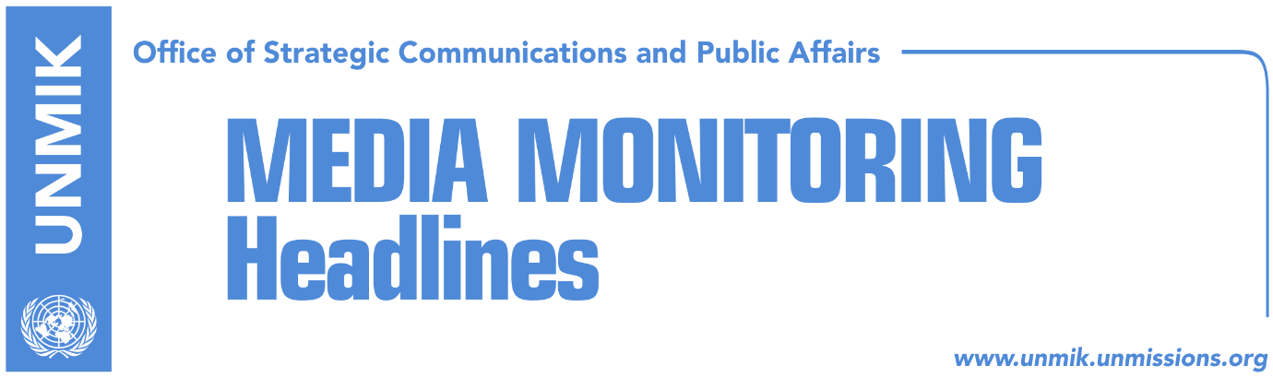

Main Stories 29 September 2017

- Veseli: European agenda, priority for Kosovo (Zeri)
- Kosovo Assembly to hold sessions on 2, 3 November (Kosovapress)
- EU: Government to annul illegal appointments (Koha Ditore)
- PM Haradinaj to report to Assembly on Minister Rikalo (Bota Sot/Koha)
- Pacolli: Citizens will move without visas soon (Epoka)
- “KSF to transform in coordination with NATO” (RTK)
- Over 25,000 observers accredited so far for local elections (Zeri)

Kosovo Media Highlights

Veseli: European agenda, priority for Kosovo (Zeri)
President of the Kosovo Assembly, Kadri Veseli, assured the head of the EU Office in Kosovo and Special Representative, Nataliya Apostolova, that the European agenda remains a priority for Kosovo and that its institutions will implement all necessary criteria to enable free movement for the people of Kosovo. Veseli also assured Apostolova that the agreement on the Instrument for Pre-Accession Assistance (IPA) will be approved by the Assembly in the coming days. Apostolova on her part noted the need for the Kosovo Assembly to give priority to all issues relating to European agenda.

Kosovo Assembly to hold sessions on 2, 3 November (Kosovapress)
President of the Kosovo Assembly, Kadri Veseli, announced that the Assembly will hold two sessions, on 2 and 3 November, to confirm parliamentary groups and to ratify agreement on the Instrument for Pre-Accession Assistance (IPA).

EU: Government to annul illegal appointments (Koha Ditore)
The paper reports on the front page that the EU has asked the government of Kosovo to annul all political appointments to nine public enterprises. This move, according to the EU, would demonstrate the government’s commitment to address difficult reforms as part of the European agenda.

PM Haradinaj to report to Assembly on Minister Rikalo (Bota Sot/Koha)
Prime Minister of Kosovo, Ramush Haradinaj, is expected to report to the Kosovo Assembly on allegations against Minister of Agriculture, Forestry and Rural Development, Nenad Rikalo, that he was involved in Serb paramilitary units during the Kosovo conflict. The request for Haradinaj’s report was submitted by the Democratic League of Kosovo (LDK) parliamentary group and is set to take place on Tuesday, 3 November.

Pacolli: Citizens will move without visas soon (Epoka)
Kosovo’s Minister for Foreign Affairs, Behgjet Pacolli, said on Thursday in Brussels that Kosovo people will be moving within the Schengen zone without visas very soon. Pacolli made this statement after his meeting with the European Parliament MP, and Rapporteur for visa liberalization for Kosovo, Tanja Fajon. Pacolli said that it is unjust for Kosovo to be the only place in Western Balkans that does not have this right and that is being kept isolated.

“KSF to transform in coordination with NATO” (RTK)
During his official visit to Brussels, Kosovo’s Minister for Foreign Affairs, Behgjet Pacolli, met with NATO Deputy Secretary General, Rose Bottemoeller. She expressed interest on the position and approach of Kosovo institutions with regards to the process of the dialogue with Serbia as well as solution for demarcation of the border with Montenegro. Pacolli said that the dialogue should have a clear time frame and expressed conviction that the demarcation matter will be overcome in the best manner, considering the good relations with Montenegro. They also discussed transformation of the Kosovo Security Force into the Armed Forces of Kosovo and agreed that this should happen with complete coordination with NATO.

Over 25,000 observers accredited so far for local elections (Zeri)
Kosovo’s Central Election Commission (CEC) has so far accredited almost 26,000 observers for upcoming local elections. Accredited observers come from different political parties, NGOs, international organizations, and the media. The figure also includes members of the EU Election Observation Mission.

Disclaimer
This media summary consists of selected local media articles for the information of UN personnel. The public distribution of this media summary is a courtesy service extended by UNMIK on the understanding that the choice of articles translated is exclusive, and the contents do not represent anything other than a selection of articles likely to be of interest to a United Nations readership. The inclusion of articles in this summary does not imply endorsement by UNMIK.

