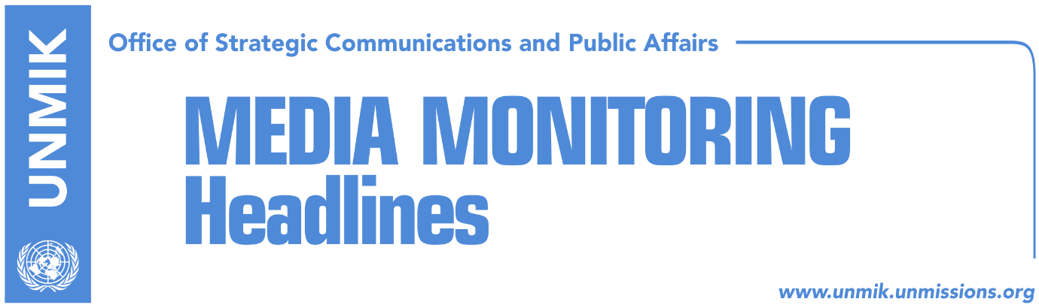

Main Stories 30 September 2017

- Pacolli informs Brussels that demarcation cannot pass right now (Koha)
- Pence supports KSF transformation via constitutional means (RTK)
- Daka: OSCE will be monitoring elections only in the north (Zeri)
- Forum 2015 seeks different dialogue between Pristina and Belgrade (Koha)
- Haradinaj to report on “Rikalo case” (RTK)

Kosovo Media Highlights

Pacolli informs Brussels that demarcation cannot pass right now (Koha)
Kosovo’s Principal Deputy Prime Minister and Minister for Foreign Affairs, Behgjet Pacolli, said after the meeting in Brussels with the EU High Representative for Foreign Affairs and Security Policy/Vice-President of the European Commission, Frederica Mogherini, that he has informed EU officials that currently Kosovo does not have the possibility to ratify the agreement for border demarcation with Montenegro and that it is seeking a different exit strategy from this challenge.
“I had the opportunity to explain to them the realistic situation in Kosovo. I think that I made it clear that demarcation as such, is not expected to be ratified at this and future period. This is clear to everyone today. I stressed this yesterday and today as well,” Pacolli said. He added that he sees possibility to work on a different alternative in order to overcome the problem.
“This challenge should be overcome and we should move forward. If this does not happen, then it would be a big mistake of both, Brussels and Pristina,” Pacolli said.

Pence supports KSF transformation via constitutional means (RTK)
The U.S. Vice President Mike Pence welcomed President of Kosovo Hashim Thaci to the White House on Friday “to reaffirm the United States' support for a sovereign, democratic, and prosperous Kosovo.”
A press release issued by the White House informs that the Vice President expressed appreciation for Thaci's leadership, along with Serbian President Vucic, to advance the EU-facilitated dialogue to normalize relations between Kosovo and Serbia. “The leaders agreed on the importance of advancing reforms to strengthen the rule of law, fight corruption, and boost economic growth. The Vice President expressed support for the transformation of the Kosovo Security Forces via constitutional means and encouraged Kosovo to ratify the border demarcation agreement with Montenegro to resolve this longstanding issue,” reads the press release.
Daka: OSCE will be monitoring elections only in the north (Zeri)
Head of the Central Election Commission (CEC), Valdete Daka, told the paper that the role of the OSCE mission in Kosovo will have a limited role during the local elections of 22 October, being that it will be monitoring elections only in the north of Kosovo. She added that less than 1.9 million people of Kosovo will have the right to vote in these elections. “CEC continues with preparations on organizing the local elections of 22 October. I can say that majority of the phases have concluded or are in conclusion process,” Daka said.

Forum 2015 seeks different dialogue between Pristina and Belgrade (Koha)
Forum 2015 from Kosovo’s foundation for Open Society, held on Friday a round table, where majority of the panelists sought a new process of the dialogue between Pristina and Belgrade.
They requested for the final phase of the dialogue to have principals, a deadline and to be co-mediated by the European Union and the United States of America. According to the participants, the dialogue should conclude with an obligatory agreement for both parties and Serbia should at least accept not to impede Kosovo on assuring the seat at the United Nations.

Haradinaj to report on “Rikalo case” (RTK)
The Prime Minister of Kosovo, Ramush Haradinaj said on Friday that he will participate at the plenary session with regards to the motion called by the Democratic League of Kosovo (LDK) caucus, against the Minister for Agriculture, Forestry and Rural Development, Nenad Rikalo. Haradinaj said that he will present the legal findings of the state prosecution, which confirmed that there is no evidence that would oblige the executive on any action.

Disclaimer
This media summary consists of selected local media articles for the information of UN personnel. The public distribution of this media summary is a courtesy service extended by UNMIK on the understanding that the choice of articles translated is exclusive, and the contents do not represent anything other than a selection of articles likely to be of interest to a United Nations readership. The inclusion of articles in this summary does not imply endorsement by UNMIK.

