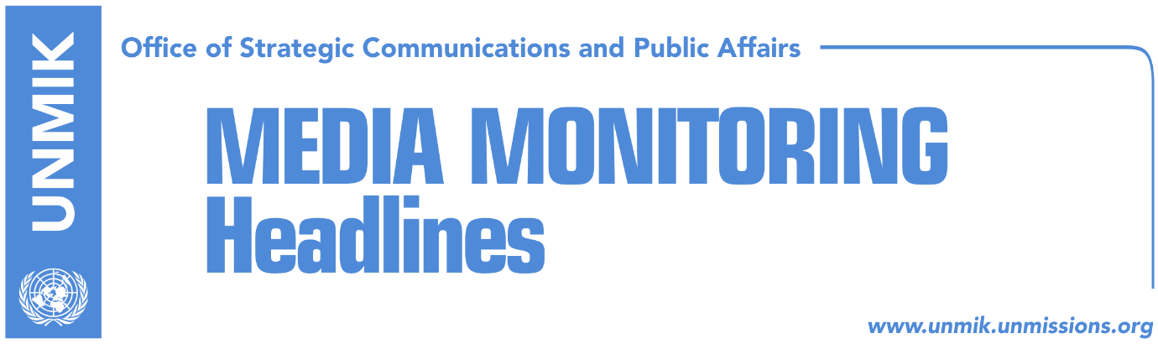

Main Stories 2 October 2017

- Haradinaj: Visa liberalisation, in record time (Zeri)
- FM Pacolli argues for U.S. involvement in dialogue with Serbia (RTK)
- Final phase of dialogue with big compromises (Koha)
- Phillips: Dialogue must result in Kosovo’s recognition by Serbia (Koha)
- “Government changes position on missing persons issue” (Koha)
- Vetevendosje MP Krasniqi released from detention (media)
- “UNMIK heading towards end of mission” (Bota Sot)

Kosovo Media Highlights

Haradinaj: Visa liberalisation, in record time (Zeri)
Prime Minister of Kosovo, Ramush Haradinaj, said that the people of Kosovo will be able to move freely to the Schengen zone in record time but did not explain how the EU’s condition for ratification of the border demarcation agreement with Montenegro will be met. In an election rally for his Alliance for the Future of Kosovo (AAK), Haradinaj said European integration is vital for Kosovo.

FM Pacolli argues for U.S. involvement in dialogue with Serbia (RTK)
Kosovo’s Foreign Minister, Behgjet Pacolli, said in a Facebook post that involvement of the U.S. in the Kosovo-Serbia dialogue is necessary. He said a final agreement between Kosovo and Serbia without the U.S.’s “direct” involvement is “almost unimaginable.”

Final phase of dialogue with big compromises (Koha)
Serbia will launch an internal dialogue on Kosovo this month, and the Government and the Office of the President in Belgrade have announced they will set up joint working groups on the matter. Meanwhile, the new Government in Pristina and the Office of the President have only said they intend to move dialogue to another phase but they have yet to present a platform. Political experts in Pristina argue that Kosovo could be asked to accept big compromises in the new phase of dialogue. Belul Beqaj, Pristina-based political analyst, told the paper: “if dialogue continues with the same composition and the same model, eventually led by Hashim Thaci, Kosovo will accept all compromises. These politicians have presented as their compromises, all offers made by others such as Rambouillet, the Ahtisaari Plan, and the Association of Serb-majority municipalities”.

Phillips: Dialogue must result in Kosovo’s recognition by Serbia (Koha)
David Phillips, from Columbia University’s Institute for Human Rights Research, told KTV that dialogue between Pristina and Belgrade must result in Kosovo’s recognition by Serbia. Phillips argued that the U.S. needs to be involved in the Brussels dialogue and that if Washington does not engage the process could fail and animosities could reemerge. “If the U.S. does not fill this space in the region of the Balkans, Russia’s neo-imperialistic policy or Turkey’s Islamic neo-Ottoman policy could try to fill the void,” Phillips said.

“Government changes position on missing persons issue” (Koha)
Soon after taking on the new post, Prime Minister of Kosovo Ramush Haradinaj had pledged to resolve the most pressing matters relating to the determination of the fate of missing persons. Kosovo’s chief negotiator on missing persons, Ibrahim Makolli, presented to Haradinaj a number of challenges they face including the need for replacement of UNMIK’s representative to the government’s commission on missing persons, appointment of an official to manage the documentations relating to missing persons, review of a number of reburial procedures, and finding a long-term solution to preserving the personal items of war crime victims. Haradinaj said he would solve these problems in a week’s time but few days later, his office said that solving problems is a process and that Haradinaj said he would address these issues in a week not actually solve them within this time.

Vetevendosje MP Krasniqi released from detention (media)
The Basic Court of Pristina has turned down the prosecutor’s request to keep in detention Vetevendosje MP Frasher Krasniqi for physically assaulting NISMA MP Milaim Zeka during a live TV debate on Friday, most media report. Krasniqi was ordered not to physically approach Zeka at the Assembly premises closer to a distance of 5 meters and to a distance of 100 meters outside the Assembly.

“UNMIK heading towards end of mission” (Bota Sot)
The paper quotes reports from Russian news agency, Sputnik, saying that President of Kosovo, Hashim Thaci, and Foreign Minister, Behgjet Pacolli, whilst in New York for the UN General Assembly session handed over a request to the President of the GA, Miroslav Lajcak, asking for transformation of UNMIK into a UN political office. Azem Vllasi, analyst, said UN mission in Kosovo is “unnecessary” and “costly” and that its transformation into a political office would help Kosovo getting closer to a UN membership. Similarly, analyst Imer Mushkolaj, said UNMIK is no longer needed and while Kosovo officials should continue asking for its closing, the ultimate decision will not be in the hands of the Kosovo leaders but the UN itself.

Disclaimer
This media summary consists of selected local media articles for the information of UN personnel. The public distribution of this media summary is a courtesy service extended by UNMIK on the understanding that the choice of articles translated is exclusive, and the contents do not represent anything other than a selection of articles likely to be of interest to a United Nations readership. The inclusion of articles in this summary does not imply endorsement by UNMIK.

