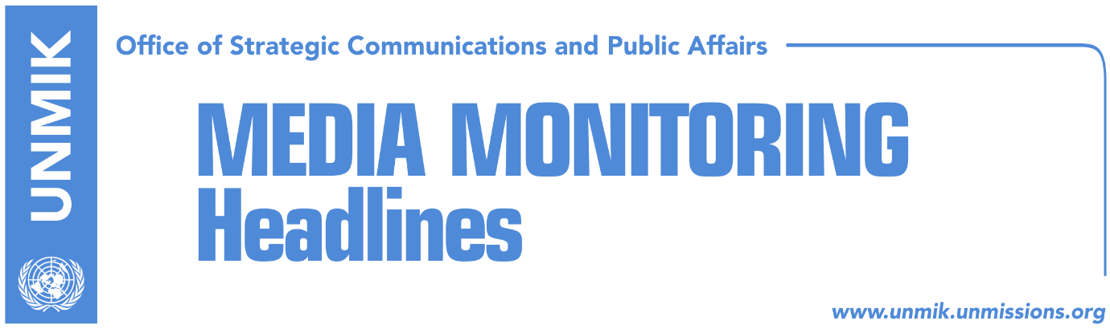

Main Stories 3 October 2017

- Thaci: The U.S. says yes to involvement on the Kosovo-Serbia dialogue (RTK)
- Thaci: Kosovo remains committed on war against terrorism (RTK)
- Opposition conditions government with IPA vote (Koha Ditore)
- German ambassador: No visa liberalisation without border demarcation (Zeri)
- Haradinaj issues “ultimatum” to ministers about Trepca law (Kosova Sot)
- Constitutional Court international judges may have mandate extended (Koha)

Kosovo Media Highlights

Thaci: The U.S. says yes to involvement on the Kosovo-Serbia dialogue (RTK)
The President of Kosovo, Hashim Thaci, told RTK that the Vice President of the United States of America, Mike Pence promised that the U.S will be directly involved in the dialogue between Pristina and Belgrade. He said that the main topic of their discussions was creation of Kosovo’s army, which according to Thaci, will happen this year. He added that three issues were discussed with the U.S Vice President: The first one, according to Thaci, was proceeding of the dialogue for normalisation of the relations between Kosovo and Serbia, as a concluding phase of this process, with a historic agreement on normalisation and reconciliation, through the leading role of the European Union.

“Time has come for direct involvement of the U.S. in the dialogue between Kosovo and Serbia. Vice President Pence has confirmed commitment and involvement of the White House in this significant process,” Thaci said. He added that this involvement would give a new meaning, dynamics and assurance for successful conclusion.

“Vice President Pence once again confirmed the U.S. position that Kosovo as a sovereign country has the right to create the Armed Forces, and also confirmed that the new force of Kosovo will be modern, with NATO standards and multiethnic. All obligations and responsibilities will be fulfilled within this year, and the Armed Forces of Kosovo will be created,” Thaci said.

He noted that the U.S. administration requests from Kosovo to conclude the issue of the demarcation of the border with Montenegro as soon as possible, which is already signed by the institutions of Kosovo and Montenegro. “To the U.S., this matter is closed and they request from us, the assembly of Kosovo, to conclude it as soon as possible, in order to move forward in the process of European integration, especially visa liberalisation,” Thaci said.

Thaci: Kosovo remains committed on war against terrorism (RTK)
The President of Kosovo, Hashim Thaci, met on Monday with the director of the CIA, Mike Pompeo. The main topic of their discussions was Kosovo’s role in the war against terrorism. “President Thaci said that Kosovo remains committed in war against terrorism and it is giving its contribution on strengthening peace and stability in region and beyond,” informs a communique issued by the Office of the President.

Opposition conditions government with IPA vote (Koha Ditore)
Kosovo opposition parties have threatened to vote against the Instrument for Pre-Accession agreement with the EU unless Prime Minister Ramush Haradinaj reveals the Serbian List’s conditions he agreed to in forming the new government. PM Haradinaj was at the Assembly yesterday to discuss the government’s programme but walked out of the session along with his ministers when asked about Serbian List conditions.

Head of Vetevendosje parliamentary group, Glauk Konjufca, said Haradinaj is liking the power but not accountability while Avdullah Hoti from the Democratic League of Kosovo (LDK) said they would not vote for IPA if Haradinaj does not reveal how he formed the new government.

German ambassador: No visa liberalisation without border demarcation (Zeri)
The new German Ambassador to Kosovo, Christian Heldt, said in a front-page interview with the paper that the longer the ratification of the border demarcation agreement with Montenegro takes, the longer it will be before the people of Kosovo will be able to move freely to Europe. “I can only repeat what we have said many times: agreement on border demarcation needs to be ratified and progress needs to be made on the fight against corruption. There is no other alternative to visa liberalisation,” Heldt underlined.

Haradinaj issues “ultimatum” to ministers about Trepca law (Kosova Sot)
Prime Minister of Kosovo, Ramush Haradinaj, has written to three line ministers asking them to undertake concrete and quick actions to implement the Law on Trepca mine and to address miners’ demands. The letters have been sent to the Minister of Economic Development, Valdrin Lluka, Minister of Labour and Social Welfare, Skender Recica, and Finance Minister, Bedri Hamza.

Constitutional Court international judges may have mandate extended (Koha)
The paper reports on the front page that the mandate of two international judges working for the Constitutional Court is set to expire next June and it is not yet clear whether they will from then on be replaced by local judges as stipulated in the Constitution of Kosovo or have their contracts extended yet again. The paper says the contracts for international judges have so far twice been extended in conflict to the procedure set out by the Constitution of Kosovo. Officials at EULEX said it was too soon to speculate on the matter while Constitutional Court did not yet comment.

Disclaimer
This media summary consists of selected local media articles for the information of UN personnel. The public distribution of this media summary is a courtesy service extended by UNMIK on the understanding that the choice of articles translated is exclusive, and the contents do not represent anything other than a selection of articles likely to be of interest to a United Nations readership. The inclusion of articles in this summary does not imply endorsement by UNMIK.

