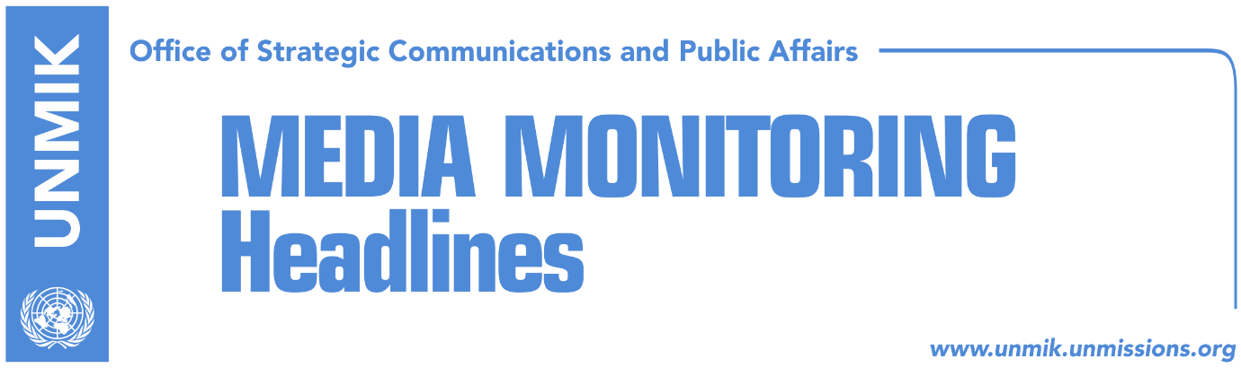

Main Stories 4 October 2017

- Assembly does not pass motion to dismiss Minister Rikalo (media)
- Montenegrin PM sends message to Haradinaj on border demarcation (RTK)
- Border demarcation commission asking for additional documents (Zeri)
- EU: Kosovo is a unique case (Koha)
- Hoxhaj: Kosovo cannot be compared to Catalonia (RTK)
- MEP Terricabras: Catalonia excepting recognition by Kosovo (Zeri)
- EU Director for Enlargement to visit Kosovo today (RTK)
- “Kosovo in UN or worsening of relations with international community” (Telegrafi)
- Government hides information on Trepca mining complex (Koha)

Kosovo Media Highlights

Assembly does not pass motion to dismiss Minister Rikalo (media)
All media report that the Kosovo Assembly did not pass a motion initiated by the Democratic League of Kosovo (LDK) to dismiss Minister of Agriculture, Nenad Rikalo, following allegations by some citizens of Pristina who claimed that Rikalo had mistreated Albanians during the 1998-99 conflict. Koha Ditore reports on its front page that Prime Minister Ramush Haradinaj “came to his minister’s defense saying that Rikalo is being attacked by the same people that squatted his apartment in Dardania neighborhood in Pristina”. Haradinaj also said that Kosovo Police and the Kosovo Intelligence Agency have no information that Rikalo was involved in the mistreatment of Albanian citizens. The paper also notes that the debate on the matter escalated into personal accusations between MPs. Bota Sot reports on the front page that the PDK-AAK-NISMA (PAN) coalition supported Rikalo and that Vetevendosje MP Donika Kadaj-Bujupi has implied that her party could stage protests demanding Rikalo’s dismissal. Epoka e Re on the front page quotes political analyst Belul Beqaj as saying that Rikalo must resign until all legal procedures on the matter are over. Beqaj did not rule out possible mass protests by the opposition. “Protests cannot be ruled out not only because of Rikalo but also because of the actions of the government,” he added.

Montenegrin PM sends message to Haradinaj on border demarcation (RTK)
Dusko Markovic, Prime Minister of Montenegro, requested from his Kosovo counterpart, Ramush Haradinaj, to be more responsible with regards to the border demarcation between the two countries. “Montenegro has supported Kosovo and understood the circumstances there but as far as this issue is considered, there cannot be any negotiations, no matter the decisions that they have made,” Markovic told the Montenegrin national broadcaster. “The issue of the ratification of the agreement is a competency of the institutions of Kosovo. I hope that they will approach it with responsibility,” he said. “I understand the circumstances, however, Podgorica has done everything that was to be done on its part and there will be no discussions on this matter, not even for a centimeter.”

Border demarcation commission asking for additional documents (Zeri)
Kosovo government’s commission on border demarcation with Montenegro is reported to have gathered several times so far and managed to review parts of the work of its predecessor. However, the commission has concluded that it needs “a considerable number of additional material,” which it will request officially from relevant institutions.

EU: Kosovo is a unique case (Koha)
European Commission spokesperson, Maja Kocijancic, dismissed allegations that the EU was applying double standards when dealing with the issue of Kosovo and Catalonia. She said there can be no parallels drawn between Kosovo and Catalonia and that “Kosovo is a sui generis case.”

Hoxhaj: Kosovo cannot be compared to Catalonia (RTK)
Kosovo’s Deputy Prime Minister, Enver Hoxhaj, said at a press conference on Tuesday that Kosovo cannot be compared to Catalonia, because Serbia committed ethnic cleansing.
He said that Kosovo was part of the Yugoslav Federation before the nineties, “but the regime which had also the support of the current President of Serbia, Aleksandar Vucic, who was the second person of the Serbian Radical Party, led by Seselj, followed the policy of ethnic cleansing. He added that during the years when countries which were part of the Yugoslav Federation became independent, no other country in Europe faced such realities in the last 30-40 years. “This is like comparing apples and pears… and this can be done by Aleksandar Vucic, who was master of Milosevic’s propaganda, but also Ivica Dacic who was the spokesperson, therefore it is absurd to listen to what they have to say about Kosovo,” Hoxhaj said. Finally, Hoxhaj stated that the Serbian PM, Ana Brnabic, is a technical person at the Serbian government and added that her statements do not make any impression.

MEP Terricabras: Catalonia excepting recognition by Kosovo (Zeri)
In a front-page interview to the paper, Catalan Member of European Parliament, Josep Maria Terricabras, said that the Catalan parliament will declare independence today and that they expect support from the international community, including Kosovo. “I am well aware of Kosovo’s case and I see a big resemblance,” said Terricabras adding that it was shameful that Spain has not recognised independence of Kosovo.

EU Director for Enlargement to visit Kosovo today (RTK)
The EU Director-General for Neighbourhood and Enlargement Negotiations, Christian Danielsson, will be visiting Kosovo today and tomorrow, to launch the Programme for Economic Reforms and meet representatives of the government, political leaders as well as other actors. Danielsson will be meeting Assembly President, Kadri Veseli, Prime Minister Ramush Haradinaj, Minister for Integration, Dhurata Hoxha, Minister for Foreign Affairs, Behxhet Pacolli, as well as the Minister of Finance, Bedri Hamza. He will also meet representatives of Vetevendosje Movement and of the Serbian List.

“Kosovo in UN or worsening of relations with international community” (Telegrafi)
In an interview for Radio Television of Vojvodina, head of the Center for International Relations and Sustainable Development think tank and former Foreign Minister of Serbia, Vuk Jeremic, said that Serbia will face a difficult situation in 2018. According to him, Serbia will have to choose between Kosovo gaining UN membership or risk worsening relations with international community.

Government hides information on Trepca mining complex (Koha)
The paper reports in one of its front-page articles that Prime Minister Ramush Haradinaj had planned to inform his cabinet about measures that need to be taken for the Trepca mining complex, but that he submitted the information only in writing. On the same day, the Office of the Prime Minister refused the paper’s request to have access to the feasibility study on the mining complex. The paper notes that it has been a year since the Kosovo government has not undertaken any of the measures listed in the law through which it could manage the key assets of the mining complex.

Disclaimer
This media summary consists of selected local media articles for the information of UN personnel. The public distribution of this media summary is a courtesy service extended by UNMIK on the understanding that the choice of articles translated is exclusive, and the contents do not represent anything other than a selection of articles likely to be of interest to a United Nations readership. The inclusion of articles in this summary does not imply endorsement by UNMIK.

