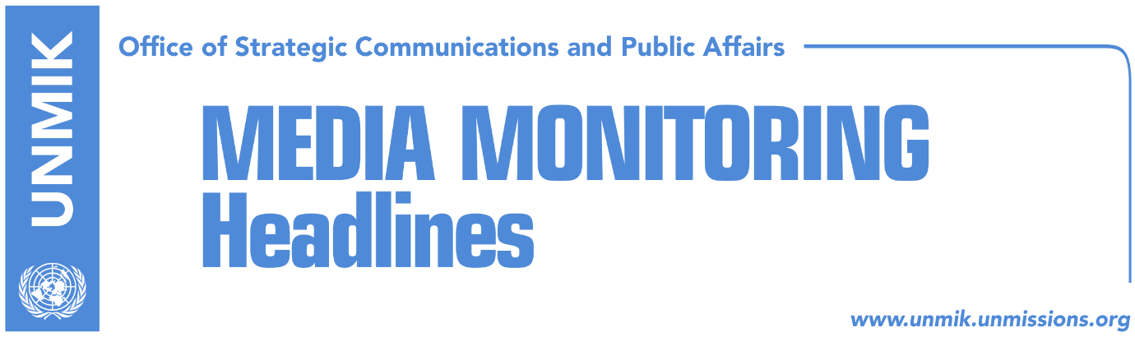

Main Stories 5 October 2017

- Kosovo claims decision not to submit UNESCO bid, pragmatic (Koha)
- British PM May urges Haradinaj to fight corruption (Zeri)
- Haradinaj: Border with Montenegro is in Cakorr and Kulla (Lajmi/Zeri)
- Demarcation commission: Montenegro is changing statements (RTK)
- Kosovo cannot attend INTERPOL conference on human trafficking (Koha)

Kosovo Media Highlights

Kosovo claims decision not to submit UNESCO bid, pragmatic (Koha)
Kosovo’s Foreign Ministry has issued a statement to the press explaining the reasons why it has not renewed application for UNESCO membership. While acknowledging that Kosovo’s membership in international organisations remains a top priority, the Foreign Ministry claims the decision to postpone application is “pragmatic” and was taken in close coordination with the U.S. and other Quint countries. “The Ministry of Foreign Affairs considers these actions contribute to the strengthening of Kosovo’s international position, furthering of relations with partners and allies, guaranteeing security, and promoting peace in the region,” the statement reads.

British PM May urges Haradinaj to fight corruption (Zeri)
The British Prime Minister, Theresa May, has congratulated Prime Minister of Kosovo, Ramush Haradinaj, on his election and said Great Britain is committed to Kosovo’s integration into the international community and normalisation of relations with Serbia. “We will continue to support the strengthening of the rule of law in your country, and we hope that your government will address the weaknesses in the justice system as a priority as well as taking the necessary steps to fight organised crime and tackle corruption,” May said in her letter.

Haradinaj: Border with Montenegro is in Cakorr and Kulla (Lajmi/Zeri)
Prime Minister of Kosovo, Ramush Haradinaj, said in an election gathering of his party, the Alliance for the Future of Kosovo (AAK), in Decan/Decani that his position on the border demarcation with Montenegro remains unchanged. “The new commission will find facts that mistakes were made in the past and that the border is in Cakorr and Kulla,” Haradinaj said. “Facts are on our side and this is how this problem will be solved,” he underlined.

Demarcation commission: Montenegro is changing statements (RTK)
Florim Isufi, member of the new State Commission on Border Demarcation and Maintenance, said Montenegro’s change of statements after the establishment of the new commission, is a signal that there is something and that they would not agree with the findings of the new commission. “Changed statements of the Montenegrins, make us be more serious on our work, in order to find all the required information to convince also the Montenegrin party that something went wrong. You can see that until the establishment of this commission, Montenegrin party was extraordinarily ready for cooperation and open to reconsider the agreement, while in the moment that this commission was established, they fundamentally changed their position. This certainly means that they have some knowledge and they do not want to agree with the new achievements. Let us see now,” Isufi said.

Kosovo cannot attend INTERPOL conference on human trafficking (Koha)
The paper reports on page two that Kosovo cannot participate in regional conferences about the fight against crime and trafficking. INTERPOL and the U.S. State Department’s Bureau of International Narcotics and Law Enforcement Affairs Office organized in Tirana a regional conference against human trafficking in the Balkans. Despite major problems with human trafficking Kosovo could not take part in the conference because it is not yet a member of INTERPOL.

Disclaimer
This media summary consists of selected local media articles for the information of UN personnel. The public distribution of this media summary is a courtesy service extended by UNMIK on the understanding that the choice of articles translated is exclusive, and the contents do not represent anything other than a selection of articles likely to be of interest to a United Nations readership. The inclusion of articles in this summary does not imply endorsement by UNMIK.

