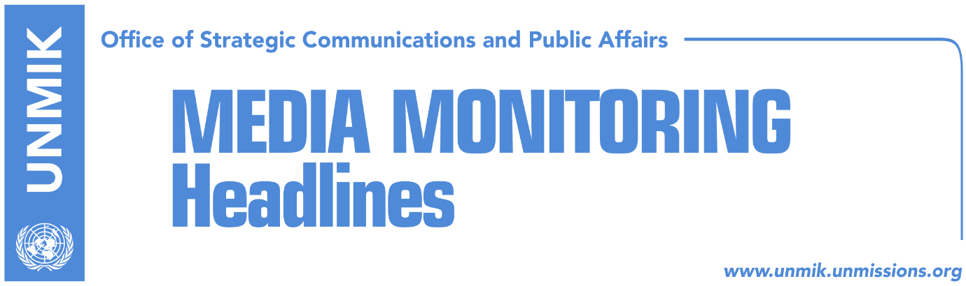

Main Stories 6 October 2017

- EU enlargement: Tear down mental walls in the Balkans (media)
- Haradinaj: We will not remain without liberalization, we are not at war (RTK)
- Bugajski: Border agreement should be ratified (RTK)
- Hoxhaj: Serbia’s recognition of Kosovo, only way forward (RTK)
- Pacolli: Serbia knows reconciliation with Kosovo will happen (DW/Telegrafi)
- Vucic: Kosovo won’t have enough votes for UNESCO even after two years (media)
- Government presents diplomatic failures as technical withdrawals (Koha)
- Two Kosovo failures in international arena (Zeri)

Kosovo Media Highlights

EU enlargement: Tear down mental walls in the Balkans (media)
“Last month the European Commission dealt another blow to the Western Balkans by promising an accession strategy for Montenegro and Serbia while neglecting the other four Balkan countries,” Hashim Thaçi, the President of Kosovo, writes in an exclusive op-ed for EURACTIV. “The Commission’s relationship with the Western Balkans, as well as the enlargement policy, has been a complicated one. Afraid of xenophobic sentiments mixed with enlargement fatigue at home, the administration was quick to promise that no further EU enlargement was to happen during the 2014-2019 mandate”. https://www.euractiv.com/section/enlargement/opinion/eu-enlargement-tear-down-mental-walls-in-the-balkans/

Haradinaj: We will not remain without liberalization, we are not at war (RTK)
The Prime Minister of Kosovo, Ramush Haradinaj, said on Thursday that the people of Kosovo will not remain without visas, as their government is fulfilling standards required by the Stabilization/Association Agreement (SAA). He added that Kosovo would not start a war with anyone for a draft agreement for demarcation with Montenegro. “As far as demarcation is concerned, it is a simple situation, some are trying to say that we are leaving them without visas, some others are trying to say that we are leaving them without land. It is not true, we will not be left without visas, we are going to gain liberalization since we are advancing on SAA. For demarcation, procedures are known as well, we are not starting a war with anyone on demarcation. Mistake was made, a commission is changed, nothing wrong has happened, and we did not breach relations with friends,” Haradinaj said.

Bugajski: Border agreement should be ratified (RTK)
The U.S. analyst for international policies, Januzs Bugajski, said that Kosovo institutions and the Assembly of Kosovo should conclude the issue of the demarcation of the border with Montenegro as soon as possible. According to him, any delay on the matter would have consequences for the future of Kosovo and integration processes.

Hoxhaj: Serbia’s recognition of Kosovo, only way forward (RTK)
Deputy Prime Minister of Kosovo, Enver Hoxhaj, took to Facebook to write that Serbia should recognize Kosovo as this is the only way to move forward and overcome conflicts that should not be left to future generations. “Serbia has continued ‘worshiping’ Milosevic, by not taking over responsibility for war crimes sponsored by Serbian state against civilian population not only in Kosovo, but also in other countries of former Yugoslavia. There cannot be normalization or sustainable peace in the region without setting justice on war crimes, and this requires maximal engagement of the Serbian state. There cannot be stability if Serbia continues to block Kosovo in the international arena. Mutual recognition is the only way to move forward and overcome conflicts, after all they cannot be left to the new generations,” Hoxhaj wrote.

Pacolli: Serbia knows reconciliation with Kosovo will happen (DW/Telegrafi)
Kosovo’s Deputy Prime Minister and Foreign Minister, Behgjet Pacolli, said in an interview to Deutsche Welle that reconciliation between Kosovo and Serbia is inevitable and that the initiative of the Serbian President Aleksandar Vucic to open an internal debate on Kosovo represents a positive and constructive move. “I know we have made many concessions and these are not concessions that happened because of our ignorance or incapacity but as a way to help Serbia reach the great reconciliation and we should never forget this. Even our withdrawal ahead of confirmation of membership at Interpol was a very clear gesture that we are helping the process of dialogue. At this moment we are seriously considering not applying to UNESCO and these are strong signals we are sending to Serbia that we are helping the process,” Pacolli said.

Pacolli also said he sees no resemblance between Kosovo and Catalonia. “Catalonia wishes to secede from a consolidated, democratic country,” Pacolli said while “Kosovo was practically occupied by Serbia.” Speaking about the border demarcation with Montenegro, Pacolli said the 2015 agreement has attained an international character and “is a de jure agreement that needs to be respected.” “However, there is another fact and that is that the opinion in Kosovo is split on this issue and this is also seen at the parliament of Kosovo,” Pacolli noted.

Vucic: Kosovo won’t have enough votes for UNESCO even after two years (media)
Serbian President Aleksandar Vucic said on Thursday that Kosovo withdrew its membership bid in UNESCO because it lacks the required votes. “I was always careful about this and I always told the truth about who has the majority in UNESCO. Where are the 15 countries that Behxhet Pacolli mentioned at the UN headquarters in New York? I think this will not happen even after two years,” Vucic told Belgrade-based B92 news agency. He also said Serbia would continue to be vigilant and fight against Kosovo’s membership in UNESCO.

Government presents diplomatic failures as technical withdrawals (Koha)
In one of its front-page stories, the paper reports that the Kosovo government’s decision to withdraw from the membership bid in UNESCO is considered as another diplomatic failure following the decision to withdraw the membership application for INTERPOL. Kosovo’s Ministry of Foreign Affairs announced it was not applying for membership in UNESCO this year after Serbian officials in Belgrade said that Kosovo is not on the agenda of UNESCO. Kosovo now has to wait until 2019 as the UNESCO General Assembly meets once in two years. Similar to the INTERPOL bid, the Kosovo government justified the withdrawal citing unfavorable circumstances and saying that it received such suggestions from the U.S. and Quint countries. The paper also recalls that Kosovo’s Foreign Minister, Behxhet Pacolli, said last month that Kosovo has secured enough votes to become a member of UNESCO.

Two Kosovo failures in international arena (Zeri)
The paper reports that decisions not to apply for membership to Interpol and UNESCO are considered to be the most serious failures so far by the new government of Kosovo led by Ramush Haradinaj. Experts warn that not applying for membership in these leading international organizations will have negative repercussions although they do admit that the fault for this does not only lie with the current government but the previous one as well. Prime Minister Ramush Haradinaj said meanwhile that entering the voting process without receiving assurances that enough votes have been secured would be damaging for Kosovo. “The year in going was marred by institutional deadlock, elections, delays in forming institutions and absence of a consistent work beforehand. So an unsustainable agenda of unconsolidated achievements towards membership in these two institutions made us rethink our strategy,” Haradinaj is quoted as telling RFE. He added however that Kosovo is already making preparations to apply to Interpol next year and renew its UNESCO bid two years from now.

Disclaimer
This media summary consists of selected local media articles for the information of UN personnel. The public distribution of this media summary is a courtesy service extended by UNMIK on the understanding that the choice of articles translated is exclusive, and the contents do not represent anything other than a selection of articles likely to be of interest to a United Nations readership. The inclusion of articles in this summary does not imply endorsement by UNMIK.

