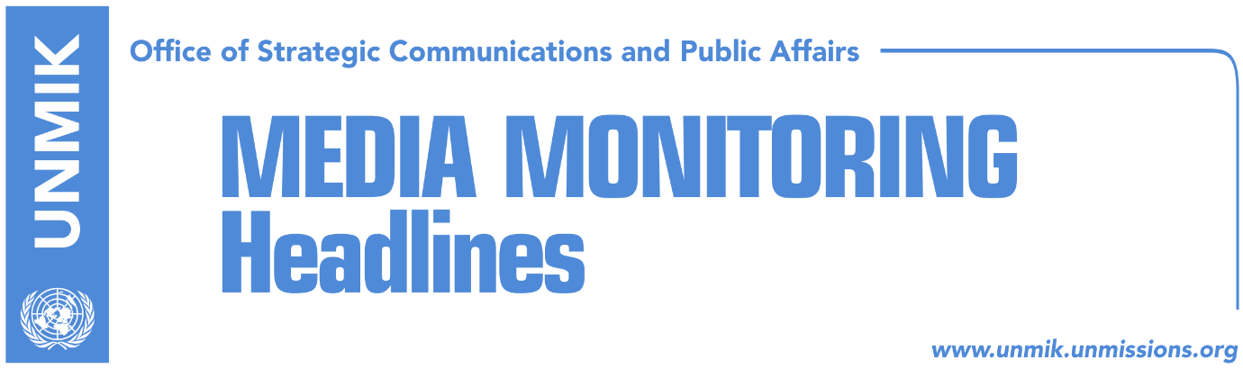

Main Stories 7 October 2017

- Kosovo government adopts draft law on Pristina (media)
- PM Haradinaj at crossroads with demarcation (Zeri)
- Bulliqi: We need time to review existing documents (RTK)
- U.S. involved in Pristina-Belgrade talks (Zeri)
- Blerim Shala appointed advisor to President Thaci (Gazeta Express)

Kosovo Media Highlights

Kosovo government adopts draft law on Pristina (media)
Most media report that the Kosovo Government adopted on Friday a draft law that regulates the functioning and legal status of Pristina. Media quote Prime Minister Ramush Haradinaj as saying: “Pristina has a special status and competencies within its territory. This law was kept in the drawers for a very long time. The law is of extraordinary importance. Its implementation will have financial implications but it is aimed at improving life in Pristina”. Finance Minister, Bedri Hamza, too said the draft law will have budgetary implications but added that “we will design it in a way that it does not overload the budget of the state. In a front-page article, Koha Ditore reports that the draft law foresees additional competencies in public security, health and public services and additional revenues from the government. The paper also notes that the draft law does not give Pristina ownership over the Youth Center despite the request from Pristina Mayor Shpend Ahmeti.

PM Haradinaj at crossroads with demarcation (Zeri)
Kosovo’s Prime Minister Ramush Haradinaj is at a crossroads with the border demarcation agreement with Montenegro, the paper reports on its front page. It notes that Podgorica is against renegotiating the agreement, which was reached in 2015, and already ratified by the Montenegrin Parliament. Meanwhile, the European Union is adamant that the ratification of the agreement is one of the last criteria for Kosovo to get visa liberalization. According to the paper, the eventual ratification of the agreement could mean “political suicide” for Haradinaj being that he was one of the biggest opponents of the deal while he was in opposition.

Bulliqi: We need time to review existing documents (RTK)
Shpejtim Bulliqi, head of the Kosovo Government’s border demarcation commission, told RTK that the commission is working with full capacity but that they need time to review the existing documents and facts on the border demarcation with Montenegro. Bulliqi said it was too early to talk about the commission’s findings. “Our first findings indicate there have been flaws in the work of the previous commission … There is no deadline for the report that will be submitted to Prime Minister Ramush Haradinaj … There are some crucial areas that need to be analyzed and this takes time. There are no deadlines but we are going to do our utmost to collect all these facts and to draft a report,” Bulliqi was quoted as saying.

U.S. involved in Pristina-Belgrade talks (Zeri)
The United States Embassy in Pristina told the paper on Friday that the U.S. are considering offering strong support to the EU-brokered talks between Pristina and Belgrade. Their statement comes after Kosovo President Hashim Thaci’s public request for the U.S. to be involved in the talks. “The U.S. government continues to support the EU-facilitated dialogue. We will work closely with the team of EU foreign policy chief, Federica Mogherini, on how to offer stronger support to the dialogue process,” U.S. officials in Pristina told the paper.

Blerim Shala appointed advisor to President Thaci (Gazeta Express)
Blerim Shala, former deputy leader of the Alliance for the Future of Kosovo (AAK), who was also coordinator of talks between Pristina and Belgrade, has been appointed political advisor to Kosovo President Hashim Thaci. The news website notes that the process of talks will now be held at the level of presidents. The Office of the President meanwhile said Shala will not have a role in the dialogue with Belgrade and that he will serve only as advisor to Thaci.

Disclaimer
This media summary consists of selected local media articles for the information of UN personnel. The public distribution of this media summary is a courtesy service extended by UNMIK on the understanding that the choice of articles translated is exclusive, and the contents do not represent anything other than a selection of articles likely to be of interest to a United Nations readership. The inclusion of articles in this summary does not imply endorsement by UNMIK.

