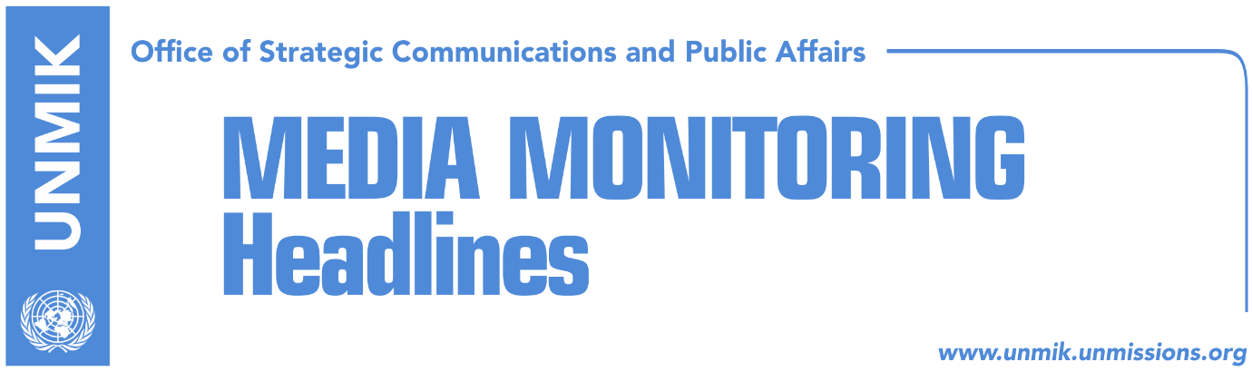

Main Stories 10 October 2017

- Thaci changes course, ‘blasts’ special court (Zeri/Bota Sot)
- UK supports Thaci’s efforts for reconciliation and justice (Koha Ditore/Zeri)
- Haradinaj: Those who do not duly implement SAA will be let go (Zeri)
- Blerim Shala appointed advisor and coordinator for dialogue (Koha)
- Glenny: Serbia will have to recognize Kosovo’s independence (Koha)
- Report: Over 50% of citizens ready to protest against special court (Koha)
- LGBTI parade in Pristina today, what is expected to happen? (Indeksonline)
- War veterans with ultimatum for the government (RTK)

Kosovo Media Highlights

Thaci changes course, ‘blasts’ special court (Zeri/Bota Sot)
Zeri reports on the front page that President of Kosovo, Hashim Thaci, voiced strong criticism against the specialist chambers saying he was skeptical it would be able to serve justice. This position, adds the paper, is in stark contrast to that a few years back when Thaci urged the Assembly MPs to vote in favour of the court’s establishment. Political analysts the paper has spoken to said that Thaci’s recent statements are not sincere and could be linked to his ‘personal calculations.’ Meanwhile, Bota Sot quotes analyst Haki Abazi as saying that special court ‘fever’ has spread in Kosovo and that Thaci and the leader of the Democratic Party of Kosovo (PDK), Kadri Veseli, fear they could be amongst the people to be indicted.

UK supports Thaci’s efforts for reconciliation and justice (Koha Ditore/Zeri)
Following media reports that the British Ambassador to Kosovo, Ruairi O’Connell, walked out of the room while President Hashim Thaci was delivering his speech criticizing the specialist chambers during a debate yesterday, the UK Embassy in Pristina clarified that it supports Thaci’s efforts for reconciliation and justice and that Ambassador O’Connell left the debate to attend to an ‘urgent’ matter.

Haradinaj: Those who do not duly implement SAA will be let go (Zeri)
Prime Minister of Kosovo, Ramush Haradinaj, said at the meeting of the ministerial council for European integration that all efforts need to be made to ensure the Stabilisation and Association Agreement (SAA) is implemented. “Reward those who help you to this end and let go and replace those who don’t,” Haradinaj told his ministers. He said there are already delays in the process of SAA implementation and that the work needs to be stepped up to reach this year’s objectives.

Blerim Shala appointed advisor and coordinator for dialogue (Koha)
The paper reports on its front page that Blerim Shala will be President Hashim Thaci’s advisor and coordinator for talks with Serbia. Although the Office of the President has yet to announce the appointment, Shala will attend a security forum in Belgrade this week in his capacity as coordinator. The topic of discussion will be “Dialogue between Pristina and Belgrade: From normalization to normality”. Artan Behrami, from the President’s Press Office, told the paper on Monday: “Mr. Blerim Shala will have the same role as other political advisors to the President. Mr. Shala together with the other advisors on coordinating the stakeholders involved in the transformation of the Kosovo Security Force into the Kosovo Armed Forces”. The paper further recalls that Shala was involved from the beginning in the dialogue for normalization of relations between Kosovo and Serbia.

Glenny: Serbia will have to recognize Kosovo’s independence (Koha)
Renowned British reporter and Balkans expert, Misha Glenny, told Belgrade-based Blic that Serbia is going to have to recognize Kosovo’s independence before it can join the European Union. “It is very clear that Germany with the support of the majority in the European Union has decided that Germany will have to agree with the de facto recognition of Kosovo as an independent state, before it can become a member of the European Union,” Glenny said.

Report: Over 50% of citizens ready to protest against special court (Koha)
A report conducted by Pax civil society organizations from Holland, the Center for Peace and Tolerance, Integra and Impunity Watch shows that 51% of Albanians are willing to protest if former KLA combatants are accused by the Special Court. 76.4% of Albanians believe it is unjust for the special court to prosecute crimes alleged in Dick Marty’s report, whereas 4.5.5% of Serb respondents said they believe the special court has a fair mandate. 64% of Albanian respondents said they were ready to protest if they deem unfair the future rulings of the special court against former KLA members.

LGBTI parade in Pristina today, what is expected to happen? (Indeksonline)
The news website reports that the first Pride Parade of the LGBTI community in Kosovo will be held today in Pristina at 11:30 starting from Skenderbeu Square to Zahir Pajaziti Square. Kosovo Police told the news website that they have not taken any additional security measures for the event. “We have been informed about the event and as in any other event Kosovo Police will be there to provide security for every citizen,” police officials said. The news website also notes that several media on Monday carried an anonymous article threatening everyone that will attend the Pride Parade.

War veterans with ultimatum for the government (RTK)
War veterans protested on Monday regarding lack of payment of their pensions for the last three months. They met with the Prime Minister of Kosovo Ramush Haradinaj, who told them that the government has completed its part of work by proceeding the draft law at the Assembly, and that the matter is now with the Assembly of Kosovo. They also met with Assembly MP Elmi Recica, who told them that the matter will be preceded for voting at the Assembly within forty days. However, the protesters gave an ultimatum to the MPs to proceed with the voting by 25 October and if this does not happen, they will set tents in front of the Assembly.

Disclaimer
This media summary consists of selected local media articles for the information of UN personnel. The public distribution of this media summary is a courtesy service extended by UNMIK on the understanding that the choice of articles translated is exclusive, and the contents do not represent anything other than a selection of articles likely to be of interest to a United Nations readership. The inclusion of articles in this summary does not imply endorsement by UNMIK.

