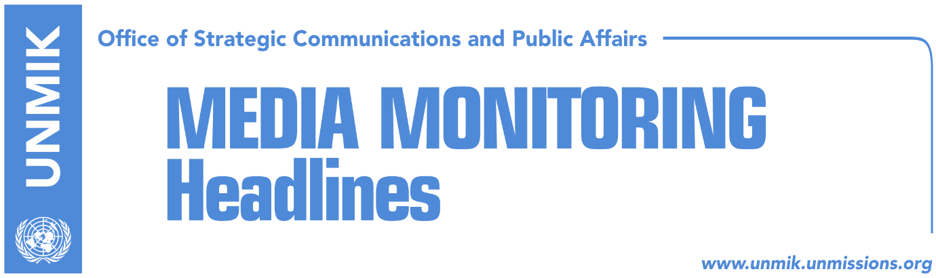

Main Stories 11 October 2017

- International community shifts blame to Kosovo after Thaci’s criticism (Koha)
- Albanian President Meta to visit Kosovo today (Epoka e Re)
- “Kosovo-Serbia recognition, prerequisite for Balkans reconciliation” (RTK)
- Berisha: KSF transformation in line with Kosovo Constitution (Zeri)
- Kosovo makes history with first ever pride parade (Prishtina Insight)
- KEDS and CEC sign power supply agreement for election day (Epoka e Re)
- Kosovo and Albania open joint diplomatic office in Milano (dailies)

Kosovo Media Highlights

International community shifts blame to Kosovo after Thaci’s criticism (Koha)
The paper reports on the front page that the representatives of the international community have pointed the finger at Kosovo institutions as responsible for a number of failures which few days ago the President of Kosovo, Hashim Thaci, blamed on the international community. Thaci’s office maintains that Kosovo agreed to the establishment of the specialist chambers “by respecting the advice from the international community.” “In exchange, the international community, as always, has pledged support for membership in the Council of Europe, speedy visa liberalisation, massive support for UNESCO membership, swift establishment of the Kosovo Armed Forces, and new recognitions,” Thaci’s office replied in a statement to the paper. Meanwhile, European Commission spokesperson, Maja Kocijancic, told the paper that the EU has reconftimed the Western Balkans’ European perspective noting however that Kosovo needs to immediately implement reforms in the field of rule of law and economy, play an active role in the region and make progress in the dialogue with Belgrade. “Kosovo has no time to lose,” Kocijancic said. The U.S. Embassy in Pristina stated that Kosovo’s cooperation with specialist chambers will strengthen Kosovo’s international position and that the U.S. strongly supports Kosovo’s membership in international organizations. At the same time, the UK Embassy denied making any promises to Kosovo institutions in exchange for voting in favour of specialist chambers while membership in international organizations depends on specific criteria of each institution. “United Kingdom is working in supporting Kosovo’s full international integration,” a response by the UK Embassy reads.

Albanian President Meta to visit Kosovo today (Epoka e Re)
President of Albania, Ilir Meta, is expected to visit Kosovo today on the invitation from Kosovo President, Hashim Thaci. A joint press conference will take place after the meeting, the paper reports.

“Kosovo-Serbia recognition, prerequisite for Balkans reconciliation” (RTK)
Kosovo’s Deputy Prime Minister, Enver Hoxhaj, said after the opening of the Regional Youth Cooperation Office (RYCO) of the Western Balkans in Pristina that there can be no inter-society reconciliation if a country that was the source of conflict does not changes its agenda. “Key prerequisite to reconciliation in the Balkans is inter-state recognition between Kosovo and Serbia,” Hoxhaj wrote on Facebook.

Berisha: KSF transformation in line with Kosovo Constitution (Zeri)
The Kosovo Security Force (KSF) Minister, Rrustem Berisha, said after a meeting with Hungarian Ambassador to Kosovo, Laszlo Markusz, that transformation of the KSF into an armed force will be in line with the Constitution of Kosovo and in a transparent manner. Furthermore, the transformation process will take place in coordination with the local institutions and the international allies, Berisha added.

Kosovo makes history with first ever pride parade (Prishtina Insight)
Hundreds of people from Kosovo and the region marched in Prishtina for the country’s first ever pride parade on Tuesday. “We are proud to lead the first pride parade in Kosovo. Today I’m raising my voice for everyone that could not walk with us today,” said LGBTQ activist Lendi Mustafa as the march drew to a close and turned into a dance party at Zahir Pajaziti square.
Read more: http://prishtinainsight.com/first-pride-parade-mag/tory with first ever pride parade

KEDS and CEC sign power supply agreement for election day (Epoka e Re)
The Central Election Commission (CEC) signed yesterday an agreement with the Kosovo Energy Distribution Services (KEDS) providing that there will be no electricity cuts on 22 October, local election day. KEDS director, George Karagutoff, said electricity supply will be stable on election day. “Election day will be a working day for us. There will be electricity,” he said.

Kosovo and Albania open joint diplomatic office in Milano (dailies)
Kosovo and Albania have opened a joint consular office in Milano, Italy, announced Prime Minister of Albania, Edi Rama, on Facebook. “We will open more dignified joint offices for consular services for Albanians across the world,” Rama wrote.

Disclaimer
This media summary consists of selected local media articles for the information of UN personnel. The public distribution of this media summary is a courtesy service extended by UNMIK on the understanding that the choice of articles translated is exclusive, and the contents do not represent anything other than a selection of articles likely to be of interest to a United Nations readership. The inclusion of articles in this summary does not imply endorsement by UNMIK.

