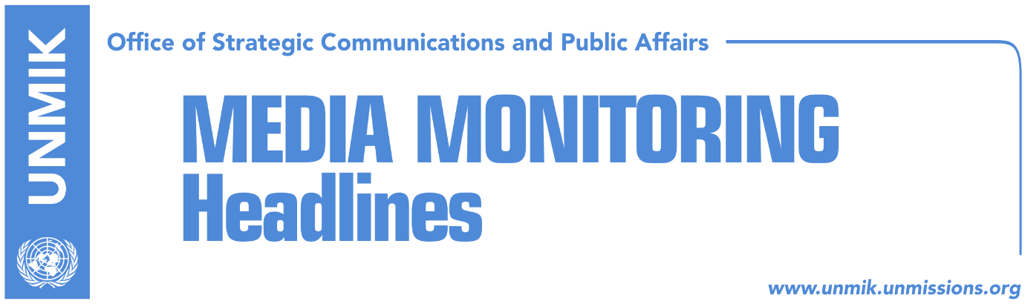

Main Stories 12 October 2017

- President Thaci backs down from statement on special court (Koha)
- Internationals didn’t promise favors in exchange for special court (Zeri)
- Mogherini expects progress on Kosovo-Serbia dialogue (RTK)
- Pieter Feith disappointed with EULEX and Kosovo-Serbia dialogue (RTK)
- O’Connell: Nomination of unprofessional people do not help Kosovo (Epoka)
- Apostolova to hold meetings with heads of parliamentary groups (RTK)

Kosovo Media Highlights

President Thaci backs down from statement on special court (Koha)
In its leading front-page article, the paper notes that Kosovo President Hashim Thaci said on Monday that the special court, which will address war crimes allegations, was established following promises by internationals that Kosovo would have many benefits, but according to Thaci these promises were never kept. International officials denied Thaci’s claims, and the latter then criticized the media of improper reporting. Thaci said on Wednesday: “There is no shift in my position [on the special court]. I reconfirm this, because the entire leadership of Kosovo, including myself, have made the best possible choice given the circumstances and the international context. We had two choices. Both were difficult and of course bad: the first choice, the international community imposed it on us and we agreed to the establishment of the special court, which at least functions according to Kosovo laws. The second option was that if the institutions of the Republic of Kosovo would reject the court, the issue would then have been moved to the United Nations”.

Internationals didn’t promise favors in exchange for special court (Zeri)
The paper reports on page three that international officials in Pristina have denied Kosovo President Hashim Thaci’s claims that they promised favors in exchange for the establishment of the special court. On the matter, the British Embassy in Pristina told the paper: “we have not made any promises to Kosovo for the special court and it is not fair to claim otherwise. Membership in international organizations is based on specific membership criteria in individual organizations. The United Kingdom is working on supporting Kosovo’s full international integration”. U.S. Embassy representatives in Pristina said in a written response to the paper that the US will remain committed to the successful operation of the special court. “The United States remains fully committed to the successful operation of Kosovo Specialist Chambers in The Hague, and we hail the commitment of state institutions to cooperate with the Court. Kosovo’s cooperation with this process will strengthen the international position of the state and will be a concrete indicator of the basic democratic principles where the rule of law applies to all citizens alike,” the statement noted.

Mogherini expects progress on Kosovo-Serbia dialogue (RTK)
The EU High Representative for Foreign Policies and Security, Frederica Mogherini, said on Wednesday that she saw good possibility for Kosovo and Serbia in making progress towards normalization of the relations during the coming years. “I see this possibility of a qualitative jump happening let us say, from now until the end of 2018,” Mogherini said after meeting the Prime Minister of Serbia, Ana Brnabic. She added that results can be expected even earlier. “I think that both parties are committed and possess political conditions at home, that did not exist in the past and I see great determination on reaching results,” she said.

Pieter Feith disappointed with EULEX and Kosovo-Serbia dialogue (RTK)
Former EU representative to Kosovo, Pieter Feith, told the Belgrade news agency, Tanjug that progress reached in the dialogue between Belgrade and Pristina is not sufficient. He said that he is disappointed with the results of the work of EULEX, and added that nothing concrete has been reached in the dialogue. “Since 2008, the intention was to strengthen the rule of law, even though a lot has been done, we still did not reach our goal, which slows Kosovo’s chances on its path towards the EU,” Feith said. He added that the only way for membership of Western Balkans countries to the EU, is overcoming problems between neighbors, therefore, he said, a lot remains to be done.

O’Connell: Nomination of unprofessional people do not help Kosovo (Epoka)
The government of Kosovo and the Embassy of the United Kingdom, signed on Wednesday a memorandum of understanding on recruitment of senior leading positions. After signing of the memorandum, Kosovo’s Prime Minister said that the intention is to assure a legal and credible process of recruitment of all individuals that will carry responsibilities at agencies which are under the competence of the government. The Ambassador of the United Kingdom to Kosovo, Ruairi O’Connell said that phenomenon of nominating unprofessional people do not help Kosovo.

Apostolova to hold meetings with heads of parliamentary groups (RTK)
Starting from today, Head of the EU Office in Kosovo, Natalia Apostolova, will be holding meetings with heads of the Parliamentary groups and parliamentary commissions of PDK, Vetevendosje, LDK, AAK, Serbian List, NISMA, 6+ and women’s group. The intention of the meetings is understanding priorities of the new composition of the Assembly, inform MPs with EU’s priorities for the future period and discuss ways in which the EU in Kosovo could support MPs on implementation of reforms related to European agenda.

Disclaimer
This media summary consists of selected local media articles for the information of UN personnel. The public distribution of this media summary is a courtesy service extended by UNMIK on the understanding that the choice of articles translated is exclusive, and the contents do not represent anything other than a selection of articles likely to be of interest to a United Nations readership. The inclusion of articles in this summary does not imply endorsement by UNMIK.

