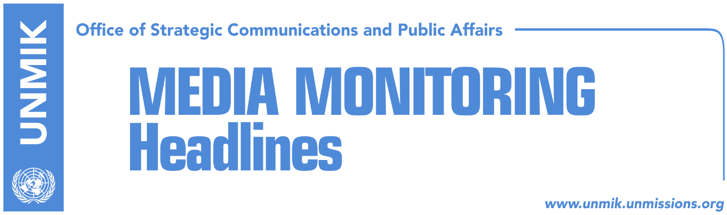

Main Stories 27 October 2017

- Haradinaj: I expect no miracles from demarcation (Koha)
- Thaci: Kosovo promotes equality of non-majority communities (Zeri, Epoka)
- Pacolli meets Turkish FM Cavusoglu (Zeri)
- Budget review adopted in principle (Koha Ditore)
- Three cars set ablaze in the north (dailies)

Kosovo Media Highlights

Haradinaj: I expect no miracles from demarcation (Koha)
In an interview for “New Bugajski Hour” show aired on RTK, Prime Minister of Kosovo Ramush Haradinaj spoke of the need to swiftly resolve the border demarcation issue with Montenegro but noted that he expects no miracles. He said Kosovo is split on the issue and there is no majority in the Assembly to ratify the current agreement and that this is why the government decided to appoint a new border demarcation commission in a bid to get to the truth of the matter. “I can hope that one day by some miracle we will have two-thirds,” Haradinaj said. “As soon as we get the result we will get to work. First with political partners in Kosovo and political parties, including opposition, so that we know where we stand. But at the same time, with Washington and other allies, or Europeans, to let them know that this is our reality and then with Montenegro to inform it of our new developments,” Haradinaj said.

Thaci: Kosovo promotes equality of non-majority communities (Zeri, Epoka)
At the regional conference on protection and promotion of human rights and the rights of non-majority communities organised by the Consultative Council for Communities, President of Kosovo Hashim Thaci said Kosovo promotes equality of all non-majority communities through representation in institutions and the government of Kosovo as well as through introducing a quota at public universities. Thaci said Kosovo takes pride in the dialogue it has established between different communities, be it ethnic or religious. He also spoke about the initiative for setting up a Commission on Truth and Reconciliation as an effort to close the chapter of conflict and build a new one of peace and co-habitation.

Pacolli meets Turkish FM Cavusoglu (Zeri)
Kosovo’s Foreign Minister, Behgjet Pacolli, met the Turkish Foreign Minister, Mevlut Cavusoglu, and called on Turkey to use its authority to ask Serbia to unblock the Albania-Kosovo interconnection line. Pacolli said millions of euros have been dedicated to the project but that Serbia keeps blocking it. Cavusoglu on his part said Turkey would continue to support Kosovo and its efforts to gain membership in international organizations but noted that Kosovo institutions need to close businesses funded by Fethullah Gulen.

Budget review adopted in principle (Koha Ditore)
The draft law on 2017 budget review passed the first reading at the Assembly of Kosovo yesterday and the ruling parties requested the second reading take place through an accelerated procedure and be put to vote before the end of the month. Opposition parties, Vetevendosje and the Democratic League of Kosovo (LDK) objected to this.

Three cars set ablaze in the north (dailies)
Three cars and business equipment were set ablaze on Thursday morning at the “Bosniak Mahalla” neighbourhood in the northern part of Mitrovica. Two of the cars were owned by an Albanian man who is also owner of the adjacent bakery which was also damaged in the fire. Head of Kosovo Police operation unit in the north, Zeljko Bojic, told Radio Free Europe that the case it being treated as arson while the owner of the bakery, Tefik Fetahu, told Klan Kosova that security cameras show unidentified persons throwing something at the cars, suspected to be explosive device.

Disclaimer
This media summary consists of selected local media articles for the information of UN personnel. The public distribution of this media summary is a courtesy service extended by UNMIK on the understanding that the choice of articles translated is exclusive, and the contents do not represent anything other than a selection of articles likely to be of interest to a United Nations readership. The inclusion of articles in this summary does not imply endorsement by UNMIK.

