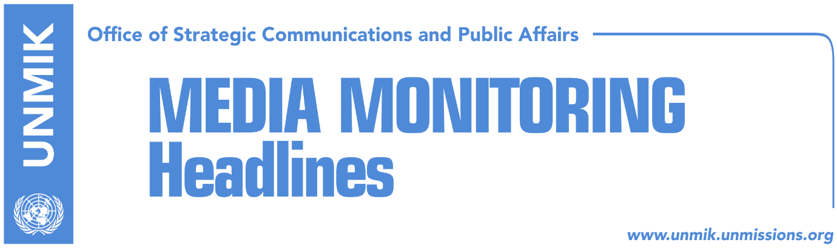

Main Stories 1 November 2017

- Hoti: Assembly to pass new resolution on dialogue with Serbia (Bota Sot)
- CEC announces final results, 19 municipalities go to runoffs (dailies)
- Secret alliances ahead of runoffs (Zeri)
- NATO’s opposition thwarts draft law on Kosovo armed forces (Koha)
- Serbian List calls for establishment of Association/Community (Zeri)
- KJC selects president of Mitrovica Basic Court (Koha)

Kosovo Media Highlights

Hoti: Assembly to pass new resolution on dialogue with Serbia (Bota Sot)
Head of the Democratic League of Kosovo (LDK) parliamentary group, Avdullah Hoti, said that the Assembly of Kosovo needs to pass a new resolution laying out the platform for dialogue with Serbia. He said President of Kosovo, Hashim Thaci, has so far acted unilaterally and possesses no authorizations to represent Kosovo in the negotiating process. “Assembly needs to be involved in this process through an overseeing role,” Hoti said.

CEC announces final results, 19 municipalities go to runoffs (dailies)
The Central Election Commission (CEC) announced the final results of the local elections in Kosovo saying that half of municipalities will have to head to a second round of election as no candidate managed to win more than 50 percent of the votes. CEC also announced that mayoral runoffs will take place on 19 November.

Secret alliances ahead of runoffs (Zeri)
The paper reports on the front page that political parties whose candidates are running in the second round of mayoral elections are expected to reach possible coalitions during next week but while some will be announced to the public, others are likely to remain secret for fear of repercussions. Meanwhile Artan Murati from the Kosovo Democratic Institute (KDI) said that alliances between political parties ahead of runoffs will not automatically translate into more votes. “We have cases from the past that despite agreements between political parties, the electorate voted differently,” Murati noted.

NATO’s opposition thwarts draft law on Kosovo armed forces (Koha)
Although the Government of Kosovo has included in its legislative agenda draft law on establishment of armed forces, it is unlikely to act on sending this to the Assembly following the recent NATO delegation visit to Kosovo, the paper reports on the front page. NATO’s Deputy Secretary General, Rose Gottemoeller, said in Pristina last week that Kosovo Security Force’s mandate should only be changed through constitutional amendments. Sources told the paper that Gottemoeller made it clear to Kosovo leaders that NATO would not support any unilateral action and that such a move would jeopardize Kosovo’s relations with the Alliance. Prime Minister Ramush Haradinaj’s office said the government is committed to KSF transformation into armed forces but that the process is not tied to a specific timeframe. “This process will be concluded in full inter-institutional consensus, in close cooperation with NATO and international partners,” said the government of Kosovo in a written response.

Serbian List calls for establishment of Association/Community (Zeri)
In a meeting yesterday with the Head of the EU Office in Kosovo, Nataliya Apostolova, representatives of the Serbian List called for establishment of the Association/Community of Serb-majority municipalities and noted that Kosovo institutions have much more issues to focus on right now other than establishment of armed forces. Apostolova said she expects the process of establishment of the Association/Community of Serb-majority municipalities to be stepped up once the second round of local elections is concluded and that Prime Minister Ramush Haradinaj has readiness to work to this end.

KJC selects president of Mitrovica Basic Court (Koha)
Kosovo Judicial Council in a meeting yesterday selected judge Nikola Kabasic as president of the Mitrovica Basic Court. KJC said in a statement that Kabasic received more votes than his counter candidate, Tomislav Petrovic.

Disclaimer
This media summary consists of selected local media articles for the information of UN personnel. The public distribution of this media summary is a courtesy service extended by UNMIK on the understanding that the choice of articles translated is exclusive, and the contents do not represent anything other than a selection of articles likely to be of interest to a United Nations readership. The inclusion of articles in this summary does not imply endorsement by UNMIK.

