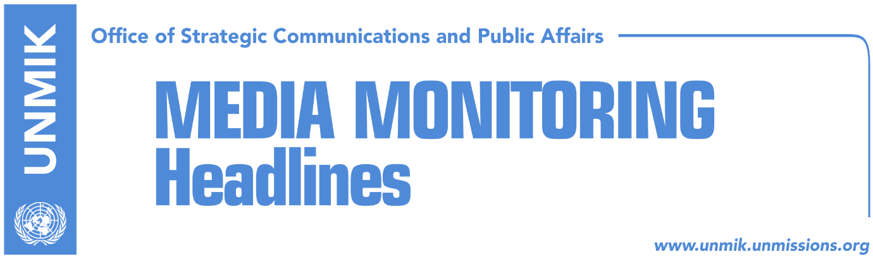

Main Stories 3 November 2017

- PM Haradinaj to travel to Brussels on 17 November (Zeri)
- Haradinaj: We are waiting for results from demarcation commission (RTK)
- SAA parliamentary committee clashes over position of chairperson (Zeri)
- Pacolli gives up on “recognitions” that never came (Koha)
- Vetevendosje: Decision on Kumanova group, politically motivated (RTK)
- FYROM flag set on fire in two Kosovo cities (Telegrafi)
- Kosovo might withdraw from CEFTA if represented by UNMIK (RTK)

Kosovo Media Highlights

PM Haradinaj to travel to Brussels on 17 November (Zeri)
Prime Minister of Kosovo, Ramush Haradinaj, is expected to undertake a visit to Brussels on 17 November. A statement issued by his office states that Haradinaj’s visit will focus on European Reform Agenda and implementation of the Stabilisation and Association Agreement. Visit to Brussels will be Haradinaj’s second abroad since taking power.

Haradinaj: We are waiting for results from demarcation commission (RTK)
Kosovo Prime Minister, Ramush Haradinaj, said on Thursday that the border with Montenegro is at Cakorr and added that Kosovo already has a state commission, and that he would wait for their findings before moving forward. “We will speak when we receive the results, and we of course are aware of the position of the President and many other parties in Kosovo. I believe that you are aware of my position, Kosovo knows, so the findings will be leading us,” Haradinaj said mentioning arbitrage as one of the possible options. “But we all know one thing and I think we all agree that they do not have the two thirds on the existing version, because it is wrong. The real border is at Kulla and Cakorr, but it moved to Kuqishte and we all know that it is wrong,”Haradinaj said.

SAA parliamentary committee clashes over position of chairperson (Zeri)
Representatives of the ruling and opposition parties to the Assembly’s committee on Stabilisation and Association Agreement (SAA) clashed over the post of chairperson after the opposition accused Xhavit Haliti from the Democratic Party of Kosovo (PDK) of having been appointed to the post by Assembly President Kadri Veseli and not voted by the members of the Assembly presidency. Opposition representatives also requested a visit to Strasbourg be postponed to after runoff elections in Kosovo which was denied by Haliti.

Pacolli gives up on “recognitions” that never came (Koha)
The paper reports on its front page that Kosovo’s Ministry for Foreign Affairs published on Thursday the updated list of countries that have recognized Kosovo’s independence. Two recognitions, from Nigeria and Uganda, have been removed from the list. Kosovo’s Foreign Minister, Behxhet Pacolli, had announced the two recognitions during the Thaci 2 government, but Pristina never received the verbal notes from Nigeria and Uganda.

Vetevendosje: Decision on Kumanova group, politically motivated (RTK)
Vetevendosje Movement considers that the decision of the Skopje Basic Court against “Kumanova Group” is politically motivated and an inhuman and degrading treatment, in contradiction with conventions for human rights. “Macedonia’s past has proven that many cases and judicial processes against Albanians resulted to be set up by state authorities, by discrediting investigative authorities and judiciary. The new Government of the Republic of Macedonia has not so far taken responsibilities to undertake measures against those who set up these cases. Instead, in the territory governed by them, these cases and processes discredited from professionalism, political independence, and impartiality of police and judiciary powers, continue to occur,” is written in a press release issued by Vetevendosje.

FYROM flag set on fire in two Kosovo cities (Telegrafi)
The sentencing of 33 Albanians to a total of 746 years in prison by a court in the former Yugoslav Republic of Macedonia (FYROM) for plotting attacks and clashing with authorities in 2015 has triggered reactions in Kosovo. In Gjilan/Gnjilane, a group of football fans set the FYROM flag on fire to protest against the ruling and the same was done in Peja/Pec by a group of citizens.

Kosovo might withdraw from CEFTA if represented by UNMIK (RTK)
Kosovo’s Minister for Trade and Industry, Bajram Hasani, warned that Kosovo will consider withdrawing from CEFTA, if their demands for equal treatment and not being represented by UNMIK are not taken into account. “This agreement, which was reached in late 2006, and is recognized with the UNMIK preamble, is perhaps the only one that does not recognize Kosovo or the Republic of Kosovo. We are invited to participate at CEFTA’s roundtable on the 23rd of this month. Of course we are going to raise some issues there. We have also requested from the EU Office to make pressure on UNMIK to give up its preamble and to be recognized as the Republic of Kosovo. There is of course another possibility of being recognized by all the member states and to be treated equally, otherwise, we might consider the possibility of withdrawing from CEFTA, if our request is not taken into consideration,” Hasani said.

Disclaimer
This media summary consists of selected local media articles for the information of UN personnel. The public distribution of this media summary is a courtesy service extended by UNMIK on the understanding that the choice of articles translated is exclusive, and the contents do not represent anything other than a selection of articles likely to be of interest to a United Nations readership. The inclusion of articles in this summary does not imply endorsement by UNMIK.

