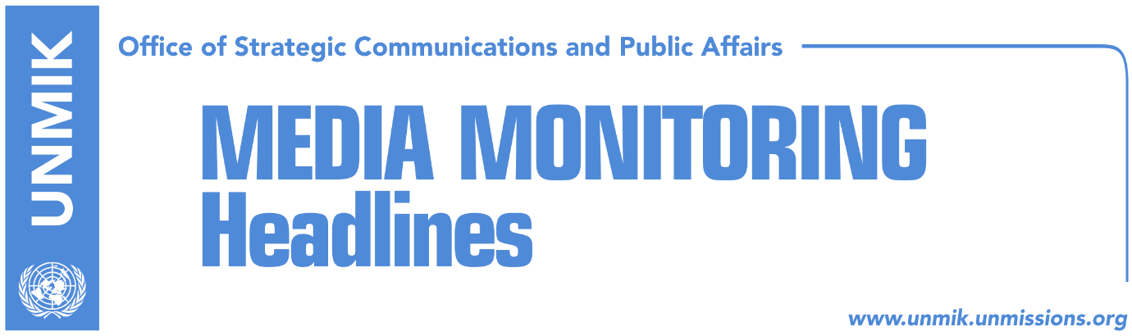

Main Stories 8 November 2017

- MPs: No dialogue without a new Assembly resolution (Koha/KP)
- Serbia calls for Association set up, prior to new round of dialogue (Kosova Sot)
- Kosovo government in no hurry to set up Association/Community (Zeri)
- Haradinaj values work of border demarcation commission (Epoka)
- Ymeri: Border demarcation agreement to be renegotiated (RFE)
- “Internal political quarrels delay European agenda” (Koha Ditore)
- Kosovo more endangered from political than religious threats (Koha)

Kosovo Media Highlights

MPs: No dialogue without a new Assembly resolution (Koha/KP)
Heads of Assembly committees said dialogue between Kosovo and Serbia should not resume without a new Assembly resolution. Chair of the Assembly’s committee on foreign affairs, Vjosa Osmani from the Democratic League of Kosovo (LDK), said that a new resolution would have to clarify the role of the president and the prime minister in the dialogue process as well as set red lines. She said it was concerning that the President of Kosovo was taking on the lead of the dialogue. “First, if the president leads this process, the Assembly would not be able to oversee it and second, if agreements are reached at the level of presidents, the president has no implementing mechanisms or can he order the government to implement them,” Osmani said. Head of the Assembly’s committee on European Integration, Blerta Deliu-Kodra from the Democratic Party of Kosovo (PDK), also called for a new resolution which, she underlined, should have the consent of parliamentary parties. Meanwhile, Vetevendosje’s Albulena Haxhiu, who chairs the committee on legislation, said there should be no new stages of the Kosovo-Serbia dialogue without the assessment of agreements reached so far.

Serbia calls for Association set up, prior to new round of dialogue (Kosova Sot)
The President of Serbia, Aleksandar Vucic, met Tuesday with head of the EU mission in Serbia, Sem Fabrizi. Vucic stressed the need of the establishment of the Association of Serb-majority Municipalities in Kosovo. “It is important for the agreement on Association of Serb-majority Municipalities to start implementation prior to the new round of the dialogue between Belgrade and Pristina,” Vucic said. He added that 1,670 days have passed since the deadline for implementation of this agreement.

Kosovo government in no hurry to set up Association/Community (Zeri)
Despite calls from the Serbian List officials for establishment of the Association/Community of Serb-majority municipalities as soon as possible, the government of Kosovo is in no rush to undertake such an action, the paper reports on page three. “The Association of Serb-majority municipalities will be established in line with the Constitutional Court’s ruling and based on Kosovo’s Constitution and its legislation. However, there is no time or any other pressure as to when this issue will be addressed but it will be done in optimal time,” Kosovo government said in a written response to the paper.

Haradinaj values work of border demarcation commission (Epoka)
The Prime Minister of Kosovo, Ramush Haradinaj, hosted on Tuesday an informative meeting with the State Commission for Demarcation and Maintenance of the State Border, to discuss engagement and activities of the Commission. According to a press release, members of the commission informed Haradinaj about their work and collection and processing of data from different sources, from the field as well as working meetings of the last week in Croatia and Slovenia. PM Haradinaj valued the work and commitment of the Commission and added that final report should be of high professional level, based on original, valid and verified facts.

Ymeri: Border demarcation agreement to be renegotiated (RFE)
In an interview to Radio Free Europe, Vetevendosje leader Visar Ymeri said that the border demarcation agreement with Montenegro should be renegotiated and that Montenegro cannot unilaterally implement the 2015 agreement. “In light of new facts and those presented so by experts of the Republic of Kosovo but also experts from the Republic of Albania, the agreement should be renegotiated with Montenegro,” Ymeri said and continued: “Even if Montenegro considers this issue closed, it is not closed if Kosovo does not consider it so because, at the end of the day, this is an agreement between two countries and requires both consents,” he added.

“Internal political quarrels delay European agenda” (Koha Ditore)
The paper reports on the front page that implementation of the European agenda in Kosovo has stalled because of internal political quarrels. As a result of these disagreements, the joint Kosovo-EU meeting on Stabilisation and Association Agreement (SAA) set to take place in Strasbourg has been postponed. Vetevendosje MP, Albulena Haxhiu, confirmed the postponement of the meeting after Vetevendosje leader Visar Ymeri wrote to the chairman of the European Parliament joint committee on SAA, Tonino Picula. “MPs from the ruling parties were determined to go without us but we got confirmation today that the meeting has been cancelled as it would be pointless if the opposition were not to attend,” Haxhiu said.

Kosovo more endangered from political than religious threats (Koha)
Kosovo Center for Security Studies announced that ever since the declaration of independence, Kosovo has been more endangered by political threats than the religious ones. The report of this Center, ‘Assessment of dangers in Kosovo since declaration of independence, February 2008 – June 2017”, notes that of 73 identified incidents, 45 of them were political, while 26 were religious. According to the report, security bodies in Kosovo were much faster in preventing religious threats.

Disclaimer
This media summary consists of selected local media articles for the information of UN personnel. The public distribution of this media summary is a courtesy service extended by UNMIK on the understanding that the choice of articles translated is exclusive, and the contents do not represent anything other than a selection of articles likely to be of interest to a United Nations readership. The inclusion of articles in this summary does not imply endorsement by UNMIK.

