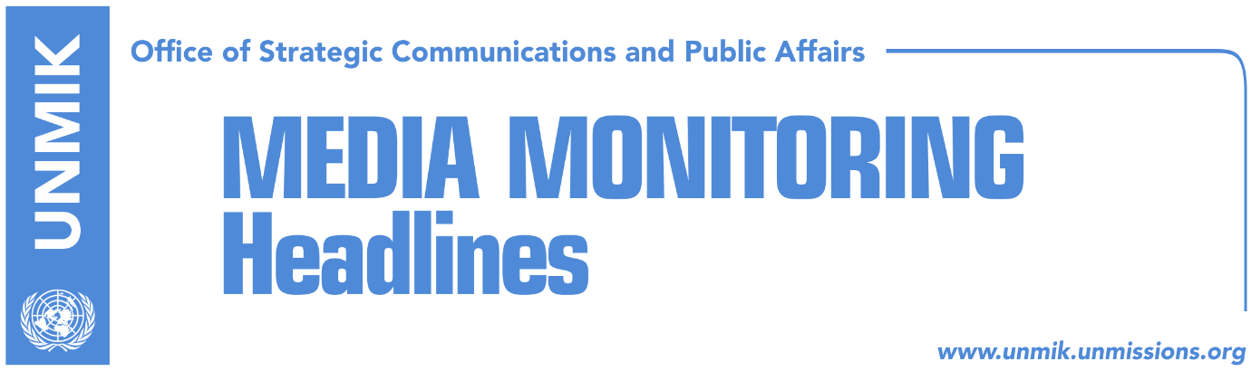

Main Stories 9 November 2017

- UN SG Guterres: Dialogue requires strong commitment (RTK)
- Yee: The U.S. continues to help Kosovo-Serbia dialogue (VOA, Epoka)
- Duncan: Britain to continue support for Kosovo (Koha)
- EU: Arbitration is no solution for visa liberalisation (Koha Ditore)
- Kosovo expects CEFTA members to endorse UNMIK’s removal (Koha)
- Haradinaj met with Lamberto Zannier (Zeri)
- Djuric: We are ready to fight in Kosovo (Zeri)
- Association of Journalists condemns Veseli’s response (Koha Ditore)

Kosovo Media Highlights

UN SG Guterres: Dialogue requires strong commitment (RTK)
The UN Secretary-General Antonio Guterres said that the dialogue between Belgrade and Pristina requires strong commitment and added that permanent peace is possible with sustainable normalization of relations. In his quarterly report on the work of the UN mission in Kosovo, Guterres stressed that UNMIK has been working on trust building among the communities in Kosovo. He said implementation of the Brussels Agreement signed in 2013 was annulled several times and added that “the reached agreements of high level make sense only if they gain wide support and action from both parties. Speaking about the normalization of relations between Kosovo and Serbia during this period, the SG said the dialogue has passed at a presidential level and that both parties stressed importance of moving the dialogue to more deeper matters.

Yee: The U.S. continues to help Kosovo-Serbia dialogue (VOA, Epoka)
The U.S. Deputy Assistant Secretary for European and Eurasian Affairs, Hoyt Brian Yee, told Voice of America that Kosovo and Serbia could send a clear message that they possess the political will to make difficult political decisions, required from both parties during the future meetings of the dialogue process in Brussels. He added that the U.S. will continue to help the dialogue process, however the main responsibility belongs to the two governments in Belgrade and Pristina. He added that U.S. policies should serve in the future to increase accountability of the governments in Balkans.

Duncan: Britain to continue support for Kosovo (Koha)
The President of Kosovo, Hashim Thaci, received on Wednesday the British Minister for Europe and the Americas, Sir Alan Duncan, with whom he discussed about the developments in Kosovo and the region. President Thaci expressed his gratitude for the continued support of Great Britain to Kosovo, for recognizing Kosovo and for Kosovo’s membership into international organizations. “Kosovo’s independence also bears the big stamp of London”, Thaci said. The British Minister for Europe and the Americas, Sir Alan Duncan, said that Great Britain remains committed to the region, despite London’s relationship with Brussels. “We want a region that lives in peace and stability”, stated Duncan. Thaci emphasized that Kosovo is a promoter of peace and dialogue in the region and works to build good neighborly relations with all, including Serbia.
Duncan met also with the Prime Minister of Kosovo, Ramush Haradinaj. During a media statement after the meeting, Haradinaj said that Duncan's visit is a rejuvenation of relations between Kosovo and United Kingdom, which dates back from the very difficult times when the United Kingdom supported the people of Kosovo. He further stressed that they are in new dimensions of co-operation, by mentioning the London meeting that will be held in July next year. "One of the most important developments during next year is the Balkans Summit that will be held in July in London, and one of the main reasons for my visit is to discuss with you and other neighbours about the work we should focus on this Summit, and we hope that we will be able to host a very constructive and meaningful event", said Minister Duncan.
EU: Arbitration is no solution for visa liberalisation (Koha Ditore)
The paper reports on the front page that the European Commission has not given signals it is ready to consider the border demarcation criteria as being fulfilled if the issue ends up in international arbitration. “European Commission is waiting for implementation of the delayed criteria for visa liberalisation relating to the track record of convictions in cases of organised crime and high-level corruption and ratification of the border agreement with Montenegro,” said to the paper EC spokesperson Kasia Kolanko. Last week, Kosovo Prime Minister Ramush Haradinaj said that the obstacles to visa liberalisation would be removed if the border demarcation issue with Montenegro is sent to arbitration. He said that in such a case, the EU would have to consider the border issue closed and grant visa liberalisation to the people of Kosovo.

Kosovo expects CEFTA members to endorse UNMIK’s removal (Koha)
The way Kosovo is being represented at the Central European Free Trade Agreement (CEFTA) will depend on the will of its members, said the EU Office in Kosovo in response to the call from the Kosovo’s Ministry of Trade and Industry to remove UNMIK from representing Kosovo. The EU said that it supports any agreement between Western Balkans countries, including CEFTA, “we encourage any issue relating to CEFTA regulations and their implementation be addressed to the CEFTA secretariat.”

Haradinaj met with Lamberto Zannier (Zeri)
The Prime Minister of Kosovo, Ramush Haradinaj, met on Wednesday with the OSCE High Commissioner for national minorities, Lamberto Zannier. Haradinaj said after the meeting that they discussed regional cooperation, integration in society and advancing of the minority rights through education and increase of social welfare. He added that Kosovo has made significant and sustainable steps on promotion and advancing of the rights for all minorities as well as their integration in Kosovo institutions.

Djuric: We are ready to fight in Kosovo (Zeri)
Marko Djuric, Director of the Office for Kosovo at the Serbian government, said on Wednesday during a religious ceremony in Mitrovica North that Serbs and Serbia will fight in Kosovo to defend “what is ours.” He added that as long as they are ready to fight for it, they will never lose it. “I want the entire Serbia to listen that we are ready to fight, this is why we are in our land,” Djuric said. He added that in Kosovo, each day is a day of war for defense of Serbia’s interests in Kosovo, to keep national, cultural and religious identity and this is the reason that Serbia is proud of Mitrovica.

Association of Journalists condemns Veseli’s response (Koha Ditore)
The Association of Kosovo Journalists (AGK) has condemned the response head of the Assembly and leader of the Democratic Party of Kosovo (PDK), Kadri Veseli, made to a question from a Koha reporter calling it political and commissioned by someone. During a visit to Kosovo Clinical and University Centre, Veseli was asked why the construction of the hospital in Ferizaj/Urosevac was being politicized at a time of election campaign, Veseli replied: “It is not good for you, journalists, to politicize this issue. Do not make ordered questions.” AGK said in a statement that it was concerned over the way Veseli replied to the question by giving it negative connotation. “Each politician and state leader should find better ways of rebuttal instead of slipping into such allegations aimed at denigrating the image of journalists,” AGK said.

Disclaimer
This media summary consists of selected local media articles for the information of UN personnel. The public distribution of this media summary is a courtesy service extended by UNMIK on the understanding that the choice of articles translated is exclusive, and the contents do not represent anything other than a selection of articles likely to be of interest to a United Nations readership. The inclusion of articles in this summary does not imply endorsement by UNMIK.

