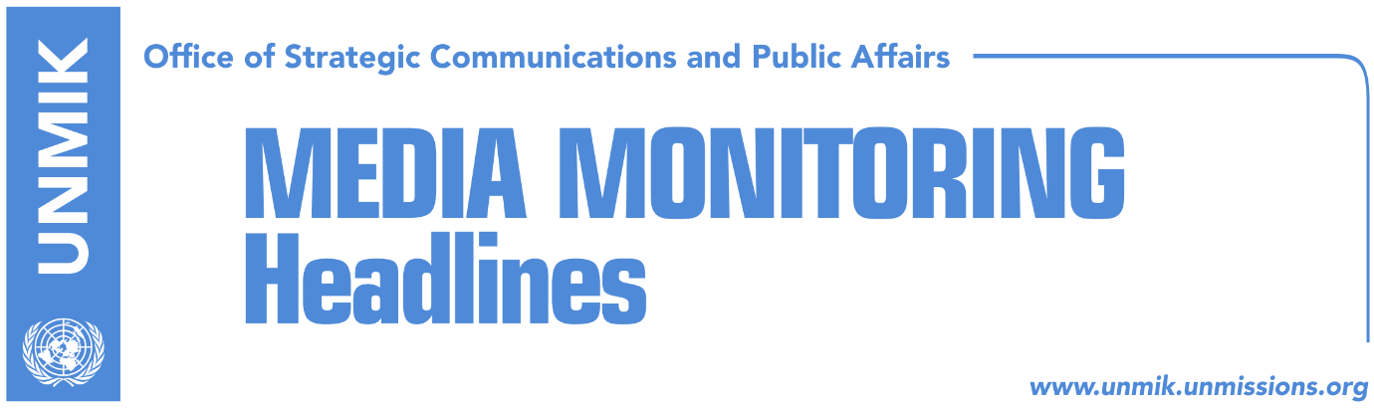

Main Stories 10 November 2017

- Ymeri anticipates Kosovo heading to fresh elections next year (Zeri)
- Isufi: New border commission to present realistic assessment (Epoka e Re)
- Serwer: Haradinaj not to resist border demarcation (Zeri)
- Hoxha: Demarcation agreement should be endorsed (Lajmi)
- Russia asks Serbian List to block demarcation with Montenegro (Zeri)
- Haradinaj government views many failures as successes (Koha)
- Vucic predicts: Serbs will be offered money to vote Kosovo Army (media)
- FYROM PM to visit Kosovo in December (Indeksonline)

Kosovo Media Highlights

Ymeri anticipates Kosovo heading to fresh elections next year (Zeri)
In a front-page interview to the paper, Vetevendosje leader Visar Ymeri said that he expects Kosovo to hold new parliamentary elections as early as next year. He said the current government of Kosovo is counting down its days in power and that the sooner it falls, the better. With regards to the motion of no-confidence, Ymeri said that the opposition should make sure it has all the necessary votes before putting it on the agenda and should also carefully consider the reasons for the motion. “You cannot want to bring a government down just because you are in the opposition but because you are unhappy with the way it is governing,” Ymeri said. He added that Vetevendosje continues to oppose the establishment of the Association/Community of Serb-majority municipalities calling it “unnecessary.”

Isufi: New border commission to present realistic assessment (Epoka e Re)
Deputy leader of the Alliance for the Future of Kosovo (AAK), Ahmet Isufi, said in an interview to the paper that the border demarcation commission will present a realistic assessment of what has happened in the process so far. “We are not talking about narrow political interests but about the territory of Kosovo and the national interest of the country,” Isufi said in a response to allegations that the commission, namely the government of Kosovo, is pursuing a false cause.

Serwer: Haradinaj not to resist border demarcation (Zeri)
The U.S. Balkans analyst, Daniel Serwer, said Prime Minister of Kosovo Ramush Haradinaj should not resist the ratification of the border demarcation agreement with Montenegro. “My advice to him is to get out of this rabbit hole as soon as possible. Kosovo has many other crucial issues to be concerned about,” Serwer said.

Hoxha: Demarcation agreement should be endorsed (Lajmi)
Kosovo’s Minister for European Integration, Dhurata Hoxha, has reiterated that Kosovo has fulfilled all the conditions for visa liberalisation by the European Union, except for the ratification of the demarcation agreement with Montenegro. “We have to conclude the processes, but then we should coordinate with the European Union in order for them to keep their promise. Kosovo is marking satisfactory progress in the process of visa liberalisation,” Hoxha said. She added that only one condition has remained to be fulfilled by Kosovo. “Demarcation should be ratified, the one that was signed and agreed by Kosovo and Montenegro,” she said. “Officials at EU were satisfied with the reached progress, but we have to continuously work on this process, we should not stop, despite fulfilment of a condition. We should continuously show that we are fighting corruption,” Hoxha said.

Russia asks Serbian List to block demarcation with Montenegro (Zeri)
Deputy General Secretary of the governing political party in Russia, Sergei Zeleznjak said that Serb representatives at the Assembly of Kosovo should block the process of demarcation with Montenegro. In an article published on “United Russia”, Zeleznjak said that members of the Serbian List should impede endorsement of the agreement on the border between Kosovo and Montenegro. “Their governing coalition in Kosovo gives them opportunity to stop transformation of the Kosovo Security Force into Kosovo’s Armed Forces, block demarcation process with Montenegro and other Albanian dangerous scenarios,” Zeleznjak who is also MP at Russian Duma, reportedly said.

Haradinaj government views many failures as successes (Koha)
The paper reports on its front page that it has been sixty days since the Haradinaj-led government has started work “but it has left no marks in decision-making except for setting records in overpopulating the government – with five deputy prime ministers, 21 ministers and around 50 deputy ministers”. The government sent to the paper a list of actions that it qualified as successes. But the paper notes that some these actions were seen as failures by the public such as the European agenda, Trepca, UNESCO and higher education. The paper also quotes political analysts in Pristina as saying that given the very small support in the Assembly, the Haradinaj-led government will not be long-lived.

Vucic predicts: Serbs will be offered money to vote Kosovo Army (media)
Serbian President Aleksandar Vucic said on Thursday that Albanians and one part of the international community have a clear objective of weakening the position of Serbia and the Serbian List in Kosovo. Vucic said there will be continuous pressure on Serb members of the Kosovo Assembly to agree with the formation of the Armed Forces. “There could be cases when people will be offered from €20.000 to 30.000 for Serbs to take part in the formation of the Kosovo Army in order to weaken the position of Serbia and the Serb people,” Vucic was quoted as saying in Serbian media.

FYROM PM to visit Kosovo in December (Indeksonline)
Zoran Zaev, Prime Minister of the Former Yugoslav Republic of Macedonia, is expected to visit Kosovo in the second week of December. A government spokesman in Skopje told the news website that Zaev is scheduled to meet his Kosovo counterpart, Ramush Haradinaj, in Pristina. “Yes, Prime Minister Zoran Zaev will visit Kosovo in December after an invitation from Prime Minister Haradinaj. The agenda of the visit has yet to be defined,” the spokesman said.

Disclaimer
This media summary consists of selected local media articles for the information of UN personnel. The public distribution of this media summary is a courtesy service extended by UNMIK on the understanding that the choice of articles translated is exclusive, and the contents do not represent anything other than a selection of articles likely to be of interest to a United Nations readership. The inclusion of articles in this summary does not imply endorsement by UNMIK.

